|  |  |
| --- | --- |
| logo ngan.png | **MINISTRY OF EDUCATION**  **AND TRAINING** |

**FPT UNIVERSITY**

|  |
| --- |
| Capstone Project Document |
| Test Online |

|  |  |
| --- | --- |
| **Group 10** | |
| **Group Members** | Lê Quốc Thanh – Team leader – 60363  Ngô Duy Hiếu – Team member – 60402  Vũ Minh Điền – Team member – 60347  Võ Tá Mạnh Thắng – Team member – 60474 |
| **Supervisor** | TrươngThị NgọcTuyền |
| **Ext Supervisor** | N/A |
| **Capstone Project code** | eTest |

– Ho Chi Minh City, 09/2013 –

***ACKNOWLEDGEMENTS***

A project is not a work that one person alone can finish, even a team. We got a lot of help from others people. With all our respect, we would love to thanks each person that helps us on this project.

First of all, we thank FPT University for giving us a chance to work on this project, a chance to improve ourselves, a chance to grow up all these years.

Secondly, we’re really thankful to Ms. Trương Thị Ngọc Tuyền (our supervisor) for yelling at us, for being angry with us so that we can find out our mistakes, for guiding us, clearing our mind when we stuck.

We also want to give our respect and grateful for all teachers who teaching us, make us stronger with valuable lessons.

We cannot forget about all the authors of the articles that we read on the internet. Thanks for your kindness of sharing knowledge with us.

Most important of all, with all our respect we greatly thanks and acknowledge our family.

And finally, we will thanks for anyone in the future that has interest in this project and want to give a hand improving it.

**Table Contents**

1 Introduction 1

1.1 Project Information 1

1.2 Overview of existing methods 1

1.3 Limitation of the existing system 1

1.4 Benefits of expected system 1

2 Software Project Management Plan 2

2.1 Problem Definition 2

2.1.1 Name of this Capstone Project 2

2.1.2 Problem Abstract 2

2.1.3 Project Overview 2

2.1.3.1 The Current System 2

2.1.3.2 The Proposed System 2

2.1.3.3 Boundaries of the System 3

2.1.3.4 Development Environment 3

2.2 Project organization 4

2.2.1 Software Process Model 4

2.2.2 Roles and Responsibilities 5

2.2.3 Tools and Techniques 5

2.3 Project management plan 6

2.3.1 Tasks: 6

2.3.1.1 Researching 6

2.3.1.2 Create Project Introduction 6

2.3.1.3 Create Software Project Plan (PMP) 6

2.3.1.4 Create Software Requirements Specification (SRS) 7

2.3.1.5 Create Software Design Description (SDD) 7

2.3.1.6 Design Database 7

2.3.1.7 Layout Design: 7

2.3.1.8 Create Coding Framework: 8

2.3.1.9 Training 8

2.3.1.10 System Implement and Test 8

2.3.1.11 Create User’s Manual 8

2.3.1.12 Input Initial Data 9

2.3.1.13 Deployment 9

2.3.2 Task Sheet: Assignments and Timetable 9

2.3.3 All Meeting Minutes 9

2.4 Convention Rules 9

3 Software Requirement Specification (SRS) 10

3.1 User Requirement Specification 10

3.2 System Requirement Specification 10

3.2.1 External Interface Requirements 10

3.2.1.1 User Interfaces 10

3.2.1.2 Communications Protocol 10

3.2.2 Functional Requirements 11

3.2.2.2 Account Management 15

3.2.2.2.1 Login 15

3.2.2.2.2 Logout 16

3.2.2.2.3 View Account Info 16

3.2.2.2.4 Change Password 16

3.2.2.2.5 Change Account info 18

3.2.2.3 Users Management 18

3.2.2.3.1 Search User 18

3.2.2.3.2 View User Details 18

3.2.2.3.3 Create User 18

3.2.2.3.4 Edit User 20

3.2.2.3.5 Delete User 20

3.2.2.3.6 Activate User 20

3.2.2.3.7 Deactivate User 20

3.2.2.3.8 Import User 20

3.2.2.4 Participants Management 22

3.2.2.4.1 Search Participant 22

3.2.2.4.2 View Participant Details 22

3.2.2.4.3 Create Participant 22

3.2.2.4.4 Delete Participant 24

3.2.2.4.5 Activate Participant 24

3.2.2.4.6 Deactivate Participant 24

3.2.2.4.7 Import Participant 24

3.2.2.5 Subjects Management 26

3.2.2.5.1 Search Subject 26

3.2.2.5.2 View Subject Details 26

3.2.2.5.3 Create Subject 26

3.2.2.5.4 Edit Subject 28

3.2.2.5.5 Delete Subject 28

3.2.2.5.6 Activate Subject 28

3.2.2.5.7 Deactivate Subject 28

3.2.2.5.8 Import Subject 28

3.2.2.6 Sections Management 30

3.2.2.6.1 Search Section 30

3.2.2.6.2 View Section Details 30

3.2.2.6.3 Create Section 31

3.2.2.6.4 Edit Section 32

3.2.2.6.5 Delete Section 32

3.2.2.6.6 Activate Section 32

3.2.2.6.7 Deactivate Section 32

3.2.2.7 Questions Management 33

3.2.2.7.1 Search Question 33

3.2.2.7.2 View Question Details 33

3.2.2.7.3 Create Question 33

3.2.2.7.4 Edit Question 35

3.2.2.7.5 Delete Question 35

3.2.2.7.6 Activate Question 35

3.2.2.7.7 Deactivate Question 35

3.2.2.7.8 Import Question 35

3.2.2.7.9 Add Question to Section 37

3.2.2.7.10 Remove Question from Section 38

3.2.2.8 Tests Management 38

3.2.2.8.1 Search Test 38

3.2.2.8.2 View Test Details 39

3.2.2.8.3 Create Test 39

3.2.2.8.4 Edit Test 40

3.2.2.8.5 Delete Test 40

3.2.2.8.6 Activate Test 40

3.2.2.8.7 Deactivate Test 41

3.2.2.8.8 Take the Test 41

3.2.2.8.9 Take the Quick Test 42

3.2.2.9 Discussions Management 44

3.2.2.9.1 Search Discussion 44

3.2.2.9.2 View Discussion Details 44

3.2.2.9.3 Create Discussion 44

3.2.2.9.4 Edit Discussion 45

3.2.2.9.5 Delete Discussion 46

3.2.2.9.6 Activate Discussion 46

3.2.2.9.7 Deactivate Discussion 46

3.2.2.10 Reports Management 46

3.2.2.10.1 Search Report 46

3.2.2.10.2 View Report Details 46

3.2.2.10.3 Send Question Report 46

3.2.2.10.4 Send Section Report 47

3.2.2.10.5 Send Discussion Report 49

3.2.2.10.6 Send Test Report 50

3.2.2.10.7 Mark as Read Report 52

3.2.2.10.8 Mark as Unread Report 52

3.2.2.10.9 Delete Report 52

3.2.2.11 Feedbacks Management 52

3.2.2.11.1 Search Feedback 52

3.2.2.11.2 View Feedback Details 52

3.2.2.11.3 Send Feedback 52

3.2.2.11.4 Mark as Read Feedback 54

3.2.2.11.5 Mark as Unread Feedback 54

3.2.2.11.6 Delete feedback 54

3.2.3 Non-Functional Requirement 54

3.2.3.1 Reliability 54

3.2.3.2 Availability 54

3.2.3.3 Security 54

3.2.3.4 Maintainability 55

3.2.3.5 Portability 55

3.2.3.6 Performance 55

3.3 Entity Relationship Diagram 56

4 System Design Description (SDD) 57

4.1 Design Overview 57

4.2 System Architectural Design 58

4.2.1 Choice of System Architecture 58

4.2.2 Discussion of Alternative Designs 59

4.2.2.1 MVC (Model-View-Controller) 59

4.2.3 Description of System Interface 60

4.2.3.1 User interfaces 60

4.2.3.2 Hardware interfaces 60

4.2.3.3 Software interfaces 60

4.2.3.4 Communication interfaces 60

4.3 Component Diagram 61

4.4 Detailed Description of Components 62

4.4.1 Account Management 62

4.4.1.1 Class Diagram 62

4.4.1.2 Class Diagram Explanation 62

4.4.2 Users Management 63

4.4.2.1 Class Diagram 63

4.4.2.2 Class Diagram Explanation 63

4.4.3 Subjects Management 64

4.4.3.1 Class Diagram 64

4.4.3.2 Class Diagram Explanation 64

4.4.4 Participants Management 65

4.4.4.1 Class Diagram 65

4.4.4.2 Class Diagram Explanation 65

4.4.5 Sections Management 66

4.4.5.1 Class Diagram 66

4.4.5.2 Class Diagram Explanation 66

4.4.6 Questions Management 67

4.4.6.1 Class Diagram 67

4.4.6.2 Class Diagram Explanation 67

4.4.7 Tests Management 68

4.4.7.1 Class Diagram 68

4.4.7.2 Class Diagram Explanation 68

4.4.8 Discussions Management 69

4.4.8.1 Class Diagram 69

4.4.8.2 Class Diagram Explanation 69

4.4.9 Reports Management 70

4.4.9.1 Class Diagram 70

4.4.9.2 Class Diagram Explanation 70

4.4.10 Feedbacks Management 71

4.4.10.1 Class Diagram 71

4.4.10.2 Class Diagram Explanation 71

4.5 Sequence Diagram 72

4.5.1 Account Management 72

4.5.1.1 Login 72

4.5.1.2 Logout 73

4.5.1.3 View Account Info 73

4.5.1.4 Change Password 74

4.5.1.5 Change Account Info 75

4.5.2 Users Management 75

4.5.2.1 Search User 75

4.5.2.2 View User Details 75

4.5.2.3 Create User 76

4.5.2.4 Edit User 77

4.5.2.5 Delete User 77

4.5.2.6 Activate User 77

4.5.2.7 Deactivate User 77

4.5.2.8 Import User 78

4.5.3 Participants Management 79

4.5.3.1 Search Participant 79

4.5.3.2 View Participant Details 79

4.5.3.3 Create Participant 80

4.5.3.4 Delete Participant 81

4.5.3.5 Activate Participant 81

4.5.3.6 Deactivate Participant 81

4.5.3.7 Import Participant 82

4.5.4 Subjects Management 83

4.5.4.1 Search Subject 83

4.5.4.2 View Subject Details 83

4.5.4.3 Create Subject 84

4.5.4.4 Edit Subject 85

4.5.4.5 Delete Subject 85

4.5.4.6 Activate Subject 85

4.5.4.7 Deactivate Subject 85

4.5.4.8 Import Subject 86

4.5.5 Sections Management 87

4.5.5.1 Search Section 87

4.5.5.2 View Section Details 87

4.5.5.3 Create Section 88

4.5.5.4 Edit Section 88

4.5.5.5 Delete Section 89

4.5.5.6 Activate Section 89

4.5.5.7 Deactivate Section 89

4.5.6 Questions Management 89

4.5.6.1 Search Question 89

4.5.6.2 View Question Details 89

4.5.6.3 Create Question 90

4.5.6.4 Edit Question 91

4.5.6.5 Delete Question 91

4.5.6.6 Activate Question 91

4.5.6.7 Deactivate Question 91

4.5.6.8 Import Question 92

4.5.6.9 Add Question to Section 93

4.5.6.10 Remove Question from Section 94

4.5.7 Tests Management 94

4.5.7.1 Search Test 94

4.5.7.2 View Test Details 94

4.5.7.3 Create Test 95

4.5.7.4 Edit Test 95

4.5.7.5 Delete Test 96

4.5.7.6 Activate Test 96

4.5.7.7 Deactivate Test 96

4.5.7.8 Take the Test 97

4.5.7.9 Take the Quick Test 98

4.5.8 Discussions Management 99

4.5.8.1 Search Discussion 99

4.5.8.2 View Discussion Details 99

4.5.8.3 Create Discussion 100

4.5.8.4 Edit Discussion 101

4.5.8.5 Delete Discussion 101

4.5.8.6 Activate Discussion 101

4.5.8.7 Deactivate Discussion 101

4.5.9 Reports Management 101

4.5.9.1 Search Report 101

4.5.9.2 View Report Details 101

4.5.9.3 Send Question report 102

4.5.9.4 Send Section Report 103

4.5.9.5 Send Discussion Report 104

4.5.9.6 Send Test Report 105

4.5.9.7 Mark as Read Report 106

4.5.9.8 Mark as Unread Report 106

4.5.9.9 Delete Report 106

4.5.10 Feedbacks Management 106

4.5.10.1 Search Feedback 106

4.5.10.2 View Feedback Details 106

4.5.10.3 Send Feedback 107

4.5.10.4 Mark as Read Feedback 108

4.5.10.5 Mark as Unread Feedback 108

4.5.10.6 Delete Feedback 108

4.6 Database Design 109

4.6.1 Physical Diagram 109

4.6.2 Table Dictionary 110

4.6.2.1 Users Table 110

4.6.2.2 Roles Table 111

4.6.2.3 Participants Table 111

4.6.2.4 Subjects Table 111

4.6.2.5 Sections Table 111

4.6.2.6 SectionQuestions Table 111

4.6.2.7 Questions Table 112

4.6.2.8 QuestionTypes Table 112

4.6.2.9 Answers Table 112

4.6.2.10 Matches Table 112

4.6.2.11 Tests Table 113

4.6.2.12 TestQuestions Table 113

4.6.2.13 TestTypes Table 113

4.6.2.14 UserTests Table 113

4.6.2.15 UserAnswers Table 114

4.6.2.16 Discussions Table 114

4.6.2.17 Reports Table 114

4.6.2.18 Feedbacks Table 115

5 System Implementation & Test 115

5.1 Introduction 115

5.1.1 System Overview 115

5.1.2 Test Approach 115

5.2 Test plan 116

5.2.1 Feature to be tested: 116

5.2.1.1 Account Management 116

5.2.1.2 Users Management 116

5.2.1.3 Participants Management 116

5.2.1.4 Subjects Management 116

5.2.1.5 Sections Management 117

5.2.1.6 Questions Management 117

5.2.1.7 Tests Management 117

5.2.1.8 Discussions Management 118

5.2.1.9 Reports Management 118

5.2.1.10 Feedbacks Management 118

5.2.2 Feature not to be tested 118

5.2.3 Testing tools and Environment 119

5.3 Test case 120

5.3.1 Account Management 120

5.3.1.1 Login 120

5.3.1.2 Logout 122

5.3.1.3 View Account Info 122

5.3.1.4 Change Password 122

5.3.1.5 Change Account Info 125

5.3.2 Users Management 125

5.3.2.1 Search User 125

5.3.2.2 View User Details 125

5.3.2.3 Create User 126

5.3.2.4 Edit User 130

5.3.2.5 Delete User 130

5.3.2.6 Activate User 130

5.3.2.7 Deactivate User 130

5.3.2.8 Import User 131

5.3.3 Participants Management 132

5.3.3.1 Search Participant 132

5.3.3.2 View Participant Details 133

5.3.3.3 Create Participant 133

5.3.3.4 Delete Participant 134

5.3.3.5 Activate Participant 134

5.3.3.6 Deactivate Participant 135

5.3.3.7 Import Participant 135

5.3.4 Subjects Management 137

5.3.4.1 Search Subject 137

5.3.4.2 View Subject Details 137

5.3.4.3 Create Subject 137

5.3.4.4 Edit Subject 139

5.3.4.5 Delete Subject 139

5.3.4.6 Activate Subject 139

5.3.4.7 Deactivate Subject 139

5.3.4.8 Import Subject 140

5.3.5 Sections Management 142

5.3.5.1 Search Section 142

5.3.5.2 .View Section Details 142

5.3.5.3 Create Section 142

5.3.5.4 Edit Section 143

5.3.5.5 Delete Section 143

5.3.5.6 Activate Section 143

5.3.5.7 Deactivate Section 144

5.3.6 Questions Management 144

5.3.6.1 Search Question 144

5.3.6.2 View Question Details 144

5.3.6.3 Create Question 144

5.3.6.3.1 Create Single Choice Question 144

5.3.6.3.2 Create Multiple Choice Question 146

5.3.6.3.3 Create Matching Question 149

5.3.6.3.4 Create True/False Question 151

5.3.6.4 Edit Question 152

5.3.6.5 Delete Question 152

5.3.6.6 Activate Question 152

5.3.6.7 Deactivate Question 152

5.3.6.8 Import Question 152

5.3.6.9 Add Question to Section 154

5.3.6.10 Remove Question from Section 155

5.3.7 Tests Management 155

5.3.7.1 Search Test 155

5.3.7.2 View Test Details 155

5.3.7.3 Create Test 155

5.3.7.4 Edit Test 158

5.3.7.5 Delete Test 158

5.3.7.6 Activate Test 158

5.3.7.7 Deactivate Test 158

5.3.7.8 Take the Test 159

5.3.7.9 Take the Quick Test 160

5.3.8 Discussions Management 163

5.3.8.1 Search Discussion 163

5.3.8.2 View Discussion Details 163

5.3.8.3 Create Discussion 163

5.3.8.4 Edit Discussion 165

5.3.8.5 Delete Discussion 165

5.3.8.6 Activate Discussion 165

5.3.8.7 Deactivate Discussion 165

5.3.9 Reports Management 165

5.3.9.1 Search Report 165

5.3.9.2 View Report Details 165

5.3.9.3 Send Question Report 166

5.3.9.4 Send Section Report 167

5.3.9.5 Send Discussion Report 167

5.3.9.6 Send Test Report 168

5.3.9.7 Mark as Read Report 168

5.3.9.8 Mark as Unread Report 168

5.3.9.9 Delete Report 168

5.3.10 Feedbacks Management 168

5.3.10.1 Search Feedback 168

5.3.10.2 View Feedback Details 168

5.3.10.3 Send Feedback 169

5.3.10.4 Mark as Read Feedback 170

5.3.10.5 Mark as Unread Feedback 170

5.3.10.6 Delete Feedback 170

5.4 Checklists 172

5.4.1 Checklist of Validation 172

5.4.2 Submission Checklist 173

6 System User’s Manual 174

6.1 Installation Guide 174

6.1.1 System requirements 174

6.1.2 Installation 174

6.1.2.1 Deploy Database 174

6.1.2.2 Deploy Application 175

6.2 User’s Guide 180

List of Figures 181

# Introduction

## Project Information

* Project title: Test Online.
* Project code: eTest.
* Project start Date: September 10, 2013.
* Project finish Date: December 21, 2013.

## Overview of existing methods

Currently, in FPT University, every subject just finished in 4 or 6 weeks with a lot of tests. Therefore, students have no long time to prepare for the tests. Moreover, the tests take about 60 – 70 percent of total marks of each subject.  
The CMS just let students take quiz or final examination, but it does not provide anything to help the students take the trail tests as the training by themselves before they take the real test to make sure a good mark.

## Limitation of the existing system

The CMS does not allow the students to take any trial tests or provides any ways to prepare the quiz or final examination while they have no long time to prepare for the tests.

## Benefits of expected system

The purpose of Test Online System helps FPT University students have an environment that they can study to prepare for the tests at the University:

* Allow the student to take the trial test for preparing the quiz or final examination. The tests can be posted by students or teacher.
* They can share their questions to others and studying together.

The students (or the teachers) takes the trial test or posts the question if they have the permission to access that subject.

# Software Project Management Plan

## Problem Definition

### Name of this Capstone Project

This Capstone Project Name is “Test Online” or “eTest” in short.

### Problem Abstract

Test Online is a website that allows FPT students taking the trial test for preparing the quiz or final examination. The tests can be posted by students or teachers. This website helps students studying by themselves before taking the test at the University.

Requirements: There are two modules need to be implemented:

* Front end: This part is served for students who wants to take the test.
* Back end: This part is served for students who want to create the questions by themselves to studying and for teachers who teach the students at FPT University to post their trial tests for students.

### Project Overview

#### The Current System

The currently system do not allow the students to take any trial tests or provides any ways to prepare the quiz or final examination while they have no long time to prepare for the tests.

#### The Proposed System

The system is developed web-base. This will provide these features to support the students, teachers and admin:

* Student: This feature allows students port and manage their posted question, taking the trial tests.
* Teacher: The teacher had same functions like student and mores. The teachers are responsible for creating Test for students.
* Admin: The Admin manage the system include users, subject, participants, question, test and so on.

#### Boundaries of the System

The boundaries of the Test Online for FPT University:

* Apply for FPT University only.
* Only main functions of the system will be developed.

#### Development Environment

**Hardware requirements:**

* A computer with hardware that capable of running Windows 7 operating system, 2GB of RAM for addition software.

**Software requirements:**

* Operating System: Windows 7 Professional (32 or 64 bit).

## Project organization

### Software Process Model

The software will be developed by using waterfall model. The waterfall model developing process includes five main phases:



**Figure 1 - Waterfall model**

* + - Requirement analysis and software definition: The first phase is also the most important phase of the process which may cause great effect to other phases. This phase includes gathering requirements from customer, or from other source like the Internet, and producing the most detail and accurate software definition.
    - System design: This phase is fundamental for implementation phase. Based on customer’s requirements to create logical modules, and definite their inter relations. Using algorithm and diagram to describe implementation of those modules.
    - System implementation and Unit testing: Developing software modules follow detail designs, and doing unit testing for each module.
    - Integration and System testing: Testing output, performance in modules integrating process, and retests all functions of whole system.
    - System deployment and maintenance: After testing completely, the software is handle over client, developing team will respond for maintenance of the system.

### Roles and Responsibilities

|  |  |  |
| --- | --- | --- |
| Name | Role | Responsibilities |
| Trương Thị Ngọc Tuyền | Supervisor | * Specify project requirement * Give advice on business and technical problem |
| Lê Quốc Thanh | Leader | * Manage project plan and process * Support team member * Build up team member morale |
| Ngô Duy Hiếu | Member | * Doing development tasks * Writing and reviewing document * Performing testing |
| Vũ Minh Điền | Member | * Doing development tasks * Writing and reviewing document * Performing testing |
| Võ Tá Mạnh Thắng | Member | * Doing development tasks * Writing and reviewing document * Performing testing |

### Tools and Techniques

* Tools:
  + Visual Studio 2010 Ultimate
  + MS SQL Server 2008 Express
  + StarUML 5.0.2.1570
* Technologies:
  + Server side: C#, ASP.NET MVC4, MSSQL
  + Client side: HTML5, CSS3, JavaScript, jQuery 1.7.1, Bootstrap 2.3.2, TinyMCE 4.0.10

## Project management plan

### Tasks

#### Researching

* Description: discuss with supervisor on important aspects of the system being built. Evaluate the feasibility to implement it on time.
* Deliverables: N/A.
* Resources Needed: 4 people for 2 day.
* Dependencies and Constraints: N/A.
* Risk: Project may not be feasible for developing because of strange requirements or lack of technologies.

#### Create Project Introduction

* Description: Create Project Introduction.
* Deliverables: Project Introduction document.
* Resources Needed: 4 people for 1 day.
* Dependencies and Constraints: Depend on researching results and project features.
* Risk: Members lack of experience in getting requirement.

#### Create Software Project Plan (PMP)

* Description: Define project organization: software process, role and responsibility as well as technology being used. Create Project Management Plan with task list.
* Deliverables: Project Management Plan document.
* Resources Needed: 4 people for 2 days.
* Dependencies and Constraints: Depend on project introduction, scheduled tasks must be within 15 weeks.
* Risk: Planned task may not balance. Team may not be able to keep works in schedule due to lack of understanding about project requirement or technology. The schedule may need to change due to changes in later phases.

#### Create Software Requirements Specification (SRS)

* Description: Create software requirements specification.
* Deliverables: software requirements specification document.
* Resources Needed: 4 people for 6 days.
* Dependencies and Constraints: Depend on customer requirement.
* Risk: Difficulty to understand requirement, misunderstanding requirement may lead to failure in later phase.

#### Create Software Design Description (SDD)

* Description: Design system architecture and system components.
* Deliverables: SDD document.
* Resources Needed: 4 people for 11 days.
* Dependencies and Constraints: Depends on the completion of SRS document.
* Risk: Risks may include choosing inappropriate architecture and design patterns, causing the system hard to maintain, or wasting coding efforts.

#### Design Database

* + Description: Create logical and physical database design.
  + Deliverables: Database Design model.
  + Resources Needed: 1 people for 3 days.
  + Dependencies and Constraints: Depends on SRS document and SDD document.
  + Risk: The database design can be inappropriate or changed based on customers’ requirements.

#### Layout Design:

* Description: Design project web base layout.
* Deliverables: Project web base layout.
* Resources Needed: 1 people for 2 days.
* Dependencies and Constraints: Depend on SRS and SDD documents.
* Risk: SRS and SDD may not detail enough to design the layout.

#### Create Coding Framework:

* Description: Map the architecture design into source code, create the project solution files and common classes, and implement common functions.
* Deliverables: Visual Studio project and solution files containing coding framework.
* Resources Needed: 1 people for 1 day.
* Dependencies and Constraints: Depend on SRS and SDD documents.
* Risk: SRS and SDD may not detail enough to create coding framework.

#### Training

* Description: Training technologies by yourself
* Deliverables: N/A
* Resources Needed: 3 people for 3 day.
* Dependencies and Constraints: Depend on SRS and SDD documents.
* Risk: No experience.

#### System Implement and Test

* + Description: Implement the system based on requirements and perform test.
  + Deliverables: Executable programs, source code and test reports.
  + Resources Needed: 4 people for 24 days.
  + Dependencies and Constraints: Depends on the completion of SRS, SDD, database design, layout design and coding framework.
  + Risk: Test may not be performed thoroughly, causing spending many efforts in system test phase.

#### Create User’s Manual

* Description: Create User’s manual.
* Deliverables: User’s manual document.
* Resources Needed: 4 people for 5 days.
* Dependencies and Constraints: Depend on SRS, SDD documents and coding is finished.
* Risk: The project may do not cover all of SRS and SDD documents.

#### Input Initial Data

* Description: Collect and input data for the system before release.
* Deliverables: Initial data.
* Resources Needed: 2 people for 1 day.
* Dependencies and Constraints: Coding and system test are finished.
* Risk: N/A.

#### Deployment

* Description: Deploy the system on server.
* Deliverables: Running website with domain and hosting.
* Resources Needed: 4 people for 2 day.
* Dependencies and Constraints: Coding and system test are finished, initial data is inputted.
* Risk: The owner host lacks of support in some components such as database engine.

### Task Sheet: Assignments and Timetable

* Reference to CD:
  + <root>/Documents/Tasksheet.xlsx
  + <root>/Documents/Project Plan.mpp

### All Meeting Minutes

* Reference to CD: <root>/Documents/Meeting Minutes/

## Convention Rules

* Reference to CD: <root>/Documents/C# Coding Conventions.docx

# Software Requirement Specification (SRS)

## User Requirement Specification

Test Online (or eTest is short name) is a website that allows FPT students taking the trial test for preparing the quiz or final examination. The tests can be posted by students or teachers. This website helps students studying by themselves before taking the test at the University.

Requirements: There are two modules need to be implemented:

* Front end: This part is served for students who want to take the test.
* Back end: This part is served for students who want to create the questions by themselves to studying and for teachers who teach the students at FPT University to post their trial tests for students.

## System Requirement Specification

### External Interface Requirements

#### User Interfaces

- The system main functions look like CMS so user interface should be simple and friendly.

#### Communications Protocol

- The system is web base so it’s should be applied HTTP is main communication protocol.

### Functional Requirements

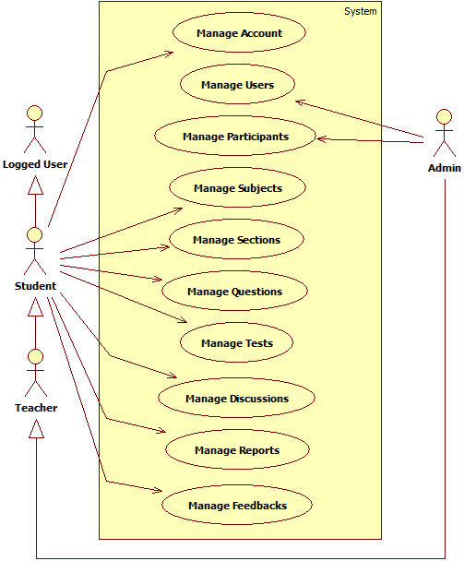

**Figure 2 - Overall use case diagram**

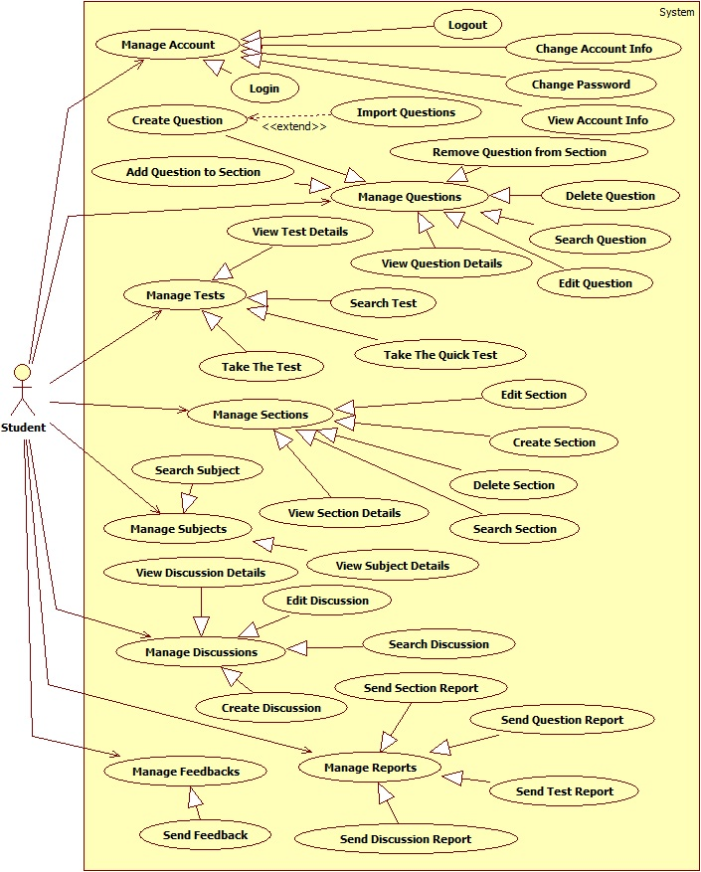

**Figure 3 – Student’s use case diagram**

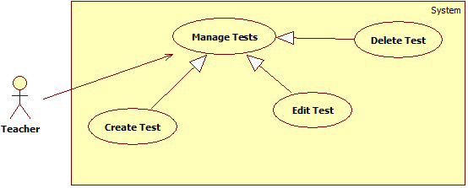

**Figure 4 – Teacher’s use case diagram**

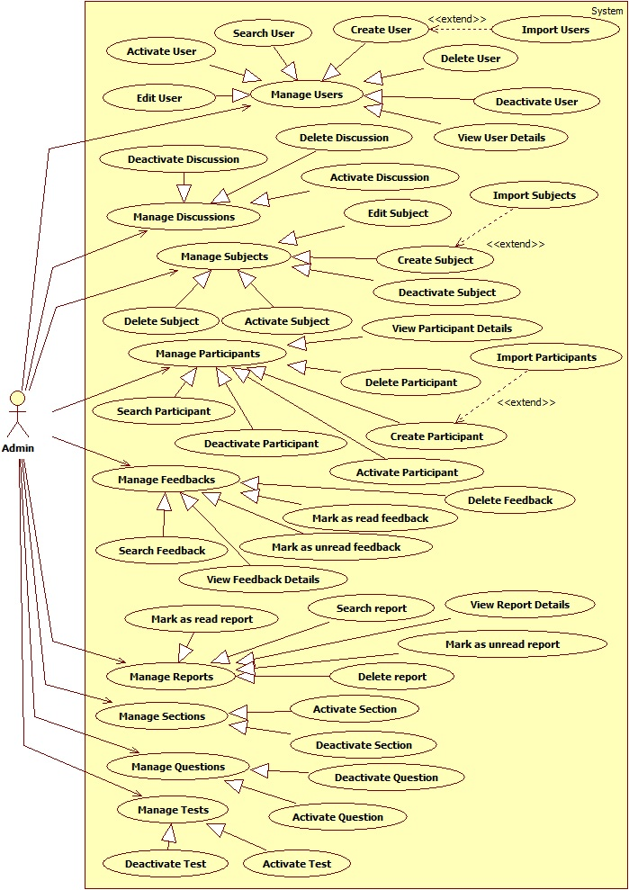

**Figure 5 – Admin’ use case diagram**

#### 

#### Account Management

##### Login

Use Case Diagram

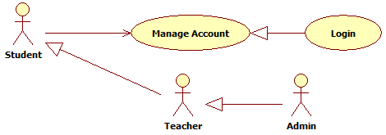

**Figure 6: Login UseCase**

Use Case Specification

|  |  |  |  |  |
| --- | --- | --- | --- | --- |
| USE CASE | | | | |
| Use-case No. | UC_001 | Use-case Version | | 0.1 |
| Use-case Name | Login | | | |
| Author | Ngô Duy Hiếu | | | |
| Date | 17/09/2013 | Priority | High | |
| **Actor:** Admin, Teacher, Student  **Summary:** This use case allows administrator, student and teacher to log on into the system  **Goal:** Authenticate user.  **Triggers:** User access website area that is intended for student, teacher and administrator.  **Pre-conditions:** User has an account and has not logged in yet  **Post-conditions.**  **Success:** User has logged in.  Redirects to Home page  **Fail:** Redirects to Login page  **Main Success Scenario.**   |  |  |  | | --- | --- | --- | | Step | Actor Action | System Response | | 1 | User go to website page | Website will show [Login] page | | 2 | User input information into username field and password field |  | | 3 | User click “Login” button [Alternative 1] | Check account validity and redirect to Home page [Exception 1] |   **Alternative Scenario.**   |  |  |  | | --- | --- | --- | | No. | Actor Action | System Response | | 1 | User click “Reset” button | Clear username field and password field. |   **Exceptions**.   |  |  |  | | --- | --- | --- | | No. | Actor Action | System Response | | 1 | User credential is not valid | Display error message “Invalid username or password”. |   Relationships: N/A  Business Rules: N/A | | | | |

##### Logout

* + Reference to CD: <root>/Documents/eTest Document - Full.docx

##### View Account Info

* + Reference to CD: <root>/Documents/eTest Document - Full.docx

##### Change Password

Use Case Diagram

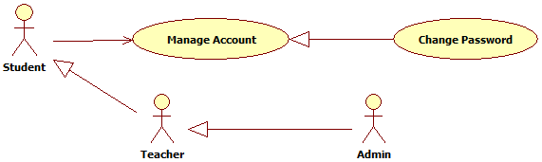

**Figure7: Change Password UseCase**

Use Case Specification

|  |  |  |  |  |
| --- | --- | --- | --- | --- |
| USE CASE | | | | |
| Use-case No. | UC_004 | Use-case Version | | 0.1 |
| Use-case Name | Change Password | | | |
| Author | Ngô Duy Hiếu | | | |
| Date | 17/09/2013 | Priority | High | |
| **Actor:** Student, Teacher, Admin  **Summary:** This use case allows student, teacher or admin can change password of them  **Goal:** Change password.  **Triggers:** User click “Password” tab on “View Account Info” page  **Pre-conditions:** User has logged in as Student, Teacher or Admin  **Post-conditions.**  **Success:** The password is changed.  **Fail:** Password is not changed. Display error message  **Main Success Scenario.**   |  |  |  | | --- | --- | --- | | Step | Actor Action | System Response | | 1 | Go to “View Account Info” page, click on “Password” tab | Display “Change Password” page | | 2 | Input information |  | | 3 | Click “Save” button [Alternative 1] | Check information validity and change password |   **Alternative Scenario.**   |  |  |  | | --- | --- | --- | | No. | Actor Action | System Response | | 1 | Click “Reset” button | Clear all information to blank field. |   **Exceptions**.   |  |  |  | | --- | --- | --- | | No. | Actor Action | System Response | | 1 | Old password is not right | Display error message: “Your old password is wrong. Please try again!” | | 2 | New password is same with Old password | Display error message: “New password must be different with old password” | | 3 | Confirm new password is not same with New password | Display error message: “Confirm new password must be equal New password” |   Relationships: N/A  Business Rules: N/A | | | | |

##### Change Account info

* + Reference to CD: <root>/Documents/eTest Document - Full.docx

#### Users Management

##### Search User

* + Reference to CD: <root>/Documents/eTest Document - Full.docx

##### View User Details

* + Reference to CD: <root>/Documents/eTest Document - Full.docx

##### Create User

Use Case Diagram

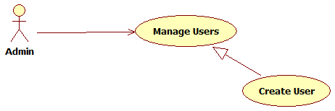

**Figure 8: Create User UseCase**

Use Case Specification

|  |  |  |  |  |
| --- | --- | --- | --- | --- |
| USE CASE | | | | |
| Use-case No. | UC_008 | Use-case Version | | 0.1 |
| Use-case Name | Create User | | | |
| Author | Ngô Duy Hiếu | | | |
| Date | 17/09/2013 | Priority | High | |
| **Actor:** Admin  **Summary:** This use case allows admin can create new user  **Goal:** Create a new User.  **Triggers:** Admin click “Create User” button  **Pre-conditions:** User has logged in as Admin  **Post-conditions.**  **Success:** New User has been created successfully.  **Fail:** Cannot create User and error message display on screen  **Main Success Scenario.**   |  |  |  | | --- | --- | --- | | Step | Actor Action | System Response | | 1 | Go to “User Management” page, click on “Create User” button | Display “Create User” page | | 2 | Input information |  | | 3 | Click “Create” button [Alternative 1] | Check information validity and create user [Exception 1] |   **Alternative Scenario.**   |  |  |  | | --- | --- | --- | | No. | Actor Action | System Response | | 1 | Click “Reset” button | Clear all information to blank field. | | 2 | Click “Cancel” button | Redirect to “User Management” page. |   **Exceptions**.   |  |  |  | | --- | --- | --- | | No. | Actor Action | System Response | | 1 |  | Display error message: “This user has been register. Please check again!” |   Relationships: N/A  Business Rules: N/A | | | | |

##### Edit User

* + Reference to CD: <root>/Documents/eTest Document - Full.docx

##### Delete User

* + Reference to CD: <root>/Documents/eTest Document - Full.docx

##### Activate User

* + Reference to CD: <root>/Documents/eTest Document - Full.docx

##### Deactivate User

* + Reference to CD: <root>/Documents/eTest Document - Full.docx

##### Import User

Use Case Diagram



**Figure 9: Import User UseCase**

Use Case Specification

|  |  |  |  |  |
| --- | --- | --- | --- | --- |
| USE CASE | | | | |
| Use-case No. | UC_013 | Use-case Version | | 0.1 |
| Use-case Name | Import User | | | |
| Author | Vũ Minh Điền | | | |
| Date | 09/17/2013 | Priority | High | |
| **Actor:** Admin  **Summary:** This use case allows administrator to import list users to database.  **Goal:** Import users.  **Triggers:** User clicks “Import Users” on User Management page.  **Pre-conditions:** User has an account of administrator and logged. Access to User Management page  **Post-conditions.**  **Success:** Add new list users to database.  Show list users imported.  **Fail:** Redirects to Import page.  **Main Success Scenario.**   |  |  |  | | --- | --- | --- | | Step | Actor Action | System Response | | 1 | User clicks “Import Users” on User Management page. | Display Import page. | | 2 | User click “Browse” button. | Display Upload file box | | 3 | User select file , click “Open” button [Alternative 1] | Checks validation of file. [Exception 1, 2] | | 4 | User click “Import” button. [Alternative 2, 3] | Check valid file.  Redirect to ImportResult page [Exception 3] |   **Alternative Scenario.**   |  |  |  | | --- | --- | --- | | No. | Actor Action | System Response | | 1 | User clicks “Cancel” button | Back to Import page | | 2 | User clicks “Reset” button | Clear the selected file | | 3 | User clicks “Cancel” button | Redirect to User Management page. |   **Exceptions**.   |  |  |  | | --- | --- | --- | | No. | Actor Action | System Response | | 1 | User select the file is not excel file | Display error message that require user select another file. | | 2 | User select the file is larger than 2MB | Display error message that require user select another file. | | 3 | User select the file has wrong format | Display error message that require user download template. |   Relationships: N/A  Business Rules: N/A | | | | |

#### Participants Management

##### Search Participant

* + Reference to CD: <root>/Documents/eTest Document - Full.docx

##### View Participant Details

* + Reference to CD: <root>/Documents/eTest Document - Full.docx

##### Create Participant

Use Case Diagram

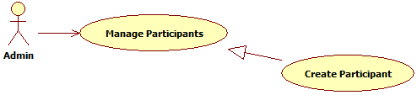

**Figure 10: Create Participant UseCase**

Use Case Specification

|  |  |  |  |  |
| --- | --- | --- | --- | --- |
| USE CASE | | | | |
| Use-case No. | UC_016 | Use-case Version | | 0.1 |
| Use-case Name | Create Participation | | | |
| Author | Vũ Minh Điền | | | |
| Date | 09/17/2013 | Priority | High | |
| **Actor:** Admin  **Summary:** This use case allows administrator to add new user enroll to subject.  **Goal:** Add new user enroll to subject.  **Triggers:** User clicks “Create Participant” on Participant Management page.  **Pre-conditions:** User has an account of administrator and logged.  **Post-conditions.**  **Success:** Add new user to subject.  Show detail of the new participant.  **Fail:** Redirects Create page.  **Main Success Scenario.**   |  |  |  | | --- | --- | --- | | Step | Actor Action | System Response | | 1 | User clicks “Create Participant” on Participant Management page. | Display input field for add user to this subject. | | 2 | User input username or full name. |  | | 3 | User clicks “Save” button  [Alternative 1, 2] | Check for username, full name validity and  Redirect to Participant Management page. [Exception 1,2] |   **Alternative Scenario.**   |  |  |  | | --- | --- | --- | | No. | Actor Action | System Response | | 1 | User clicks “Reset” | Clear textbox | | 2 | User clicks “Cancel” | Redirect to Participant Management page. |   **Exceptions**.   |  |  |  | | --- | --- | --- | | No. | Actor Action | System Response | | 1 | User leave the textbox empty | Display error message “An error occurred”. | | 2 | User doesn’t choose from the dropdown list username. | Display error message “An error occurred”. |   Relationships: N/A  Business Rules: N/A | | | | |

##### Delete Participant

* + Reference to CD: <root>/Documents/eTest Document - Full.docx

##### Activate Participant

* + Reference to CD: <root>/Documents/eTest Document - Full.docx

##### Deactivate Participant

* + Reference to CD: <root>/Documents/eTest Document - Full.docx

##### Import Participant

Use Case Diagram



**Figure 11: Import Participant UseCase**

Use Case Specification

|  |  |  |  |  |
| --- | --- | --- | --- | --- |
| USE CASE | | | | |
| Use-case No. | UC_020 | Use-case Version | | 0.1 |
| Use-case Name | Import Participant | | | |
| Author | Vũ Minh Điền | | | |
| Date | 09/17/2013 | Priority | High | |
| **Actor:** Admin  **Summary:** This use case allows administrator to import list participants to database.  **Goal:** Import participants.  **Triggers:** User clicks “Import Participants” on Subject Management page.  **Pre-conditions:** User has an account of administrator and logged. Access to Subject Management page  **Post-conditions.**  **Success:** Add new list participants to database.  Show list participants imported.  **Fail:** Redirects to Import page.  **Main Success Scenario.**   |  |  |  | | --- | --- | --- | | Step | Actor Action | System Response | | 1 | User clicks “Import Participants” on Subject Management page. | Display Import page. | | 2 | User click “Browse” button. | Display Upload file box | | 3 | User select file , click “Open” button [Alternative 1] | Checks validation of file. [Exception 1, 2] | | 4 | User click “Import” button. [Alternative 2, 3] | Check valid file.  Redirect to ImportResult page [Exception 3] |   **Alternative Scenario.**   |  |  |  | | --- | --- | --- | | No. | Actor Action | System Response | | 1 | User clicks “Cancel” button | Back to Import page | | 2 | User clicks “Reset” button | Clear the selected file | | 3 | User clicks “Cancel” button | Redirect to Subject Management page. |   **Exceptions**.   |  |  |  | | --- | --- | --- | | No. | Actor Action | System Response | | 1 | User select the file is not excel file | Display error message that require user select another file. | | 2 | User select the file is larger than 2MB | Display error message that require user select another file. | | 3 | User select the file has wrong format | Display error message that require user download template. |   Relationships: N/A  Business Rules: N/A | | | | |

#### Subjects Management

##### Search Subject

* + Reference to CD: <root>/Documents/eTest Document - Full.docx

##### View Subject Details

* + Reference to CD: <root>/Documents/eTest Document - Full.docx

##### Create Subject

Use Case Diagram



**Figure 12: Create Subject UseCase**

Use Case Specification

|  |  |  |  |  |
| --- | --- | --- | --- | --- |
| USE CASE | | | | |
| Use-case No. | UC_023 | Use-case Version | | 0.1 |
| Use-case Name | Create Subject | | | |
| Author | Vũ Minh Điền | | | |
| Date | 17/09/2013 | Priority | High | |
| **Actor:** Admin  **Summary:** This use case allows administrator to add new subject to database.  **Goal:** Add new subject.  **Triggers:** User clicks “Create Subject” dropdown list and chooses “Create Subject” on Subject Management page.  **Pre-conditions:** User has an account of administrator and logged. Access to Subject Management page  **Post-conditions.**  **Success:** Add new subject to database.  Show detail of the new subject.  **Fail:** Redirects to Create page.  **Main Success Scenario.**   |  |  |  | | --- | --- | --- | | Step | Actor Action | System Response | | 1 | User clicks “Create Subject” dropdown list and chooses “Create Subject” on Subject Management page. | Display input fields for information of subject. | | 2 | User fills subject’s information. |  | | 3 | User clicks “Create” button [Alternative 1,2] | Check for subject’s name, subject’s code validity and  Redirect to Subject Management page. [Exception 1, 2] |   **Alternative Scenario.**   |  |  |  | | --- | --- | --- | | No. | Actor Action | System Response | | 1 | User clicks “Reset” button | Clear input fields | | 2 | User clicks “Cancel” button | Redirect to manage subject |   **Exceptions**.   |  |  |  | | --- | --- | --- | | No. | Actor Action | System Response | | 1 | User input invalid subject’s name or subject’s code | Display error message that require user input again. | | 2 | User input existed subject | Display error message notify that subject existed. |   Relationships: N/A  Business Rules: N/A | | | | |

##### Edit Subject

* + Reference to CD: <root>/Documents/eTest Document - Full.docx

##### Delete Subject

* + Reference to CD: <root>/Documents/eTest Document - Full.docx

##### Activate Subject

* + Reference to CD: <root>/Documents/eTest Document - Full.docx

##### Deactivate Subject

* + Reference to CD: <root>/Documents/eTest Document - Full.docx

##### Import Subject

Use Case Diagram



**Figure 13: Import Subject UseCase**

Use Case Specification

|  |  |  |  |  |
| --- | --- | --- | --- | --- |
| USE CASE | | | | |
| Use-case No. | UC_028 | Use-case Version | | 0.1 |
| Use-case Name | Import Subject | | | |
| Author | Vũ Minh Điền | | | |
| Date | 09/17/2013 | Priority | High | |
| **Actor:** Admin  **Summary:** This use case allows administrator to import list subjects to database.  **Goal:** Import subjects.  **Triggers:** User clicks “Import Subjects” on Subject Management page.  **Pre-conditions:** User has an account of administrator and logged. Access to Subject Management page  **Post-conditions.**  **Success:** Add new list subjects to database.  Show list subjects imported.  **Fail:** Redirects to Import page.  **Main Success Scenario.**   |  |  |  | | --- | --- | --- | | Step | Actor Action | System Response | | 1 | User clicks “Import Subjects” on Subject Management page. | Display Import page. | | 2 | User click “Browse” button. | Display Upload file box | | 3 | User select file , click “Open” button [Alternative 1] | Checks validation of file. [Exception 1, 2] | | 4 | User click “Import” button. [Alternative 2, 3] | Check valid file.  Redirect to ImportResult page [Exception 3] |   **Alternative Scenario.**   |  |  |  | | --- | --- | --- | | No. | Actor Action | System Response | | 1 | User clicks “Cancel” button | Back to Import page | | 2 | User clicks “Reset” button | Clear the selected file | | 3 | User clicks “Cancel” button | Redirect to Subject Management page. |   **Exceptions**.   |  |  |  | | --- | --- | --- | | No. | Actor Action | System Response | | 1 | User select the file is not excel file | Display error message that require user select another file. | | 2 | User select the file is larger than 2MB | Display error message that require user select another file. | | 3 | User select the file has wrong format | Display error message that require user download template. |   Relationships: N/A  Business Rules: N/A | | | | |

#### Sections Management

##### Search Section

* + Reference to CD: <root>/Documents/eTest Document - Full.docx

##### View Section Details

* + Reference to CD: <root>/Documents/eTest Document - Full.docx

##### Create Section

Use Case Diagram



**Figure 14: Create Section UseCase**

Use Case Specification

|  |  |  |  |  |
| --- | --- | --- | --- | --- |
| USE CASE | | | | |
| Use-case No. | UC_031 | Use-case Version | | 0.1 |
| Use-case Name | Create Section | | | |
| Author | Vũ Minh Điền | | | |
| Date | 09/17/2013 | Priority | High | |
| **Actor:** Student, Teacher, Admin  **Summary:** This use case allows user to add new section to database.  **Goal:** Add new section.  **Triggers:** User clicks “Create Section” on Section Management page.  **Pre-conditions:** User has an account and logged. Access to Section Management page  **Post-conditions.**  **Success:** Add new section to database.  Show detail of the new section.  **Fail:** Redirects to Create page.  **Main Success Scenario.**   |  |  |  | | --- | --- | --- | | Step | Actor Action | System Response | | 1 | User clicks “Create Section” on Section Management page. | Display input fields for information of section. | | 2 | User fills section’s information. |  | | 3 | User clicks “Create” button [Alternative 1,2] | Check for section’s name validity and  Redirect to Section Management page. [Exception 1, 2] |   **Alternative Scenario.**   |  |  |  | | --- | --- | --- | | No. | Actor Action | System Response | | 1 | User clicks “Reset” button | Clear input fields | | 2 | User clicks “Cancel” button | Redirect to Section Management page |   **Exceptions**.   |  |  |  | | --- | --- | --- | | No. | Actor Action | System Response | | 1 | User input invalid section’s name | Display error message that require user input again. | | 2 | User input the existed section. | Display error message notify that the section existed. |   Relationships: N/A  Business Rules: N/A | | | | |

##### Edit Section

* + Reference to CD: <root>/Documents/eTest Document - Full.docx

##### Delete Section

* + Reference to CD: <root>/Documents/eTest Document - Full.docx

##### Activate Section

* + Reference to CD: <root>/Documents/eTest Document - Full.docx

##### Deactivate Section

* + Reference to CD: <root>/Documents/eTest Document - Full.docx

#### Questions Management

##### Search Question

* + Reference to CD: <root>/Documents/eTest Document - Full.docx

##### View Question Details

* + Reference to CD: <root>/Documents/eTest Document - Full.docx

##### Create Question

Use Case Diagram

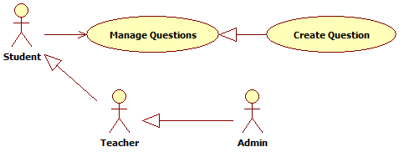

**Figure 15: Create Question UseCase**

Use Case Specification

|  |  |  |  |  |
| --- | --- | --- | --- | --- |
| USE CASE | | | | |
| Use-case No. | UC_038 | Use-case Version | | 0.1 |
| Use-case Name | Create Question | | | |
| Author | Võ Tá Mạnh Thắng | | | |
| Date | 09/17/2013 | Priority | High | |
| **Actor:** Administrator, Teacher, Student  **Summary:** This use case allows administrator, teacher and student can add new question in the system.  **Goal:** Create a new question.  **Triggers:** User clicks “Create Question” in Question Management page.  **Pre-conditions:** User has logged in system and open Question Management page.  **Post-conditions.**  **Success:** A new question has been created in the system.  **Fail:** None of question is added to the system. Display error message  **Main Success Scenario.**   |  |  |  | | --- | --- | --- | | Step | Actor Action | System Response | | 1 | User clicks “Create Question” in Question Management page | Display “Create Question” page | | 2 | User choose question type | Display question information page includes:   * Title content * Question content * Answer content * Is correct? : radio button * More Answer: button * Remove Last Answer: button * Explanation content * Create: button * Reset: button * Cancel: button | | 3 | User enter question information |  | | 4 | User clicks “Create” button [Alternative 1] | Valid enter information and create a new question with entered information. [Exception 1, 2, 3] |   **Alternative Scenario.**   |  |  |  | | --- | --- | --- | | No. | Actor Action | System Response | | 1 | User clicks “Reset” button | Clear all input controls on form. | | 2 | User clicks “Cancel” button | Redirect to Question Manage page |   **Exceptions**.   |  |  |  | | --- | --- | --- | | No. | Actor Action | System Response | | 1 | Question content or answer content is blank | Display error message: “The Content field is required.” | | 2 | Correct answer is not chosen | Display error message: “You must select the correct answer.” | | 3 | Number of answer less than 2 answers | Display error message: "You must enter at least 2 answers.” |   Relationships: N/A.  Business Rules: N/A. | | | | |

##### Edit Question

* + Reference to CD: <root>/Documents/eTest Document - Full.docx

##### Delete Question

* + Reference to CD: <root>/Documents/eTest Document - Full.docx

##### Activate Question

* + Reference to CD: <root>/Documents/eTest Document - Full.docx

##### Deactivate Question

* + Reference to CD: <root>/Documents/eTest Document - Full.docx

##### Import Question

Use Case Diagram

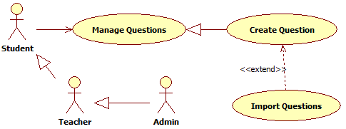

**Figure 16: Import Question UseCase**

Use Case Specification

|  |  |  |  |  |
| --- | --- | --- | --- | --- |
| USE CASE | | | | |
| Use-case No. | UC_043 | Use-case Version | | 0.1 |
| Use-case Name | Import Question | | | |
| Author | Võ Tá Mạnh Thắng | | | |
| Date | 09/17/2013 | Priority | High | |
| **Actor:** Admin, Teacher, Student  **Summary:** This use case allows administrator, teacher and student can import list of question in the system.  **Goal:** Import list of question.  **Triggers:** User clicks “Import Question” in Question Management page.  **Pre-conditions:** User has logged in system and open Question Management page.  **Post-conditions.**  **Success:** A list of question has been imported in the system.  **Fail:** None of question is imported to the system. Display error message  **Main Success Scenario.**   |  |  |  | | --- | --- | --- | | Step | Actor Action | System Response | | 1 | User clicks “Import Question” in Question Management page | Display “Import Question” page | | 2 | User clicks “Browse” button | Display box to choose file | | 3 | User choose file to import and click “Open” button [Alternative 1] | Checks validation of file. [Exception 1, 2] | | 4 | User clicks “Import” button [Alternative 2, 3] | Check valid file  Redirect to “ImportResult” page |   **Alternative Scenario.**   |  |  |  | | --- | --- | --- | | No. | Actor Action | System Response | | 1 | User clicks “Cancel” button | Back to Import page | | 2 | User clicks “Reset” button | Clear selected file | | 3 | User clicks “Cancel” button | Redirect to Question Manage page |   **Exceptions**.   |  |  |  | | --- | --- | --- | | No. | Actor Action | System Response | | 1 | The select file is not text file | Display error message: “Not an accepted file type.” | | 2 | User select the file is larger than 2MB | Display error message: “Your file is out of size.” | | 3 | User select the file has wrong format | Display error message that require user download template. |   Relationships: N/A.  Business Rules: N/A. | | | | |

##### Add Question to Section

Use Case Diagram

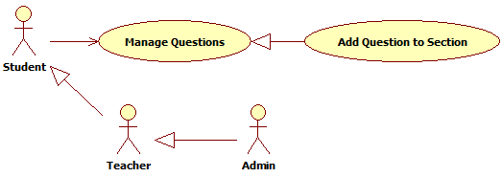

**Figure 17: Add Question to Section UseCase**

Use Case Specification

|  |  |  |  |  |
| --- | --- | --- | --- | --- |
| USE CASE | | | | |
| Use-case No. | UC_044 | Use-case Version | | 0.1 |
| Use-case Name | Add Question to Section | | | |
| Author | Võ Tá Mạnh Thắng | | | |
| Date | 09/17/2013 | Priority | High | |
| **Actor:** Admin, Teacher, Student  **Summary:** This use case allows administrator, teacher and student to add question to section.  **Goal:** Question added to section successfully.  **Triggers:** User clicks “Add to section” in Dropdown list action in Question Management page.  **Pre-conditions:** User has logged in system and open Question Management page.  **Post-conditions.**  **Success:** Question added to section successfully.  **Fail:** The question is not added to section.  **Main Success Scenario.**   |  |  |  | | --- | --- | --- | | Step | Actor Action | System Response | | 1 | User select question(s) |  | | 2 | User clicks “Add to section” in Question Management page | Display all section of this user. | | 3 |  | Display message add successful |   **Alternative Scenario.**  N/A  **Exceptions**.  N/A  Relationships: N/A.  Business Rules: N/A. | | | | |

##### Remove Question from Section

* + Reference to CD: <root>/Documents/eTest Document - Full.docx

#### Tests Management

##### Search Test

* + Reference to CD: <root>/Documents/eTest Document - Full.docx

##### View Test Details

* + Reference to CD: <root>/Documents/eTest Document - Full.docx

##### Create Test

Use Case Diagram

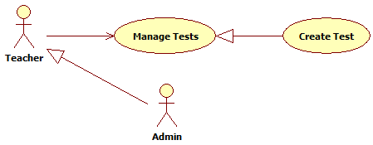

**Figure 18: Create Test UseCase**

Use Case Specification

|  |  |  |  |  |
| --- | --- | --- | --- | --- |
| USE CASE | | | | |
| Use-case No. | UC_048 | Use-case Version | | 0.1 |
| Use-case Name | Create Test | | | |
| Author | Lê Quốc Thanh | | | |
| Date | 09/17/2013 | Priority | High | |
| **Actor:** Teacher, Admin  **Summary:** This use case allows user to create a test.  **Goal:** Create new test for testing.  **Triggers:** Click on Create Test button in Test Management page.  **Pre-conditions:** User has logged in to system and went to Test Management page.  **Post-conditions.**  **Success:** Redirect to Create Test page.  **Fail:** Redirect to Error page.  **Main Success Scenario.**   |  |  |  | | --- | --- | --- | | Step | Actor Action | System Response | | 1 | User click on Create Test button on Test Management | Redirect to Create Test page. | | 2 | User selects Classic test type on test type list. | Redirect to Create Classic Test page. | | 2 | User input all information of test. |  | | 3 | User click on Create button [Alternative 1] [Alternative 2]. | Redirect to Test Details page [Exception 1]. |   **Alternative Scenario.**   |  |  |  | | --- | --- | --- | | No. | Actor Action | System Response | | 1 | User click on Reset button | The Create Test page information will be reset. | | 2 | User click on Cancel button | Redirect to Test Details page. |   **Exceptions**.   |  |  |  | | --- | --- | --- | | No. | Actor Action | System Response | | 1 | User input lack test information. | Display message that require user input all test information. |   Relationships: N/A  Business Rules: N/A | | | | |

##### Edit Test

* + Reference to CD: <root>/Documents/eTest Document - Full.docx

##### Delete Test

* + Reference to CD: <root>/Documents/eTest Document - Full.docx

##### Activate Test

* + Reference to CD: <root>/Documents/eTest Document - Full.docx

##### Deactivate Test

* + Reference to CD: <root>/Documents/eTest Document - Full.docx

##### Take the Test

Use Case Diagram



**Figure 19: Take the Test UseCase**

Use Case Specification

|  |  |  |  |  |
| --- | --- | --- | --- | --- |
| USE CASE | | | | |
| Use-case No. | UC_053 | Use-case Version | | 0.1 |
| Use-case Name | Take the Test | | | |
| Author | Lê Quốc Thanh | | | |
| Date | 09/17/2013 | Priority | High | |
| **Actor:** Student, Teacher, Admin  **Summary:** This use case allows user take the test.  **Goal:** Take the test.  **Triggers:** Click on Take the Test button in Test Details page.  **Pre-conditions:** User has logged in to system, went to Test Details page.  **Post-conditions.**  **Success:** Redirect to Testing page with all test questions.  **Fail:** Redirect to Error page.  **Main Success Scenario.**   |  |  |  | | --- | --- | --- | | Step | Actor Action | System Response | | 1 | User click on Take the Test button on Test Details page. | The system display a confirm box ask user that really want to take this test. | | 2 | User click on OK button [Alternative 1]. | Redirect to Testing page with all test questions. |   **Alternative Scenario.**   |  |  |  | | --- | --- | --- | | No. | Actor Action | System Response | | 1 | User click on Cancel button. | Close confirm box. |   **Exceptions**.  N/A  Relationships: N/A  Business Rules: N/A | | | | |

##### Take the Quick Test

Use Case Diagram

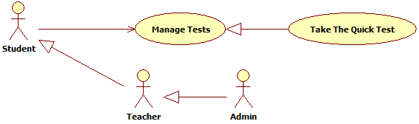

**Figure 59: Take the Quick Test UseCase**

Use Case Specification

|  |  |  |  |  |
| --- | --- | --- | --- | --- |
| USE CASE | | | | |
| Use-case No. | UC_054 | Use-case Version | | 0.1 |
| Use-case Name | Take the Quick Test | | | |
| Author | Ngô Duy Hiếu | | | |
| Date | 09/17/2013 | Priority | High | |
| **Actor:** Student, Teacher, Admin  **Summary:** This use case allows student to take the quick test.  **Goal:** Take the quick test.  **Triggers:** Click on Create Test button in Test Management page.  **Pre-conditions:** Student has logged in to system and went to Test Management page.  **Post-conditions.**  **Success:** Redirect to Create Test page.  **Fail:** Redirect to Error page.  **Main Success Scenario.**   |  |  |  | | --- | --- | --- | | Step | Actor Action | System Response | | 1 | User click on Create Test button on Test Management. | Redirect to Create Test page. | | 2 | User select Quick test type on test type list. | Redirect to Create Quick Test page. | | 3 | User input all information of test. |  | | 4 | User click on Create button [Alternative 1] [Alternative 2]. | Redirect to testing page [Exception 1]. |   **Alternative Scenario.**   |  |  |  | | --- | --- | --- | | No. | Actor Action | System Response | | 1 | User click on Reset button | The Create Test page information will be reset. | | 2 | User click on Cancel button | Redirect to Test Management page. |   **Exceptions**.   |  |  |  | | --- | --- | --- | | No. | Actor Action | System Response | | 1 | User input lack test information. | Display message that require user input all test information. |   Relationships: N/A  Business Rules: N/A | | | | |

#### Discussions Management

##### Search Discussion

* + Reference to CD: <root>/Documents/eTest Document - Full.docx

##### View Discussion Details

* + Reference to CD: <root>/Documents/eTest Document - Full.docx

##### Create Discussion

Use Case Diagram

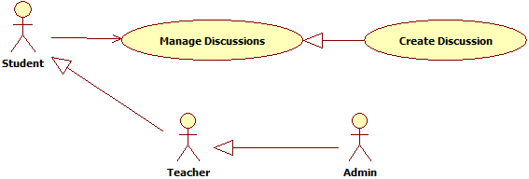

**Figure 20: Create Discussion UseCase**

Use Case Specification

|  |  |  |  |  |
| --- | --- | --- | --- | --- |
| USE CASE | | | | |
| Use-case No. | UC_57 | Use-case Version | | 0.1 |
| Use-case Name | Create Discussion | | | |
| Author | Ngô Duy Hiếu | | | |
| Date | 09/17/2013 | Priority | High | |
| **Actor:** Student, Teacher, Admin  **Summary:** This use case allows student, teacher admin can create new discussion  **Goal:** Create a new Discussion.  **Triggers:** Admin click “Create Discussion” button  **Pre-conditions:** User has logged in as Student, Teacher, Admin  **Post-conditions.**  **Success:** New Discussion has been created successfully.  **Fail:** Cannot create Discussion and error message display on screen  **Main Success Scenario.**   |  |  |  | | --- | --- | --- | | Step | Actor Action | System Response | | 1 | Go to “Discussion Management” page, click on “Create Discussion” button | Display “Create Discussion” page | | 2 | Input information |  | | 3 | Click “Create” button [Alternative 1] | Check information validity and create discussion [Exception 1] |   **Alternative Scenario.**   |  |  |  | | --- | --- | --- | | No. | Actor Action | System Response | | 1 | Click “Reset” button | Clear all information to blank field. | | 2 | Click “Cancel” button | Redirect to “Discussion Management” page. |   **Exceptions**.   |  |  |  | | --- | --- | --- | | No. | Actor Action | System Response | | 1 |  | Display error message: “This discussion has been created. Please check again!” |   Relationships: N/A  Business Rules: N/A | | | | |

##### Edit Discussion

* + Reference to CD: <root>/Documents/eTest Document - Full.docx

##### Delete Discussion

* + Reference to CD: <root>/Documents/eTest Document - Full.docx

##### Activate Discussion

* + Reference to CD: <root>/Documents/eTest Document - Full.docx

##### Deactivate Discussion

* + Reference to CD: <root>/Documents/eTest Document - Full.docx

#### Reports Management

##### Search Report

* + Reference to CD: <root>/Documents/eTest Document - Full.docx

##### View Report Details

* + Reference to CD: <root>/Documents/eTest Document - Full.docx

##### Send Question Report

Use Case Diagram



**Figure 21: Send Question Report UseCase**

Use Case Specification

|  |  |  |  |  |
| --- | --- | --- | --- | --- |
| USE CASE | | | | |
| Use-case No. | UC_064 | Use-case Version | | 0.1 |
| Use-case Name | Send Question Report | | | |
| Author | Lê Quốc Thanh | | | |
| Date | 09/17/2013 | Priority | High | |
| **Actor:** Student, Teacher, Admin  **Summary:** This use case allows user to report a question violation.  **Goal:** Report a violative question.  **Triggers:** Click on Report button on a test details page.  **Pre-conditions:** User has logged in to system, went to test details page.  **Post-conditions.**  **Success:** A message will display that report successful.  **Fail:** A message will display that report unsuccessful.  **Main Success Scenario.**   |  |  |  | | --- | --- | --- | | Step | Actor Action | System Response | | 1 | User go to test details page. |  | | 2 | User click on Report button | A popup will display to allow user enter a message | | 2 | User click on Send button [Alternative 1]. | A message will display that send successfully [Exception 1]. |   **Alternative Scenario.**   |  |  |  | | --- | --- | --- | | No. | Actor Action | System Response | | 1 | User click on Cancel button | The popup box will be closed. |   **Exceptions**.   |  |  |  | | --- | --- | --- | | No. | Actor Action | System Response | | 1 | User click on Send button. | A message will display that send unsuccessfuly. |   Relationships: N/A  Business Rules: N/A | | | | |

##### Send Section Report

Use Case Diagram



**Figure 22: Send Section Report UseCase**

Use Case Specification

|  |  |  |  |  |
| --- | --- | --- | --- | --- |
| USE CASE | | | | |
| Use-case No. | UC_065 | Use-case Version | | 0.1 |
| Use-case Name | Send Section Report | | | |
| Author | Lê Quốc Thanh | | | |
| Date | 09/17/2013 | Priority | High | |
| **Actor:** Student, Teacher, Admin  **Summary:** This use case allows user to report a section violation.  **Goal:** Report a violative section.  **Triggers:** Click on Report button on the violative section.  **Pre-conditions:** Student has logged in to system, took and open the section detail page.  **Post-conditions.**  **Success:** A message will display that report successful.  **Fail:** A message will display that report unsuccessful.  **Main Success Scenario.**   |  |  |  | | --- | --- | --- | | Step | Actor Action | System Response | | 1 | User go to any section |  | | 2 | User click on Report button in violative section | A popup box will display allow user input report content. | | 2 | User click on Send button [Alternative 1]. | A message will display that report successful [Exception 1]. |   **Alternative Scenario.**   |  |  |  | | --- | --- | --- | | No. | Actor Action | System Response | | 1 | User click on Cancel button | The popup box will be closed. |   **Exceptions**.   |  |  |  | | --- | --- | --- | | No. | Actor Action | System Response | | 1 | User click on Send button. | A message will display that report unsuccessful. |   Relationships: N/A  Business Rules: N/A | | | | |

##### Send Discussion Report

Use Case Diagram



**Figure 23: Send Discussion Report UseCase**

Use Case Specification

|  |  |  |  |  |
| --- | --- | --- | --- | --- |
| USE CASE | | | | |
| Use-case No. | UC_066 | Use-case Version | | 0.1 |
| Use-case Name | Send Discussion Report | | | |
| Author | Lê Quốc Thanh | | | |
| Date | 09/17/2013 | Priority | High | |
| **Actor:** Student, Teacher, Admin  **Summary:** This use case allows user to report a discussion violation.  **Goal:** Report a violative discussion.  **Triggers:** Click on Report button on the violative discussion.  **Pre-conditions:** Student has logged in to system, took and open the Discussion page.  **Post-conditions.**  **Success:** A message will display that report successful.  **Fail:** A message will display that report unsuccessful.  **Main Success Scenario.**   |  |  |  | | --- | --- | --- | | Step | Actor Action | System Response | | 1 | User go to any discussion |  | | 2 | User click on Report button in violative discussion | A popup box will display allow user input report content. | | 2 | User click on Send button [Alternative 1]. | A message will display that report successful [Exception 1]. |   **Alternative Scenario.**   |  |  |  | | --- | --- | --- | | No. | Actor Action | System Response | | 1 | User click on Cancel button | The popup box will be closed. |   **Exceptions**.   |  |  |  | | --- | --- | --- | | No. | Actor Action | System Response | | 1 | User click on Send button. | A message will display that report unsuccessful. |   Relationships: N/A  Business Rules: N/A | | | | |

##### Send Test Report

Use Case Diagram



**Figure 24: Send Test Report UseCase**

Use Case Specification

|  |  |  |  |  |
| --- | --- | --- | --- | --- |
| USE CASE | | | | |
| Use-case No. | UC_067 | Use-case Version | | 0.1 |
| Use-case Name | Send Test Report | | | |
| Author | Lê Quốc Thanh | | | |
| Date | 09/17/2013 | Priority | High | |
| **Actor:** Student, Teacher, Admin  **Summary:** This use case allows user to report a test violation.  **Goal:** Report a violative test.  **Triggers:** Click on Report button on the violative test.  **Pre-conditions:** Student has logged in to system, took and open the test detail page.  **Post-conditions.**  **Success:** A message will display that report successful.  **Fail:** A message will display that report unsuccessful.  **Main Success Scenario.**   |  |  |  | | --- | --- | --- | | Step | Actor Action | System Response | | 1 | User go to any test |  | | 2 | User click on Report button in violative section | A popup box will display allow user input report content. | | 2 | User click on Send button [Alternative 1]. | A message will display that report successful [Exception 1]. |   **Alternative Scenario.**   |  |  |  | | --- | --- | --- | | No. | Actor Action | System Response | | 1 | User click on Cancel button | The popup box will be closed. |   **Exceptions**.   |  |  |  | | --- | --- | --- | | No. | Actor Action | System Response | | 1 | User click on Send button. | A message will display that report unsuccessful. |   Relationships: N/A  Business Rules: N/A | | | | |

##### Mark as Read Report

* + Reference to CD: <root>/Documents/eTest Document - Full.docx

##### Mark as Unread Report

* + Reference to CD: <root>/Documents/eTest Document - Full.docx

##### Delete Report

#### Feedbacks Management

* + Reference to CD: <root>/Documents/eTest Document - Full.docx

##### Search Feedback

* + Reference to CD: <root>/Documents/eTest Document - Full.docx

##### View Feedback Details

* + Reference to CD: <root>/Documents/eTest Document - Full.docx

##### Send Feedback

Use Case Diagram

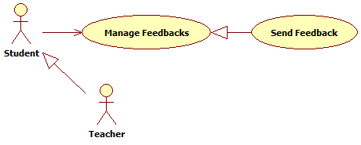

**Figure 25: Send Feedback UseCase**

Use Case Specification

|  |  |  |  |  |
| --- | --- | --- | --- | --- |
| USE CASE | | | | |
| Use-case No. | UC_073 | Use-case Version | | 0.1 |
| Use-case Name | Send Feedback | | | |
| Author | Võ Tá Mạnh Thắng | | | |
| Date | 09/17/2013 | Priority | High | |
| **Actor:** Teacher, Student  **Summary:** This use case allows teacher and student can send feedback.  **Goal:** Feedback will be sent.  **Triggers:** User clicks “Feedback” in Menu bar.  **Pre-conditions:** User has logged in system.  **Post-conditions.**  **Success:** A feedback will be sent successful  **Fail:** None of feedback is sent. Display error message  **Main Success Scenario.**   |  |  |  | | --- | --- | --- | | Step | Actor Action | System Response | | 1 | User clicks “Feedback” in Menu bar | Display “Feedback” page | | 2 | User input information |  | | 3 | User clicks “Send” button [Alternative 1,2] | Display message notify send successful [Exception 1,2] |   **Alternative Scenario.**   |  |  |  | | --- | --- | --- | | No. | Actor Action | System Response | | 1 | User clicks “Reset” button | Clear all field | | 2 | User clicks “Cancel” button | Redirect to Home page |   **Exceptions**.   |  |  |  | | --- | --- | --- | | No. | Actor Action | System Response | | 1 | User do not input information | Display error message that file is require | | 2 | Length of file is not in range | Display error message that the length is not in range |   Relationships: N/A.  Business Rules: N/A. | | | | |

##### Mark as Read Feedback

* + Reference to CD: <root>/Documents/eTest Document - Full.docx

##### Mark as Unread Feedback

* + Reference to CD: <root>/Documents/eTest Document - Full.docx

##### Delete feedback

* + Reference to CD: <root>/Documents/eTest Document - Full.docx

### Non-Functional Requirement

#### Reliability

* The system can be used like “always on” system.

#### Availability

* The system always responds to every user who got permission.

#### Security

* Users must login for using the system.

#### Maintainability

* The system is easy for maintainability.

#### Portability

* The system can be access by any browsers but recommendation for user is Mozilla Firefox v.25 or higher.

#### Performance

* Good connection with server.

## Entity Relationship Diagram

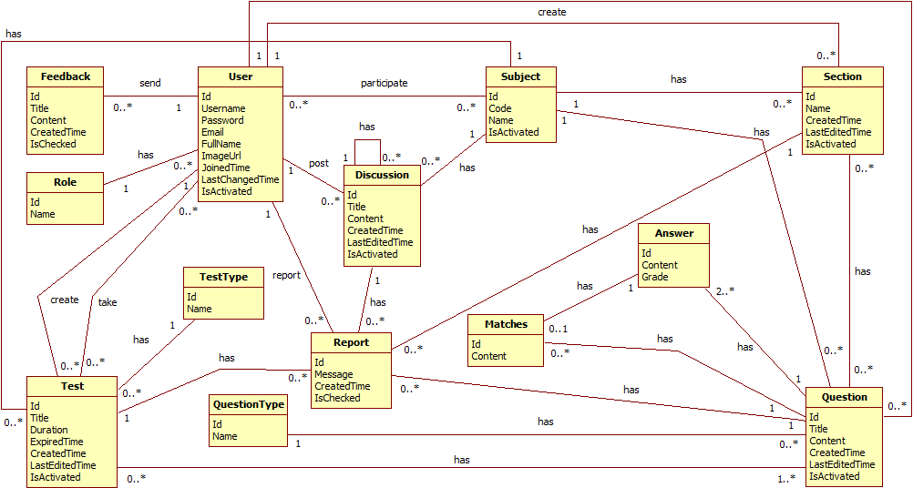

**Figure 26: Entity Relationship Diagram**

# System Design Description (SDD)

## Design Overview

* This document describes the technical and UI design of the Test Online system. It includes the architectural design and the detailed design of common functions and business functions. It also includes the design of database model.
* The architectural design describes the overall architecture of the system, and the architecture of each main component and subsystem. It will describe the patterns being used, the role of each component and the role of the system in the working environment.
* The detailed design describes static and dynamic structure for each component and function. It includes class diagrams, class explanations, and sequence diagrams of each use cases.
* The database design describes the relationship between entities, and details of each entity.

## System Architectural Design

### Choice of System Architecture

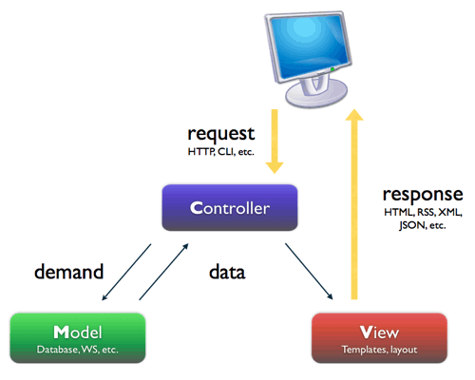

Figure 28: MVC architecture

The above diagram is explained as the following:

* **Model**: Functions that interact with the database or perform complex operations. In this architecture, model includes business logic and data access in one layer.
* **View**: The view displays the data and also takes input form user. It renders the model data into a form, such as graphics, buttons, and tables, and so on to display to the user.
* **Controller:** The controller handles all requests coming from the view or user interface. The data flows to whole application are controlled by controller.

### Discussion of Alternative Designs

#### Three-layer Architecture

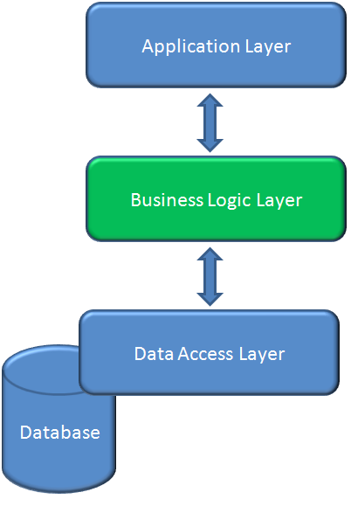

Figure 28: Three-layer architecture

* **Data layer:** is basically the server which stores all the application’s data.
* **Business layer:** is mainly working as the bridge between Data layer and Presentation layer. All the Data passes through the Business layer before passing to the presentation layer. Business layer is the sum of Business Logic and other components used to add business logic.
* **Presentation layer:** is the layer in which the users interact with an application. Presentation layer contents Shared UI code, Code Behind and Designers used to represent information to user.

### Description of System Interface

#### User interfaces

* Because this is the Management System, so the user interface is simple and friendly.

#### Hardware interfaces

* The system should be deployed online and accessible on any computer using Windows Operation System.

#### Software interfaces

* The system should be able to run on any browser support HTML 5.
* Any service exposed by the system should be accessible using HTTP protocol.

#### Communication interfaces

* The system using HTTP protocol to communicate between server and clients.

## Component Diagram

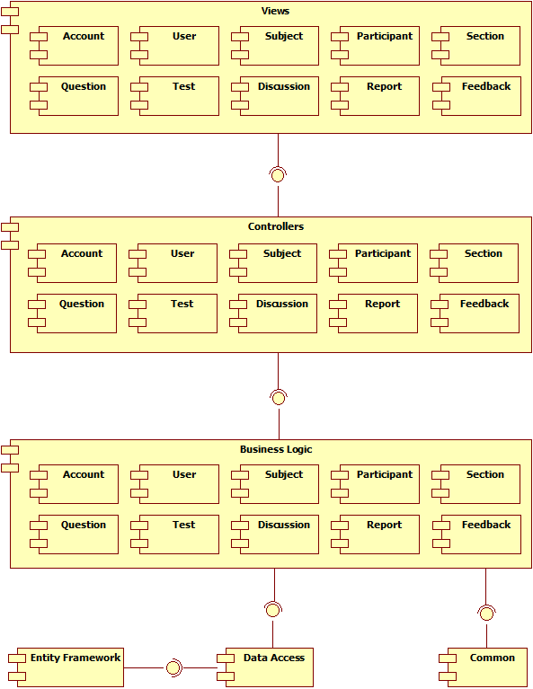

**Figure 29: Component diagram**

The architecture of Test Online system is MVC architecture. Inside each layer, ther are some components that handle one or some spcific function.

## Detailed Description of Components

### Account Management

#### Class Diagram

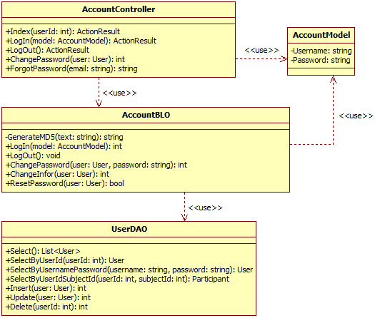

**Figure 30: Account Management**

#### Class Diagram Explanation

* + Reference to CD: <root>/Documents/eTest Document - Full.docx

### Users Management

#### Class Diagram

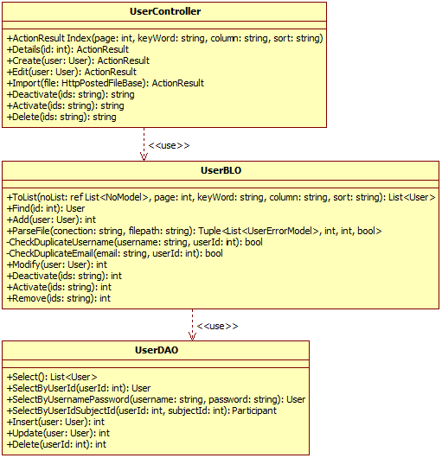

**Figure 31: Users Management**

#### Class Diagram Explanation

* + Reference to CD: <root>/Documents/eTest Document - Full.docx

### Subjects Management

#### Class Diagram

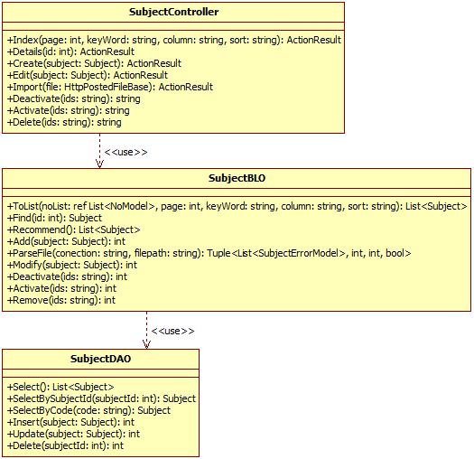

**Figure 32: Subjects Management**

#### Class Diagram Explanation

* + Reference to CD: <root>/Documents/eTest Document - Full.docx

### Participants Management

#### Class Diagram

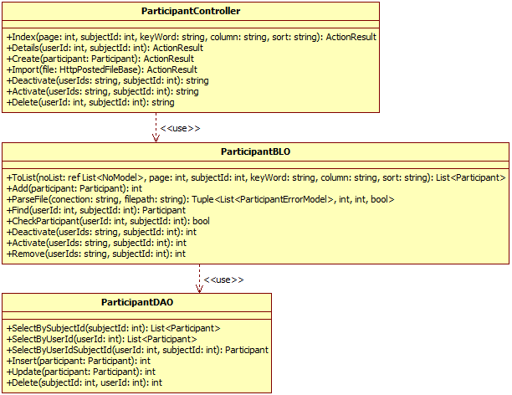

**Figure 33: Participants Management**

#### Class Diagram Explanation

* + Reference to CD: <root>/Documents/eTest Document - Full.docx

### Sections Management

#### Class Diagram

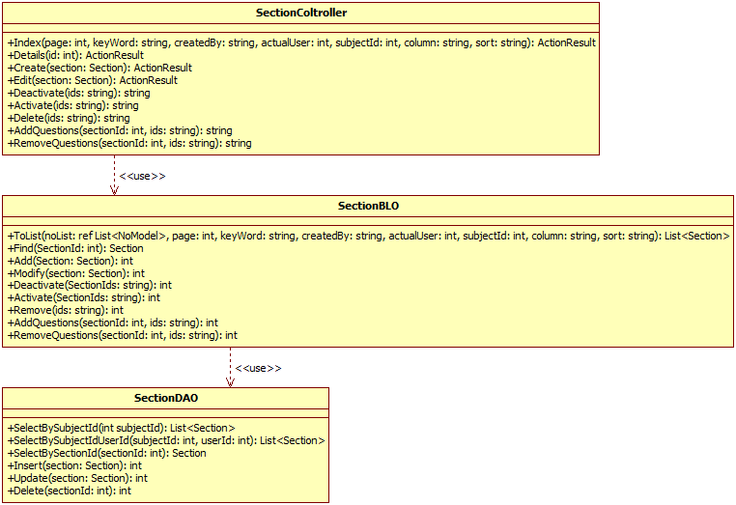

**Figure 34: Sections Management**

#### Class Diagram Explanation

* + Reference to CD: <root>/Documents/eTest Document - Full.docx

### Questions Management

#### Class Diagram

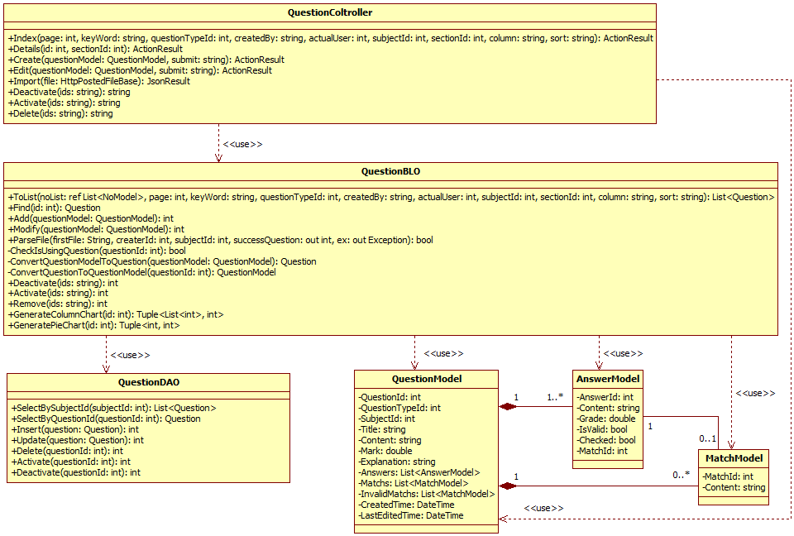

**Figure 35: Questions Management**

#### Class Diagram Explanation

* + Reference to CD: <root>/Documents/eTest Document - Full.docx

### Tests Management

#### Class Diagram

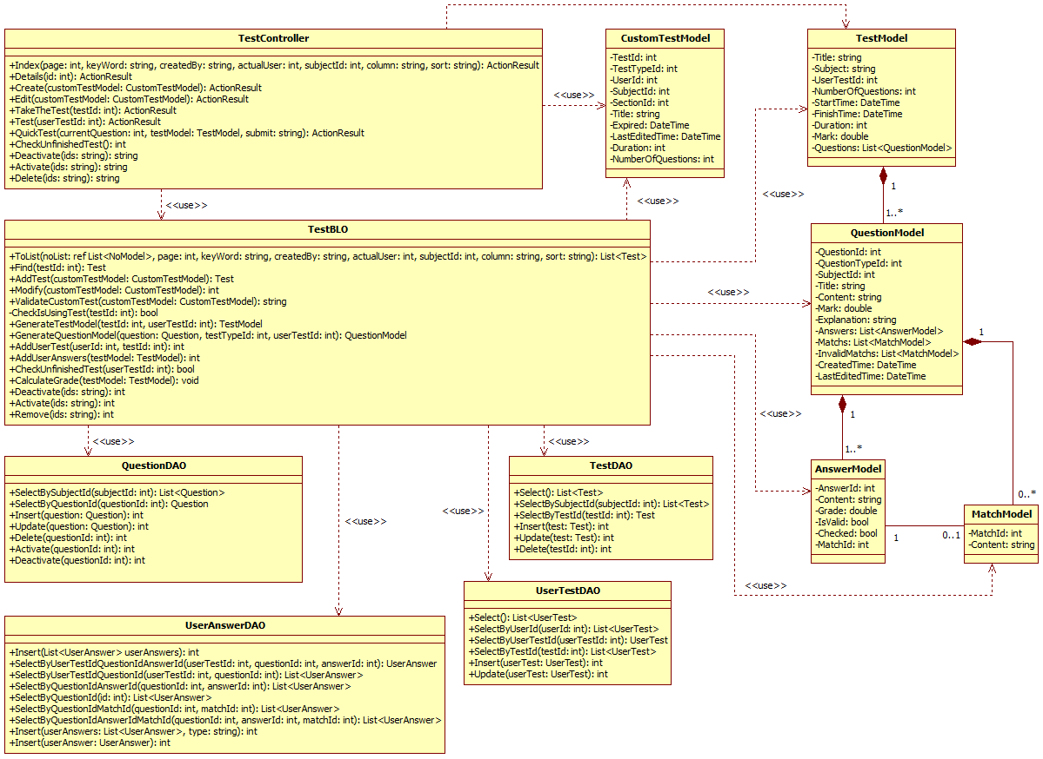

**Figure 36: Tests Management**

#### Class Diagram Explanation

* + Reference to CD: <root>/Documents/eTest Document - Full.docx

### Discussions Management

#### Class Diagram

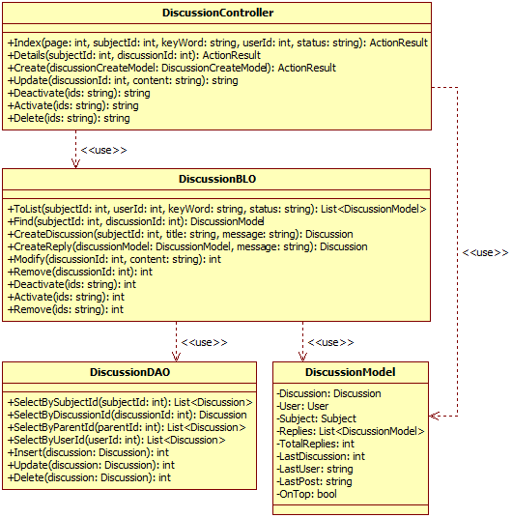

**Figure 37: Discussions Management**

#### Class Diagram Explanation

* + Reference to CD: <root>/Documents/eTest Document - Full.docx

### Reports Management

#### Class Diagram

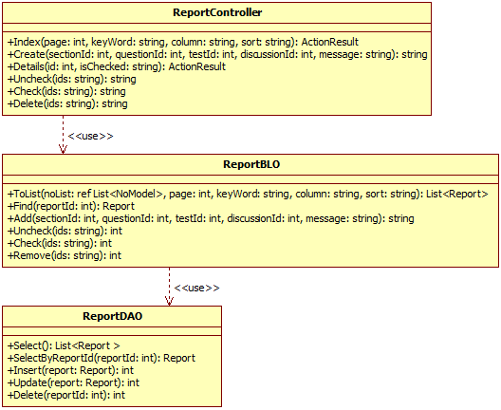

**Figure 38: Reports Management**

#### Class Diagram Explanation

* + Reference to CD: <root>/Documents/eTest Document - Full.docx

### Feedbacks Management

#### Class Diagram

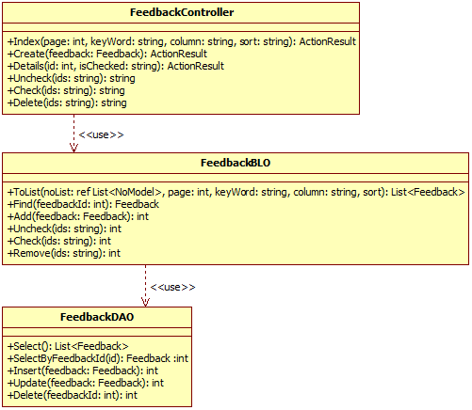

**Figure 39: Feedbacks Management**

#### Class Diagram Explanation

* + Reference to CD: <root>/Documents/eTest Document - Full.docx

## Sequence Diagram

### Account Management

#### Login

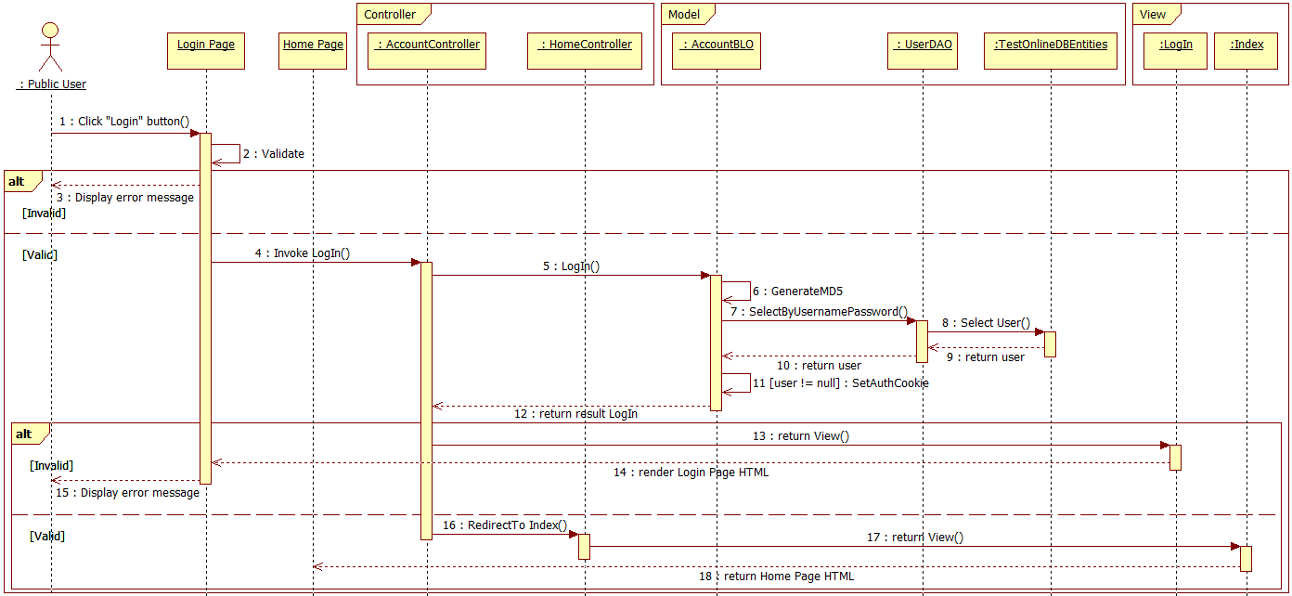

**Figure 40: Login Sequence**

#### Logout

* + Reference to CD: <root>/Documents/eTest Document - Full.docx

#### View Account Info

* + Reference to CD: <root>/Documents/eTest Document - Full.docx

#### Change Password

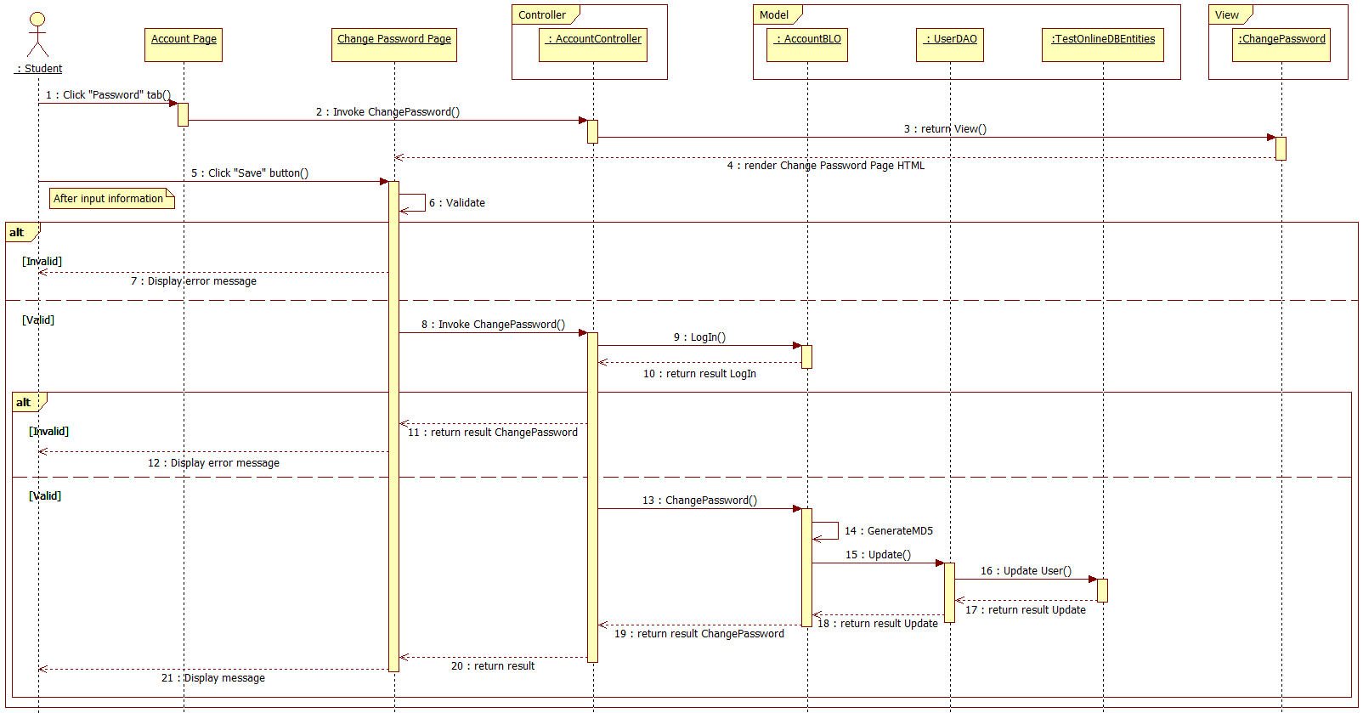

**Figure 41: Change Password Sequence**

#### Change Account Info

* + Reference to CD: <root>/Documents/eTest Document - Full.docx

### Users Management

#### Search User

* + Reference to CD: <root>/Documents/eTest Document - Full.docx

#### View User Details

* + Reference to CD: <root>/Documents/eTest Document - Full.docx

#### Create User

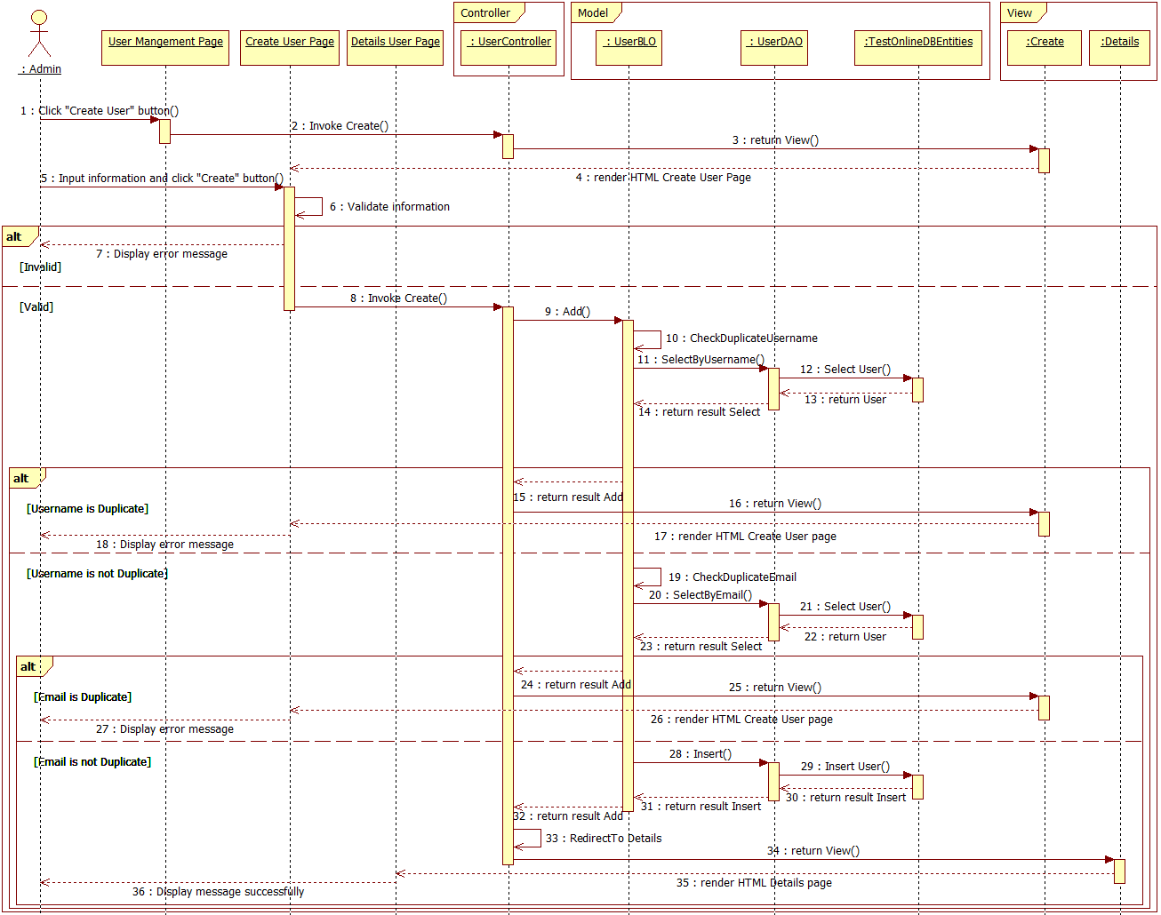

**Figure 42: Create User Sequence**

#### Edit User

* + Reference to CD: <root>/Documents/eTest Document - Full.docx

#### Delete User

* + Reference to CD: <root>/Documents/eTest Document - Full.docx

#### Activate User

* + Reference to CD: <root>/Documents/eTest Document - Full.docx

#### Deactivate User

* + Reference to CD: <root>/Documents/eTest Document - Full.docx

#### Import User

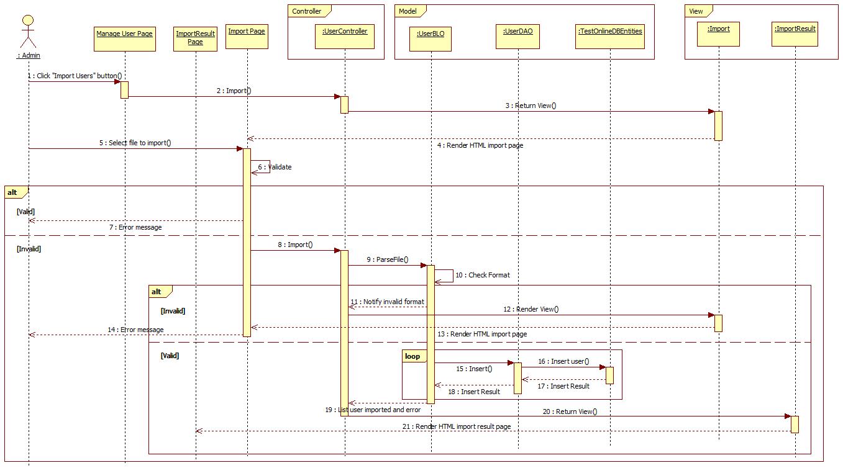

**Figure 43: Import User Sequence**

### Participants Management

#### Search Participant

* + Reference to CD: <root>/Documents/eTest Document - Full.docx

#### View Participant Details

* + Reference to CD: <root>/Documents/eTest Document - Full.docx

#### Create Participant

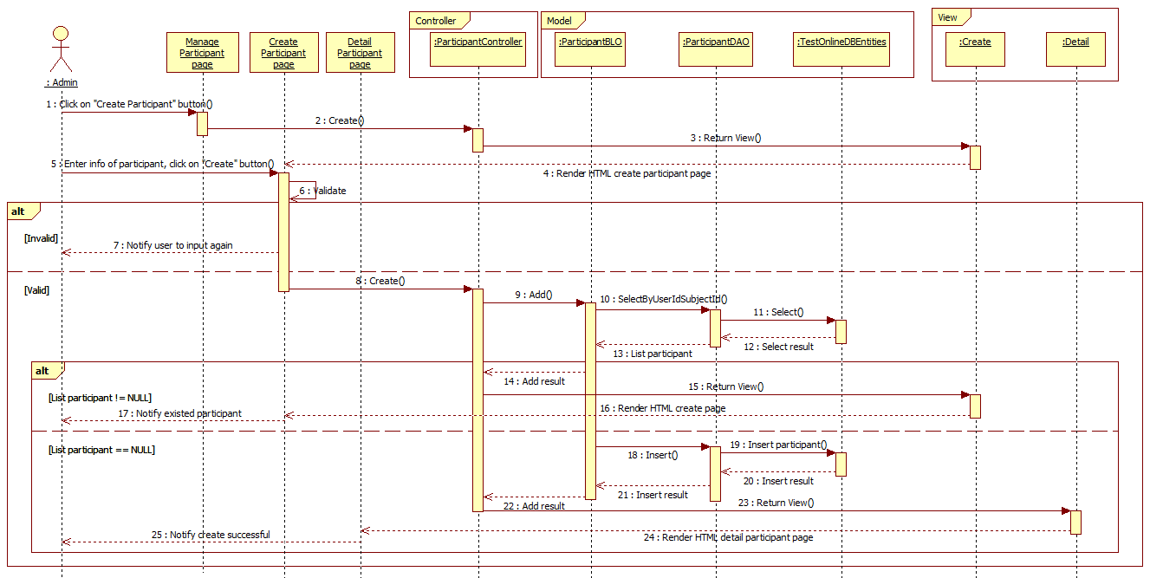

**Figure 44: Create Participant Sequence**

#### Delete Participant

* + Reference to CD: <root>/Documents/eTest Document - Full.docx

#### Activate Participant

* + Reference to CD: <root>/Documents/eTest Document - Full.docx

#### Deactivate Participant

* + Reference to CD: <root>/Documents/eTest Document - Full.docx

#### Import Participant

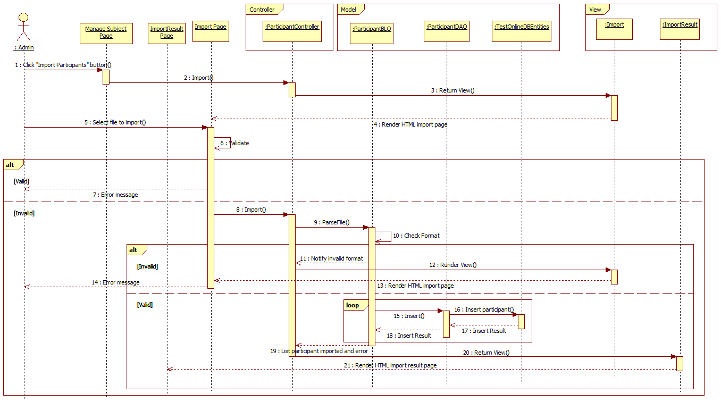

**Figure 45: Import Participant Sequence**

### Subjects Management

#### Search Subject

* + Reference to CD: <root>/Documents/eTest Document - Full.docx

#### View Subject Details

* + Reference to CD: <root>/Documents/eTest Document - Full.docx

#### Create Subject

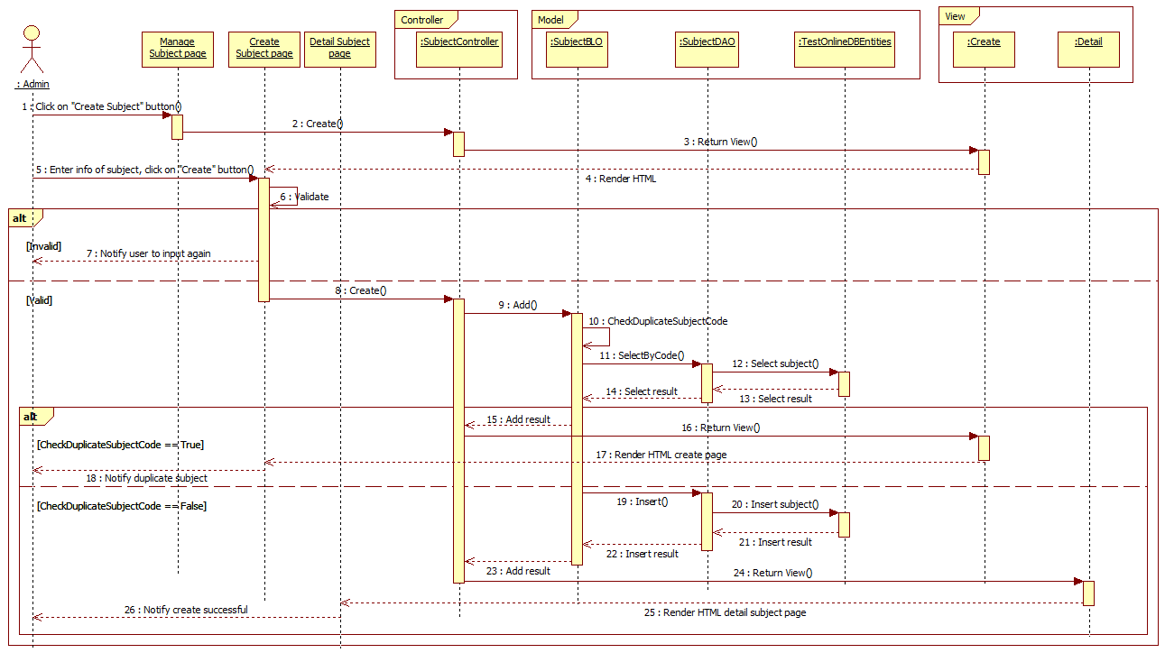

**Figure 46: Create Subject Sequence**

#### Edit Subject

* + Reference to CD: <root>/Documents/eTest Document - Full.docx

#### Delete Subject

* + Reference to CD: <root>/Documents/eTest Document - Full.docx

#### Activate Subject

* + Reference to CD: <root>/Documents/eTest Document - Full.docx

#### Deactivate Subject

* + Reference to CD: <root>/Documents/eTest Document - Full.docx

#### Import Subject

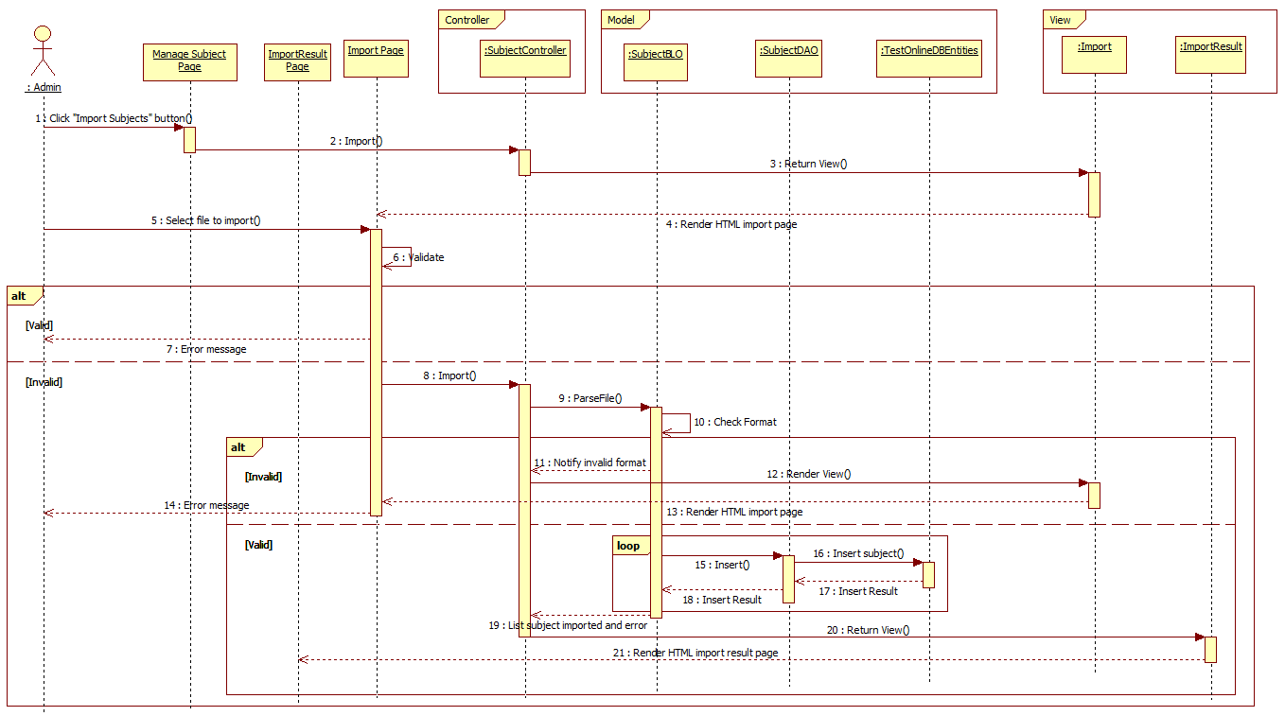

**Figure 47: Import Subject Sequence**

### Sections Management

#### Search Section

* + Reference to CD: <root>/Documents/eTest Document - Full.docx

#### View Section Details

* + Reference to CD: <root>/Documents/eTest Document - Full.docx

#### Create Section

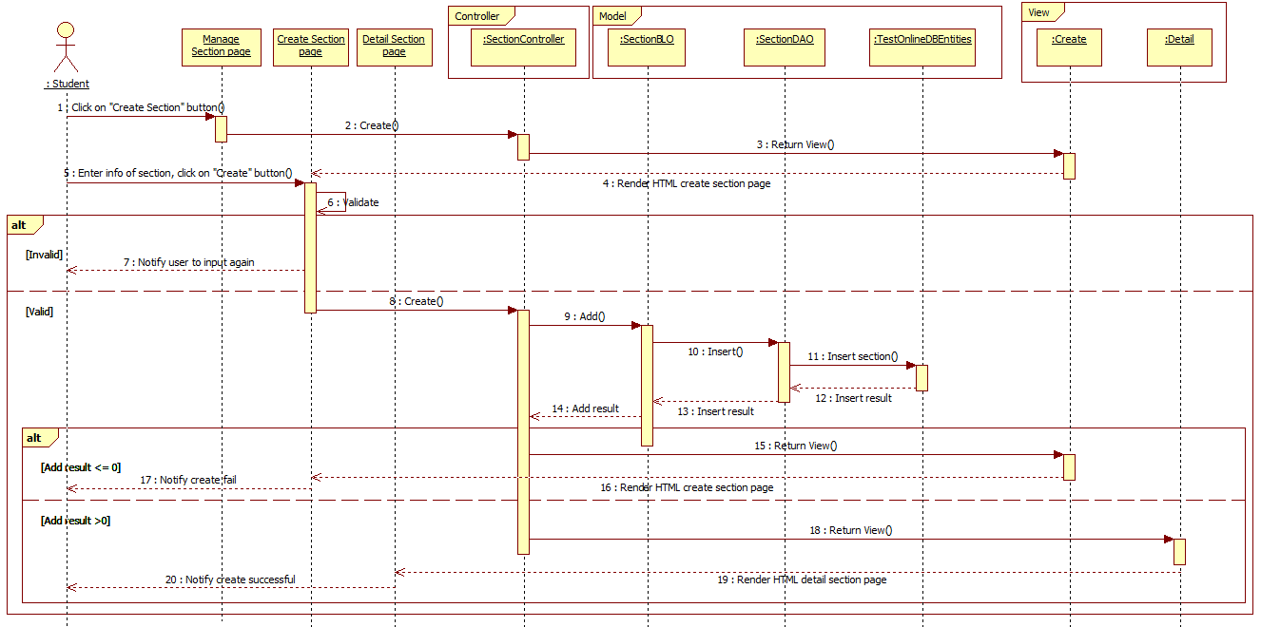

**Figure 48: Create Section Sequence**

#### Edit Section

* + Reference to CD: <root>/Documents/eTest Document - Full.docx

#### Delete Section

* + Reference to CD: <root>/Documents/eTest Document - Full.docx

#### Activate Section

* + Reference to CD: <root>/Documents/eTest Document - Full.docx

#### Deactivate Section

* + Reference to CD: <root>/Documents/eTest Document - Full.docx

### Questions Management

#### Search Question

* + Reference to CD: <root>/Documents/eTest Document - Full.docx

#### View Question Details

* + Reference to CD: <root>/Documents/eTest Document - Full.docx

#### Create Question

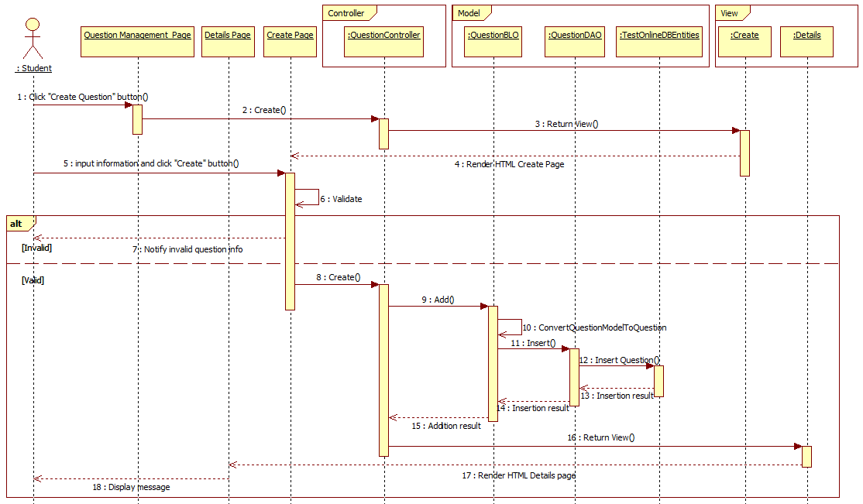

**Figure 49: Create Question Sequence**

#### Edit Question

* + Reference to CD: <root>/Documents/eTest Document - Full.docx

#### Delete Question

* + Reference to CD: <root>/Documents/eTest Document - Full.docx

#### Activate Question

* + Reference to CD: <root>/Documents/eTest Document - Full.docx

#### Deactivate Question

* + Reference to CD: <root>/Documents/eTest Document - Full.docx

#### Import Question

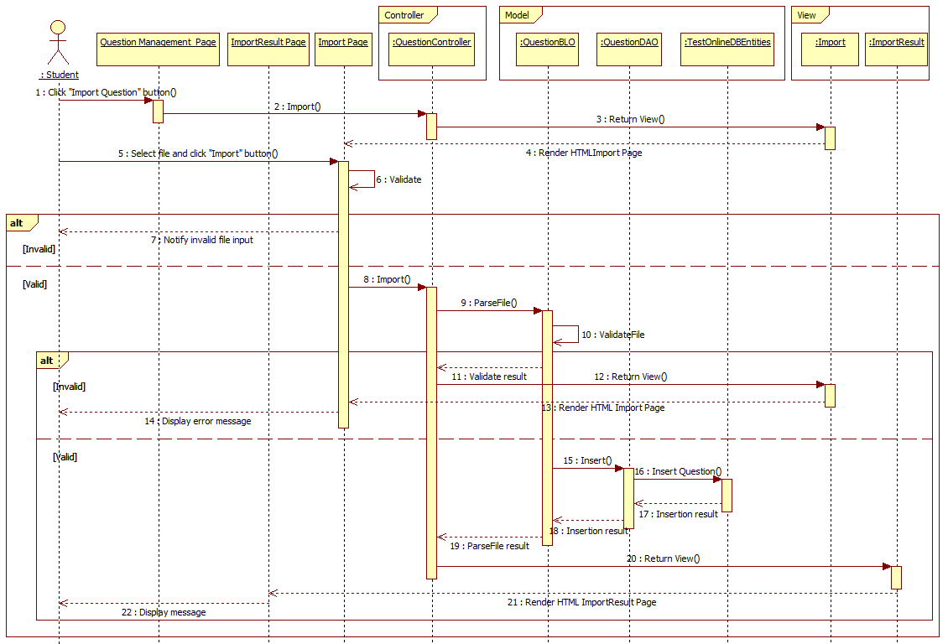

**Figure 50: Import Question Sequence**

#### Add Question to Section

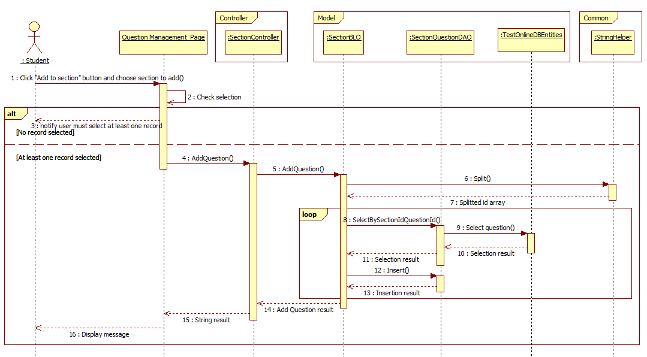

**Figure 51: Add Question to Section Sequence**

#### Remove Question from Section

* + Reference to CD: <root>/Documents/eTest Document - Full.docx

### Tests Management

#### Search Test

* + Reference to CD: <root>/Documents/eTest Document - Full.docx

#### View Test Details

* + Reference to CD: <root>/Documents/eTest Document - Full.docx

#### Create Test

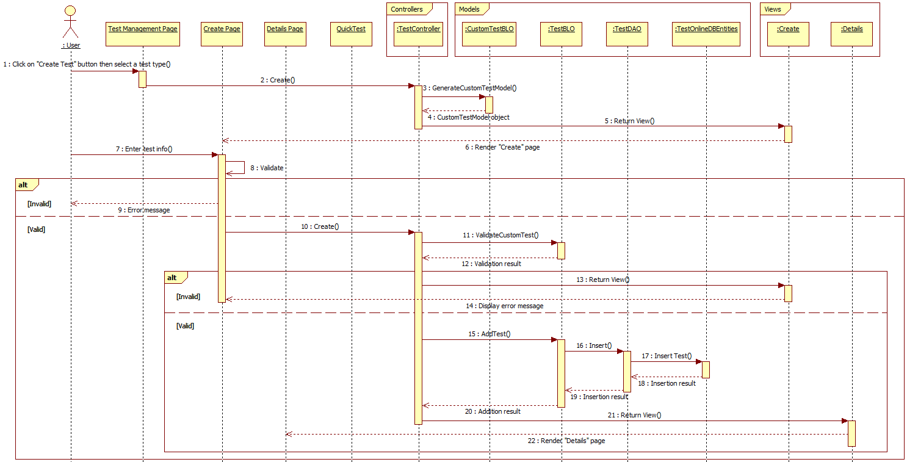

**Figure 52: Create Test Sequence**

#### Edit Test

* + Reference to CD: <root>/Documents/eTest Document - Full.docx

#### Delete Test

* + Reference to CD: <root>/Documents/eTest Document - Full.docx

#### Activate Test

* + Reference to CD: <root>/Documents/eTest Document - Full.docx

#### Deactivate Test

* + Reference to CD: <root>/Documents/eTest Document - Full.docx

#### Take the Test

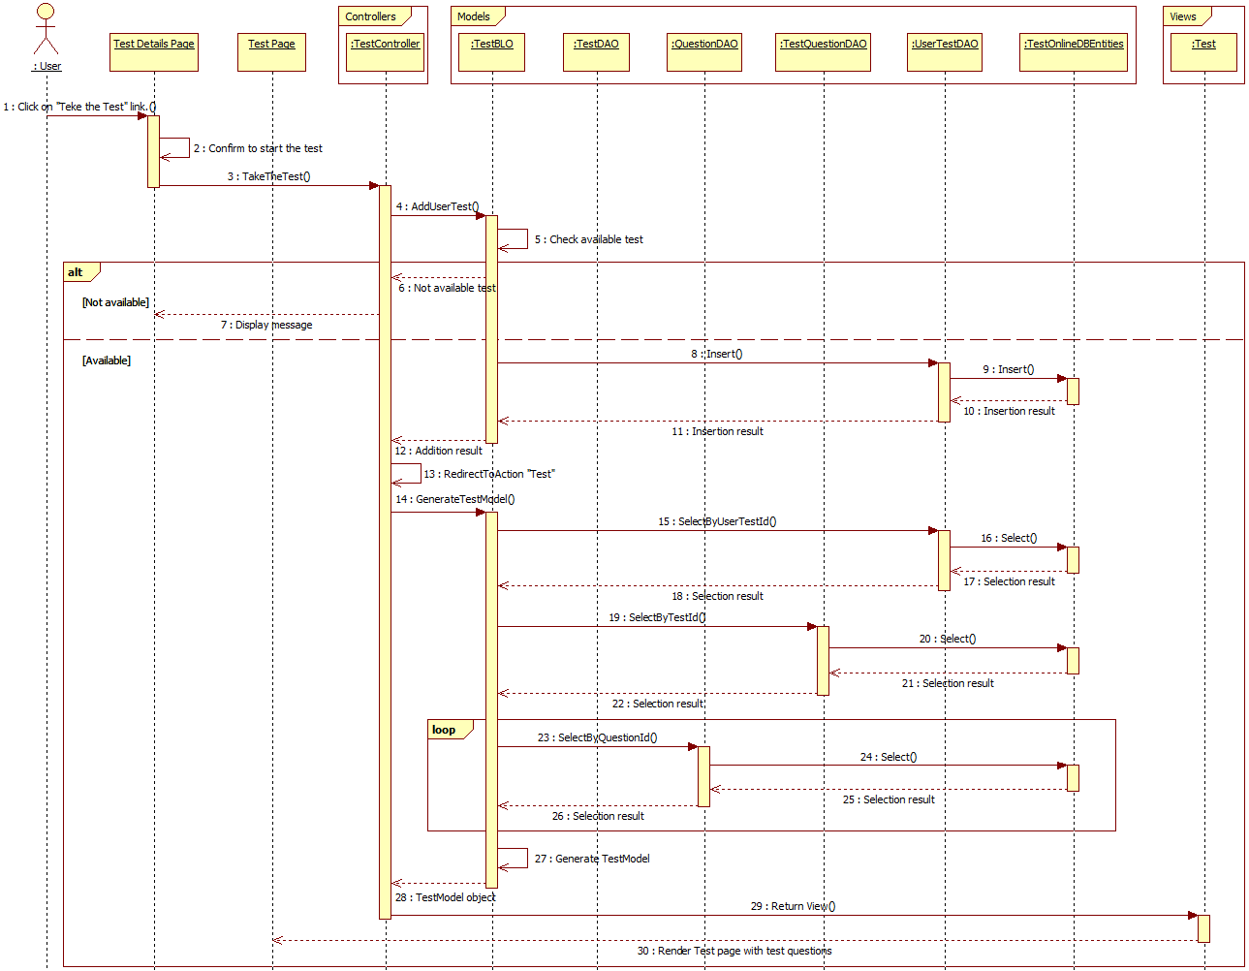

**Figure 54: Take the Test Sequence**

#### Take the Quick Test

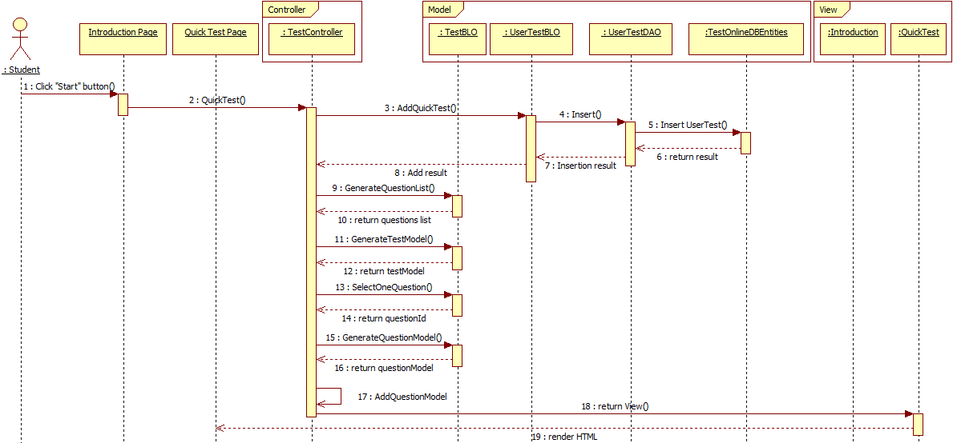

**Figure 55: Take the Quick Test Sequence**

### Discussions Management

#### Search Discussion

* + Reference to CD: <root>/Documents/eTest Document - Full.docx

#### View Discussion Details

* + Reference to CD: <root>/Documents/eTest Document - Full.docx

#### Create Discussion

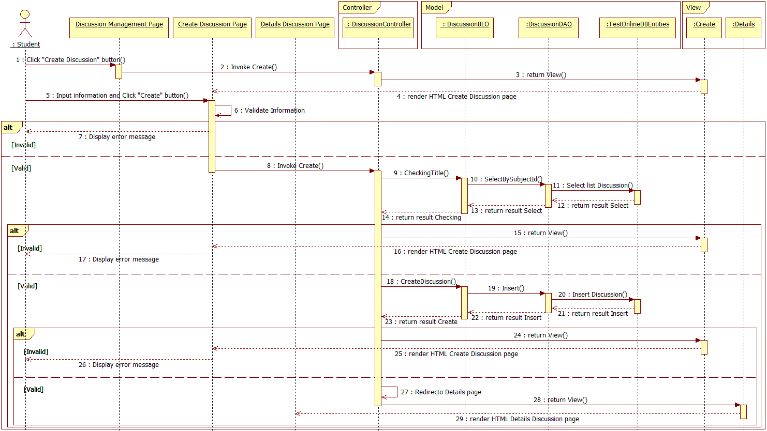

**Figure 56: Create Discussion Sequence**

#### Edit Discussion

* + Reference to CD: <root>/Documents/eTest Document - Full.docx

#### Delete Discussion

* + Reference to CD: <root>/Documents/eTest Document - Full.docx

#### Activate Discussion

* + Reference to CD: <root>/Documents/eTest Document - Full.docx

#### Deactivate Discussion

* + Reference to CD: <root>/Documents/eTest Document - Full.docx

### Reports Management

#### Search Report

* + Reference to CD: <root>/Documents/eTest Document - Full.docx

#### View Report Details

* + Reference to CD: <root>/Documents/eTest Document - Full.docx

#### Send Question report

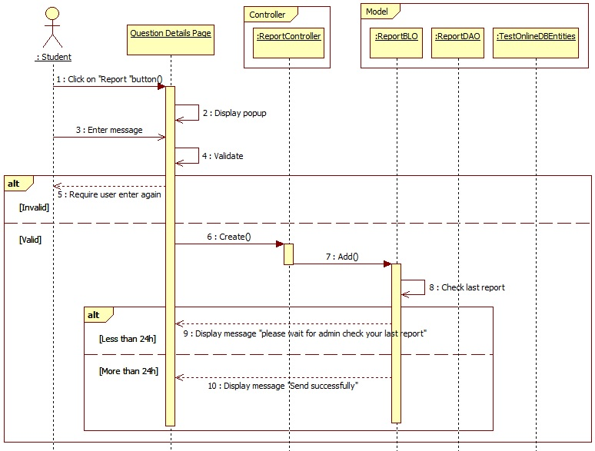

**Figure 57: Send Question Report Sequence**

#### Send Section Report

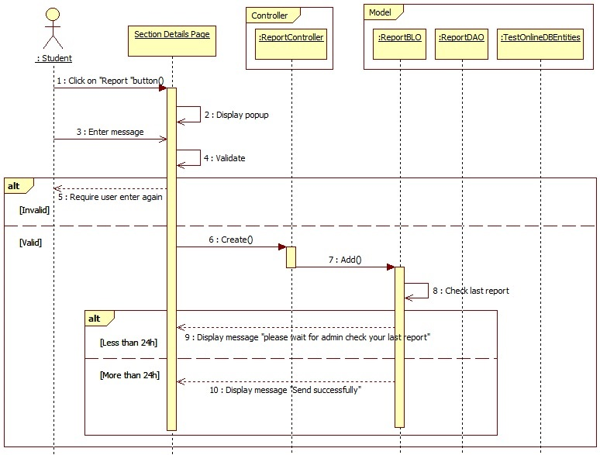

**Figure 161: Send Section Report Sequence**

#### Send Discussion Report

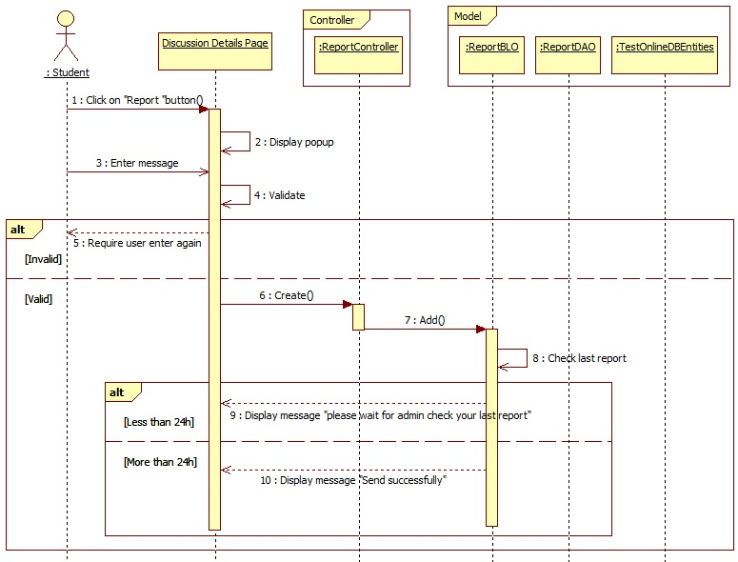

**Figure 162: Send Discussion Report Sequence**

#### Send Test Report

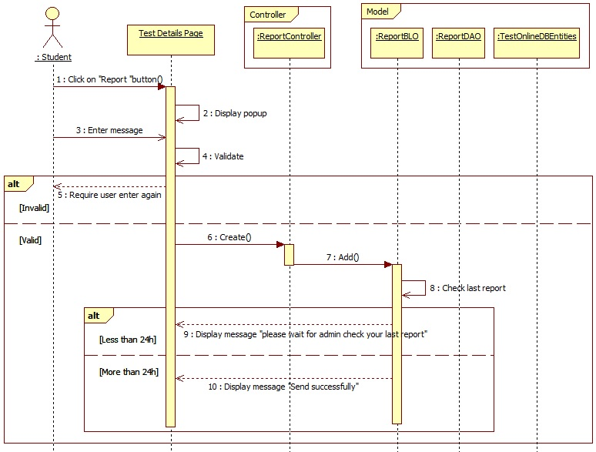

**Figure 163: Send Test Report Sequence**

#### Mark as Read Report

* + Reference to CD: <root>/Documents/eTest Document - Full.docx

#### Mark as Unread Report

* + Reference to CD: <root>/Documents/eTest Document - Full.docx

#### Delete Report

* + Reference to CD: <root>/Documents/eTest Document - Full.docx

### Feedbacks Management

#### Search Feedback

* + Reference to CD: <root>/Documents/eTest Document - Full.docx

#### View Feedback Details

* + Reference to CD: <root>/Documents/eTest Document - Full.docx

#### Send Feedback

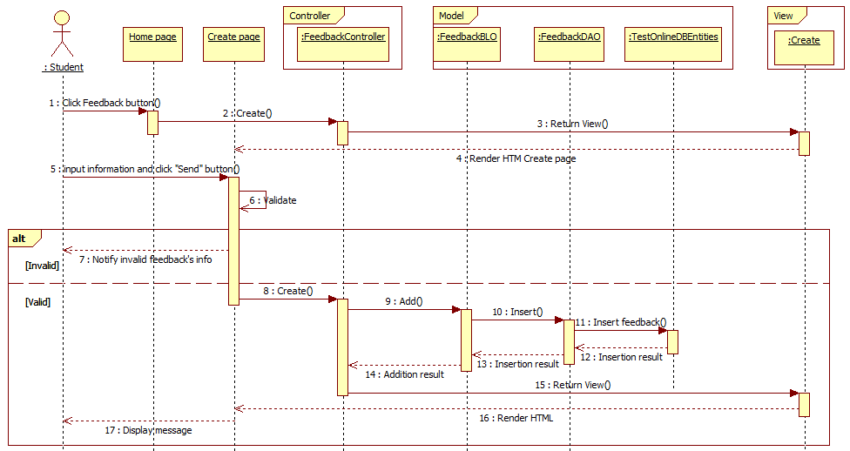

**Figure 61: Send Feedback Sequence**

#### Mark as Read Feedback

* + Reference to CD: <root>/Documents/eTest Document - Full.docx

#### Mark as Unread Feedback

* + Reference to CD: <root>/Documents/eTest Document - Full.docx

#### Delete Feedback

* + Reference to CD: <root>/Documents/eTest Document - Full.docx

## Database Design

### Physical Diagram

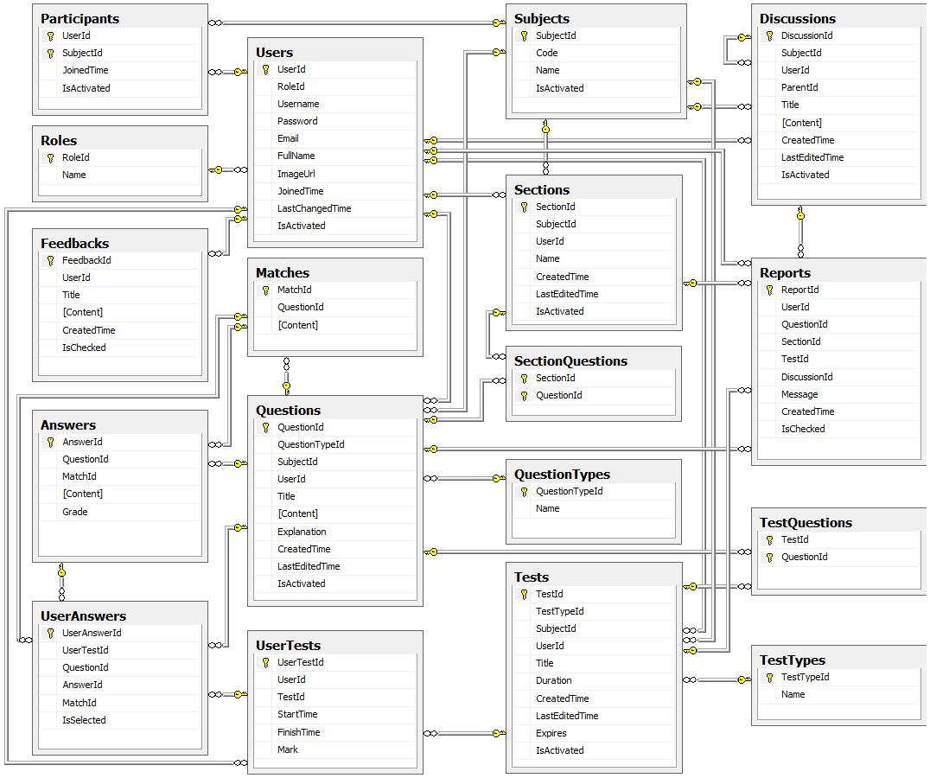

**Figure 62: Physical Diagram**

|  |  |  |
| --- | --- | --- |
| No. | Table | Description |
| 1 | Answers | Storing information about all question’s answers. |
| 2 | Discussions | Storing information about all discussions. |
| 3 | Feedbacks | Storing information about all feedback from users. |
| 4 | Matches | Storing information about all question’s match answers. |
| 5 | Participants | Storing information about all participants. |
| 6 | Questions | Storing information about all questions. |
| 7 | QuestionTypes | Storing information about all question types. |
| 8 | Report | Storing information about all violations that reported by users. |
| 9 | Roles | Storing information about all roles. |
| 10 | SectionQuestions | Storing information about all questions of section |
| 11 | Sections | Storing information about all subject’s sections. |
| 12 | Subjects | Storing information about all subjects. |
| 13 | TestQuestions | Storing information about all test’s questions. |
| 14 | Tests | Storing information about all tests. |
| 15 | TestTypes | Storing information about all test types. |
| 16 | UserAnswers | Storing information about all user’s answers. |
| 17 | Users | Storing information about all users. |
| 18 | UserTests | Storing information about all user’s test session. |

### Table Dictionary

#### Users Table

|  |  |  |  |  |
| --- | --- | --- | --- | --- |
| Field Name | Type | Null | P/F Key | Description |
| UserId | int |  | PK | The user’s ID |
| RoleId | int |  |  | The role’s ID |
| Username | varchar(20) |  |  | Username of user |
| Password | varchar(20) |  |  | Password of user |
| Email | nvarchar(50) |  |  | Email of user |
| FullName | nvarchar(50) |  |  | Full name of user |
| ImageUrl | varchar(50) |  |  | Image’s name of user |
| JoinedTime | datetime |  |  | Time when user join |
| LastChangedTime | datetime |  |  | Last time changed |
| IsActivated | boolean |  |  | User is activated or not |

#### Roles Table

|  |  |  |  |  |
| --- | --- | --- | --- | --- |
| Field Name | Type | Null | P/F Key | Description |
| RoleId | int |  | PK | The role’s ID |
| Name | nvarchar(20) |  |  | The role’s name |

#### Participants Table

|  |  |  |  |  |
| --- | --- | --- | --- | --- |
| Field Name | Type | Null | P/F Key | Description |
| UserId | int |  | PK | The user’s ID |
| SubjectId | int |  | PK | The subject’s ID |
| JoinedTime | datetime |  |  | Time when user join |
| IsActivated | bit |  |  | Participant is activated or not |

#### Subjects Table

|  |  |  |  |  |
| --- | --- | --- | --- | --- |
| Field Name | Type | Null | P/F Key | Description |
| SubjectId | int |  | PK | The subject’s ID |
| Code | varchar(10) |  |  | Code of subject |
| Name | nvarchar(100) |  |  | Name of subject |
| IsActivated | bit |  |  | Subject is activated or not |

#### Sections Table

|  |  |  |  |  |
| --- | --- | --- | --- | --- |
| Field Name | Type | Null | P/F Key | Description |
| SectionId | int |  | PK | The section’s ID |
| SubjectId | int |  | FK | The subject’s ID |
| UserId | int |  | FK | The user’s ID |
| Name | nvarchar(100) |  |  | Name of subject |
| CreateTime | datetime |  |  | Time when user create |
| LastEditedTime | datetime |  |  | Time when last edited |
| IsActivated | bit |  |  | Section is activated or not |

#### SectionQuestions Table

|  |  |  |  |  |
| --- | --- | --- | --- | --- |
| Field Name | Type | Null | P/F Key | Description |
| SectionId | int |  | PK | The section’s ID |
| QuestionId | int |  | PK | The question’s ID |

#### Questions Table

|  |  |  |  |  |
| --- | --- | --- | --- | --- |
| Field Name | Type | Null | P/F Key | Description |
| QuestionId | int |  | PK | The question’s ID |
| QuestionTypeId | int |  | FK | The question type’s ID |
| SubjectId | int |  | FK | The subject’s ID |
| UserId | Int |  | FK | The user’s ID |
| Title | nvarchar(100) |  |  | Title of question |
| [Content] | nvarchar(500) |  |  | The question’s content |
| Explanation | nvarchar(1000) | x |  | The explanation of question |
| CreatedTime | datetime |  |  | Time when created |
| LastEditedTime | datetime |  |  | Time when last edited |
| IsActivated | bit |  |  | Question is activated or not |

#### QuestionTypes Table

|  |  |  |  |  |
| --- | --- | --- | --- | --- |
| Field Name | Type | Null | P/F Key | Description |
| QuestionTypeId | int |  | PK | The question’s ID |
| Name | nvarchar(50) |  |  | The question type’s name |

#### Answers Table

|  |  |  |  |  |
| --- | --- | --- | --- | --- |
| Field Name | Type | Null | P/F Key | Description |
| AnswerId | int |  | PK | The answer’s ID |
| QuestionId | int |  | FK | The question’s ID |
| MatchId | int | x |  | The match’s ID |
| [Content] | nvarchar(500) |  |  | The content of answer |
| Grade | float |  |  | The grade of answer |

#### Matches Table

|  |  |  |  |  |
| --- | --- | --- | --- | --- |
| Field Name | Type | Null | P/F Key | Description |
| MatchId | int |  | PK | The match’s ID |
| QuestionId | int |  | FK | The question’s ID |
| [Content] | nvarchar(100) |  |  | The content of match |

#### Tests Table

|  |  |  |  |  |
| --- | --- | --- | --- | --- |
| Field Name | Type | Null | P/F Key | Description |
| TestId | int |  | PK | The test’s ID |
| TestTypeId | int |  | FK | The test type’s ID |
| SubjectId | Int |  | FK | The subject’s ID |
| UserId | int |  | FK | The user’s ID |
| Title | nvarchar(100) |  |  | The title of test |
| Duration | int |  |  | The duration of test |
| CreatedTime | datetime |  |  | Time created the test |
| LastEditedTime | datetime |  |  | Time when last edited |
| Expires | datetime |  |  | Time to expire test |
| IsActivated | bit |  |  | Status of test |

#### TestQuestions Table

|  |  |  |  |  |
| --- | --- | --- | --- | --- |
| Field Name | Type | Null | P/F Key | Description |
| TestId | int |  | PK | The test’s id |
| QuestionId | int |  | PK | The question’s id |

#### TestTypes Table

|  |  |  |  |  |
| --- | --- | --- | --- | --- |
| Field Name | Type | Null | P/F Key | Description |
| TestTypeId | int |  | PK | The test type’s ID |
| Name | nvarchar(50) |  |  | The type’s name |

#### UserTests Table

|  |  |  |  |  |
| --- | --- | --- | --- | --- |
| Field Name | Type | Null | P/F Key | Description |
| UserTestId | int |  | PK | The usertest ‘s ID |
| UserId | int |  | FK | The user’s ID |
| TestId | int | x | FK | The test’s ID |
| StartTime | datetime |  |  | The time starts the test. |
| FinishTime | datetime | x |  | The time finishes the test. |
| Mark | float | x |  | The test’s mark. |

#### UserAnswers Table

|  |  |  |  |  |  |  |
| --- | --- | --- | --- | --- | --- | --- |
| Field Name | Type | Null | P/F Key | | Description | |
| UserAnswerId | int |  | PK | The useranswer‘s ID | |
| UserTestId | int |  | FK | The usertest’s ID | |
| QuestionId | int |  | FK | The question’s ID | |
| AnswerId | int |  | FK | The answer’s ID | |
| MatchId | int | x | FK | The match’s ID | |
| IsSelected | bit | x |  | Status of answer | |

#### Discussions Table

|  |  |  |  |  |
| --- | --- | --- | --- | --- |
| Field Name | Type | Null | P/F Key | Description |
| DiscussionId | int |  | PK | The discussion‘s ID |
| SubjectId | int |  | FK | The subject’s ID |
| UserId | int |  | FK | The user’s ID |
| ParentId | int | x | FK | The parent’s ID |
| Title | nvarchar(100) |  |  | The title of the discussion. |
| [Content] | nvarchar(MAX) |  |  | The content of the discussion. |
| CreatedTime | datetime |  |  | The time create the discussion |
| LastEditedTme | datetime |  |  | The time of the last edited. |
| IsActivated | bit |  |  | Status of the discussion |

#### Reports Table

|  |  |  |  |  |
| --- | --- | --- | --- | --- |
| Field Name | Type | Null | P/F Key | Description |
| ReportId | int |  | PK | The violation ‘s ID |
| UserId | int |  | FK | The user’s ID |
| QuestionId | int | x | FK | The question’s ID |
| SectionId | int | x | FK | The section’s ID |
| TestId | int | x | FK | The test’s ID |
| DiscussionId | int | x | FK | The Discussion’s ID |
| Message | nvarchar(100) |  |  | The title of the violation |
| CreateTime | datetime |  |  | The time of reporting the violation. |
| IsChecked | bit |  |  | Status of the violation. |

#### Feedbacks Table

|  |  |  |  |  |
| --- | --- | --- | --- | --- |
| Field Name | Type | Null | P/F Key | Description |
| FeedbackId | int |  | PK | The feedback ‘s ID |
| UserId | int |  | FK | The user send the feedback |
| Title | nvarchar(100) |  |  | The title of the feedback |
| [Content] | nvarchar(500) |  |  | The content of the feedback |
| CreatedTime | datetime |  |  | The time of sending the feedback |
| IsChecked | bit |  |  | Status of the feedback. |

# System Implementation & Test

## Introduction

### System Overview

* This document describes plan and methods used in testing stage, an important step for grading the quality of product before packaging it. Testing group would plan, manage and execute the process of testing. Testers must execute and pass all test cases and technical details of system features.
* The testing group is also the coding group of eTest system.

### Test Approach

* Test goals: the testing aims to identify the remaining bugs in the system before releasing and confirm the consistency in design and implementation.
* Test type: black box testing.
* Test level: system and integration test.

## Test plan

### Feature to be tested:

#### Account Management

* Login
* Logout
* View Account Info
* Change Password
* Change Account Info

#### Users Management

* Search User
* View User Details
* Create User
* Edit User
* Delete User
* Activate User
* Deactivate User
* Import User

#### Participants Management

* Search Participant
* View Participant Details
* Create Participant
* Delete Participant
* Activate Participant
* Deactivate Participant
* Import Participant

#### Subjects Management

* Search Subject
* View Subject Details
* Create Subject
* Edit Subject
* Delete Subject
* Activate Subject
* Deactivate Subject
* Import Subject

#### Sections Management

* Search Section
* View Section Details
* Create Section
* Edit Section
* Delete Section
* Activate Section
* Deactivate Section

#### Questions Management

* Search Question
* View Question Details
* Create Question
* Edit Question
* Delete Question
* Activate Question
* Deactivate Question
* Import Question
* Add Question to Section
* Remove Question from Section

#### Tests Management

* Search Test
* View Test Details
* Create Test
* Edit Test
* Delete Test
* Activate Test
* Deactivate Test
* Take the Test
* Take the Quick Test

#### Discussions Management

* Search Discussion
* View Discussion Details
* Create Discussion
* Edit Discussion
* Delete Discussion
* Activate Discussion
* Deactivate Discussion

#### Reports Management

* Search Report
* View Report Details
* Send Question Report
* Send Section Report
* Send Discussion Report
* Send Test Report
* Mark as Read Report
* Mark as Unread Report
* Delete Report

#### Feedbacks Management

* Search Feedback
* View Feedback Details
* Send Feedback
* Mark as Read Feedback
* Mark as Unread Feedback
* Delete Feedback

### Feature not to be tested

* No features not to be tested

### Testing tools and Environment

* Environment:
  + OS: Windows 7 (32 or 64 bit)
  + Memory: 2G RAM or more
  + Browser: Firefox v25 or laster

## Test case

### Account Management

#### Login

|  |  |  |  |  |  |  |  |
| --- | --- | --- | --- | --- | --- | --- | --- |
| **ID** | **Test Case Description** | **Pre-Conditions** | **Test Case Procedure** | **Expected Output** | **Result** | **Test Date** | **Note** |
| Login. | | | | | | | |
| Steps 1. Go to Home index page  2. Click on “Login” anchor link | | | | | | | |
| AC_01 | Test Login Page |  | - Go to website homepage.  - Click on “Login” link | - [Login] page is displayed. The content includes:   * Username (textbox) * Password (textbox) * “Login” button * “Reset” button * “Forgot your password” link | Pass | 8/11/2013 |  |
| AC_02 | Test Login Validation Blank Field |  | - Go to [Login] page.  - Don’t input information.  - Click on “Login” button. | - Error message will be displayed:   * The Username is required. * The Password is required. | Pass | 8/11/2013 |  |
| AC_03 | Test Login Successfully |  | - Go to [Login] page  - Input “testUL1” for Username.  - Input “12345678” for password field.  - Click on “Login” button | - Login successfully.  - [Home] page will be shown. | Pass | 8/11/2013 |  |
| AC_04 | Test Login with wrong username |  | - Go to [Login] page.  - Input “asdfasdf” for username field.  - Input “12345678” for password field.  - Click on “Login” button. | - Error message will be displayed:   * Invalid username or password. Please try again! | Pass | 8/11/2013 |  |
| AC_05 | Test Login with wrong password |  | - Go to [Login] page.  - Input “testUL1” for username field.  - Input “asd123” for password field.  - Click on “Login” button. | - Error message will be displayed:   * Invalid username or password. Please try again! | Pass | 8/11/2013 |  |
| AC_06 | Test Login with Account has property IsActivate is False |  | - Go to [Login] page.  - Input “testUL2” for username field.  - Input “12345678” for password field.  - Click on “Login” button. | - Error message will be displayed:   * Your account has been Inactive. Please contact admin to have more information! | Pass | 8/11/2013 |  |

#### Logout

* + Reference to CD: <root>/Documents/eTest Document - Full.docx

#### View Account Info

* + Reference to CD: <root>/Documents/eTest Document - Full.docx

#### Change Password

|  |  |  |  |  |  |  |  |
| --- | --- | --- | --- | --- | --- | --- | --- |
| **ID** | **Test Case Description** | **Pre-Conditions** | **Test Case Procedure** | **Expected Output** | **Result** | **Test Date** | **Note** |
| Change Password. | | | | | | | |
| Steps 1. User login into system.  2. Click “Account” in Account bar.  3. Click “Password” tab. | | | | | | | |
| AC_09 | Test Change Validation Blank Field |  | - Go to [Change] page.  - Click “Save” button | - Error message will be displayed:   * Please input your old Password. | Pass | 8/11/2013 |  |
| AC_10 | Test Change Validation Blank New Password Field |  | - Go to [Change] page.  - Input “12345678” into Old Password field.  - Click “Save” button. | - Error message will be displayed:   * Please input your new password | Pass | 8/11/2013 |  |
| AC_11 | Test Change Validation Blank Confirm Password Field |  | - Go to [Change] page.  - Input “12345678” into Old Password field.  - Input “87654321” into New Password field.  - Click “Save” button | - Error message will be displayed:   * Confirm Password must be equal New Password | Pass | 8/11/2013 |  |
| AC_12 | Test Change Validation Old Password and New Password |  | - Go to [Change] page.  - Input “12345678” into Old Password field  - Input “12345678” into New Password field  - Click “Save” button | - Error message will be displayed:   * New Password must be different with Old Password | Pass | 8/11/2013 |  |
| AC_13 | Test Change Validation New Password and Confirm New Password |  | - Go to [Change] page.  - Input “12345678” into Old Password field  - Input “1234567” into New Password field  - Input “asdasd” into Confirm New Password field  - Click “Save” button | - Error message will be displayed:   * Confirm New Password must be equal New Password! | Pass | 8/11/2013 |  |
| AC_14 | Test “Save” button |  | - Go to [Change] page.  - Input “12345678” into Old Password field  - Input “1234567” into New Password field  - Input “1234567” into Confirm New Password field  - Click “Save” button | - Confirm popup will be displayed with message:   * Are you sure you want to change password? | Pass | 8/11/2013 |  |
| AC_15 | Test Change Password Successfully |  | - Go to [Change] page.  - Input “12345678” into Old Password field  - Input “1234567” into New Password field  - Input “1234567” into Confirm New Password field  - Click “Save” button  - Click “OK” | - Password will be changed successfully.  - A notification “Password change successfully” will be shown. | Pass | 8/11/2013 |  |
| AC_16 | Test “Reset” button |  | - Go to [Change] page.  - Input “12345678” into Old Password field  - Input “1234567” into New Password field  - Input “1234567” into Confirm New Password field  - Click “Reset” button | - [Change] page will be reloaded. | Pass | 8/11/2013 |  |

#### Change Account Info

* + Reference to CD: <root>/Documents/eTest Document - Full.docx

### Users Management

#### Search User

* + Reference to CD: <root>/Documents/eTest Document - Full.docx

#### View User Details

* + Reference to CD: <root>/Documents/eTest Document - Full.docx

#### Create User

|  |  |  |  |  |  |  |  |
| --- | --- | --- | --- | --- | --- | --- | --- |
| **ID** | **Test Case Description** | **Pre-Conditions** | **Test Case Procedure** | **Expected Output** | **Result** | **Test Date** | **Note** |
| Create User. | | | | | | | |
| Steps 1. Login the system with Admin role.  2. Click “User” in Management Bar. | | | | | | | |
| US_04 | Test Create User Page |  | - Go to [User Management] page.  - Click “Create User” button. | - [Create] page will be shown with:   * Username (textbox) * E-mail (textbox) * Password (textbox) * Confirm Password (textbox) * Full name (textbox) * Role (dropdownlist) * “Create” button * “Reset” button | Pass | 9/11/2013 |  |
| US_05 | Test Create User Validation |  | - Go to [Create] page.  - Click “Create” button. | - Error message will be displayed:   * “Username is required” * “E-mail is required” * “Password is required” * “Full name is required” * “Role is required” | Pass | 9/11/2013 |  |
| US_06 | Test Create User Successfully |  | - Go to [Create] page.  - Input information to field  - Click “Create” button | - Data table will be updated new user.  - A Notification will be displayed “New user has been created.” | Pass | 9/11/2013 |  |
| US_07 | Test Create User Validation |  | - Go to [Create] page.  - Do not input inform into Username field.  - Click “Create” button | - Error message will be displayed:   * “Username is required” | Pass | 9/11/2013 |  |
| US_08 | Test Create User Validation |  | - Go to [Create] page.  - Do not input inform into E-mail field.  - Click “Create” button | - Error message will be displayed:   * “E-mail is required” | Pass | 9/11/2013 |  |
| US_09 | Test Create User Validation |  | - Go to [Create] page.  - Do not input inform into Password field.  - Click “Create” button | - Error message will be displayed:   * Password is required” | Pass | 9/11/2013 |  |
| US_10 | Test Create User Validation |  | - Go to [Create] page.  - Do not input inform into Full name field.  - Click “Create” button | - Error message will be displayed:   * “Username is required”. * “E-mail is required” * “Password is required” * “Full name is required” | Pass | 9/11/2013 |  |
| US_11 | Test Create User Validation |  | - Go to [Create] page.  - Do not select role  - Click “Create” button | - Error message will be displayed:   * “Username is required”. * “E-mail is required” * “Password is required” * “Role is required | Pass | 9/11/2013 |  |
| US_12 | Test Create User Validation |  | - Go to [Create] page.  - Input into Username field with length less than 5 or more than 15 characters.  - Click “Create” button | - Error message will be displayed:   * “Username must be between 5 and 15 characters long” | Pass | 9/11/2013 | HieuND |
| US_13 | Test Create User Validation |  | - Go to [Create] page.  - Input into E-mail field with format “---@---.---“  - Click “Create” button | - Error message will be displayed:   * “E-mail must match with format” | Pass | 9/11/2013 |  |
| US_14 | Test Create User Validation |  | - Go to [Create] page.  - Input into Confirm Password field by different value with Password field.  - Click “Create” button | - Error message will be displayed:   * “Confirm Password must be equal Password” | Pass | 9/11/2013 |  |
| US_15 | Test Create User Validation |  | - Go to [Create] page.  Input into Fullname field with length less than 5 or more than 50 characters.  - Click “Create” button | - Error message will be displayed:   * “Full name must be between 5 and 50 characters long” | Pass | 9/11/2013 |  |

#### Edit User

* + Reference to CD: <root>/Documents/eTest Document - Full.docx

#### Delete User

* + Reference to CD: <root>/Documents/eTest Document - Full.docx

#### Activate User

* + Reference to CD: <root>/Documents/eTest Document - Full.docx

#### Deactivate User

* + Reference to CD: <root>/Documents/eTest Document - Full.docx

#### Import User

|  |  |  |  |  |  |  |  |
| --- | --- | --- | --- | --- | --- | --- | --- |
| **ID** | **Test Case Description** | **Pre-Conditions** | **Test Case Procedure** | **Expected Output** | **Result** | **Test Date** | **Note** |
| Import User. | | | | | | | |
| Steps   1. User login into the system with role Admin. 2. Click “Users” link on Management Bar. | | | | | | | |
| US_42 | Test Import User Page |  | - Go to [User Management] page.  - Click “Import Users” button. | - [Import Users] page will be displayed with:   * “Browse” button. * “Maximum size of file: 2MB” * “Download Template” link * “Import” button * “Reset” button * “Cancel” button | Pass | 9/11/2013 |  |
| US_43 | Test Import User Page Button |  | - Go to [Import Users] page.  - Click “Browse” button. | - Upload file box will be displayed. | Pass | 9/11/2013 |  |
| US_44 | Test Import User Page Button |  | - Go to [Import Users] page.  - Click “Import” button. | - Error message will be shown:   * “Please select the file” | Pass | 9/11/2013 |  |
| US_45 | Test Import User Page Button |  | - Go to [Import Users] page.  - Select any file.  - Click “Reset” button. | - The page will be reloaded. | Pass | 9/11/2013 |  |
| US_46 | Test Import User Page Download Link |  | - Go to [Import Users] page.  - Click “Download Template” link | - File template will be downloaded to client. | Pass | 9/11/2013 |  |
| US_47 | Test Import User Page Select File |  | - Go to [Import Users] page.  - Select file is not Excel | - Error message will be shown:   * “Please import by Excel Workbook file!” | Pass | 9/11/2013 |  |
| US_48 | Test Import User Page Select File |  | - Go to [Import Users] page.  - Select file Excel wil size more than 2MB. | - Error message will be shown:   * “Your file is out of size!” | Pass | 9/11/2013 |  |
| US_49 | Test Import User Page Select File |  | - Go to [Import Users] page.  - Select file a right file Excel to import.  - Click “Import” button. | - File will be imported to system and redirect to [Import User Result] page | Pass | 9/11/2013 |  |

### Participants Management

#### Search Participant

* + Reference to CD: <root>/Documents/eTest Document - Full.docx

#### View Participant Details

* + Reference to CD: <root>/Documents/eTest Document - Full.docx

#### Create Participant

|  |  |  |  |  |  |  |  |
| --- | --- | --- | --- | --- | --- | --- | --- |
| **ID** | **Test Case Description** | **Pre-Conditions** | **Test Case Procedure** | **Expected Output** | **Result** | **Test Date** | **Note** |
| Create Participant | | | | | | | |
| Steps 1. Go to list Subjects page  2. Click on subject’s name  3. Click on “Participants” button | | | | | | | |
| PA_05 | Test Create Participant page | User login into the system with role Admin. | - Click on “Create Participant” | - Show create Participant page includes:   * User (textbox) * Create (button) * Reset (button) * Cancel (button) | Pass | 9/11/2013 |  |
| PA_06 | Test Validation of Create Participant | PA_05 | - Don’t input information  - Click on “Create” button | - Display error message: “An error occurred.” | Pass | 9/11/2013 |  |
| PA_07 | Test Validation of Create Participant | PA_05 | - Input “a” in textbox  - Click on “Create” button | - Display error message: “An error occurred.” | Pass | 9/11/2013 |  |
| PA_08 | Test Validation of Create Participant | PA_05 | - Input “a” in textbox  - Choose one user in list.  - Click on User textbox. | - Clear user textbox. | Pass | 9/11/2013 |  |
| PA_09 | Test Create Participant successful | PA_05 | - Input “a” in textbox  - Choose one user in list.  - Click on “Create” button | - Display message: “The user has been added to this subject.”  - Show detail of new participant. | Pass | 9/11/2013 |  |
| PA_10 | Test “Reset” button in create Participant page | PA_05 | - Input “a” in textbox  - Choose one user in list.  - Click on “Reset” button | - Clear User textbox | Pass | 9/11/2013 |  |
| PA_11 | Test “Cancel” button in create Participant page | PA_05 | - Click on “Cancel” button | - Back to list Participants page. | Pass | 9/11/2013 |  |

#### Delete Participant

* + Reference to CD: <root>/Documents/eTest Document - Full.docx

#### Activate Participant

* + Reference to CD: <root>/Documents/eTest Document - Full.docx

#### Deactivate Participant

* + Reference to CD: <root>/Documents/eTest Document - Full.docx

#### Import Participant

|  |  |  |  |  |  |  |  |
| --- | --- | --- | --- | --- | --- | --- | --- |
| **ID** | **Test Case Description** | **Pre-Conditions** | **Test Case Procedure** | **Expected Output** | **Result** | **Test Date** | **Note** |
| **Import Participant** | | | | | | | |
| Steps   1. User login into the system with role Admin. 2. Click “Subjects” link on Management Bar. | | | | | | | |
| PA_20 | Test Import Participant Page |  | - Go to [Subject Management] page.  - Click “Import Participants” button. | - [Import Participants] page will be displayed with:   * “Browse” button. * “Maximum size of file: 2MB” * “Download Template” link * “Import” button * “Reset” button * “Cancel” button | Pass |  |  |
| PA_21 | Test Import Participant Page Button |  | - Go to [Import Participants] page.  - Click “Browse” button. | - Upload file box will be displayed. | Pass |  |  |
| PA_22 | Test Import Participant Page Button |  | - Go to [Import Participants] page.  - Click “Import” button. | - Error message will be shown:   * “Please select the file” | Pass |  |  |
| PA_23 | Test Import Participant Page Button |  | - Go to [Import Participants] page.  - Select any file.  - Click “Reset” button. | - The page will be reloaded. | Pass |  |  |
| PA_24 | Test Import Participant Page Download Link |  | - Go to [Import Participants] page.  - Click “Download Template” link | - File template will be downloaded to client. | Pass |  |  |
| PA_25 | Test Import Participant Page Select File |  | - Go to [Import Participants] page.  - Select file is not Excel | - Error message will be shown:   * “Please import by Excel Workbook file!” | Pass |  |  |
| PA_26 | Test Import Participant page select file |  | - Go to [Import Participants] page.  - Select file Excel wil size more than 2MB. | - Error message will be shown:   * “Your file is out of size!” | Pass |  |  |
| PA_27 | Test Import Participant page select file |  | - Go to [Import Participants] page.  - Select file Excel with wrong format | - Error message will be shown:   * “Please download template to have an exactly format" | Pass |  |  |
| PA_28 | Test Import Participant page select file |  | - Go to [Import Participants] page.  - Select file a right file Excel to import.  - Click “Import” button. | - File will be imported to system and redirect to [Import Participant Result] page | Pass |  |  |

### Subjects Management

#### Search Subject

* + Reference to CD: <root>/Documents/eTest Document - Full.docx

#### View Subject Details

* + Reference to CD: <root>/Documents/eTest Document - Full.docx

#### Create Subject

|  |  |  |  |  |  |  |  |
| --- | --- | --- | --- | --- | --- | --- | --- |
| **ID** | **Test Case Description** | **Pre-Conditions** | **Test Case Procedure** | **Expected Output** | **Result** | **Test Date** | **Note** |
| Create Subject | | | | | | | |
| Steps 1. Go to list Subjects page | | | | | | | |
| SU_04 | Test Create Subject page | User login into the system with role Admin. | - Click “Create Subject” button | - Display create page includes:   * Code (textbox) * Name (text box) * Create (button) * Reset (button) * Cancel (button) | Pass | 9/11/2013 |  |
| SU_05 | Test Validateion of Create Subject | SU_04 | - Don’t input information in Code/Name  - Click “Create” button | - Display error message“The Code is required.” / “The Name is required.” | Pass | 9/11/2013 |  |
| SU_06 | Test Validateion of Create Subject | SU_04 | - Don’t input in Code and Name textbox  - Click “Create” button | - Display error message“The Code is required.” and “The Name is required.” | Pass | 9/11/2013 |  |
| SU_07 | Test Validateion of Create Subject | SU_04 | - Input “c” in Code textbox  - Input “C#.Net” in Name textbox  - Click “Create” button | - Display error message“The Code length is 2-10 characters.” | Pass | 9/11/2013 |  |
| SU_08 | Test Validateion of Create Subject | SU_04 | - Input “XML” in Code textbox  - Input “x” in Name textbox  - Click “Create” button | - Display error message“The Code length is 3-100 characters.” | Pass | 9/11/2013 |  |
| SU_09 | Test Create Subject successful | SU_04 | - Input “XML” in Code textbox  - Input “XML” in Name textbox  - Click “Create” button | - Display message: “New subject has been created.”  - Show detail of the new subject. | Pass | 9/11/2013 |  |
| SU_10 | Test “Reset” button in Create Subject page | SU_04 | - Input “ABC” in Code textbox  - Click “Reset” button | - Reload page  - Clear Code textbox | Pass | 9/11/2013 |  |
| SU_11 | Test “Cancel” button in Create Subject page | SU_04 | - Click “Cancel” button | - Back to manage Subjects page. | Pass | 9/11/2013 |  |

#### Edit Subject

* + Reference to CD: <root>/Documents/eTest Document - Full.docx

#### Delete Subject

* + Reference to CD: <root>/Documents/eTest Document - Full.docx

#### Activate Subject

* + Reference to CD: <root>/Documents/eTest Document - Full.docx

#### Deactivate Subject

* + Reference to CD: <root>/Documents/eTest Document - Full.docx

#### Import Subject

|  |  |  |  |  |  |  |  |
| --- | --- | --- | --- | --- | --- | --- | --- |
| **ID** | **Test Case Description** | **Pre-Conditions** | **Test Case Procedure** | **Expected Output** | **Result** | **Test Date** | **Note** |
| **Import Subject** | | | | | | | |
| Steps   1. User login into the system with role Admin. 2. Click “Subjects” link on Management Bar. | | | | | | | |
| SU_27 | Test Import Subject Page |  | - Go to [Subject Management] page.  - Click “Import Subjects” button. | - [Import Participants] page will be displayed with:   * “Browse” button. * “Maximum size of file: 2MB” * “Download Template” link * “Import” button * “Reset” button * “Cancel” button | Pass | 9/11/2013 |  |
| SU_28 | Test Import Subject Page Button |  | - Go to [Import Subjects] page.  - Click “Browse” button. | - Upload file box will be displayed. | Pass | 9/11/2013 |  |
| SU_29 | Test Import Subject Page Button |  | - Go to [Import Subjects] page.  - Click “Import” button. | - Error message will be shown:   * “Please select the file” | Pass | 9/11/2013 |  |
| SU_30 | Test Import Subject Page Button |  | - Go to [Import Subjects] page.  - Select any file.  - Click “Reset” button. | - The page will be reloaded. | Pass | 9/11/2013 |  |
| SU_31 | Test Import Subject Page Download Link |  | - Go to [Import Subjects] page.  - Click “Download Template” link | - File template will be downloaded to client. | Pass | 9/11/2013 |  |
| SU_32 | Test Import Subject Page Select File |  | - Go to [Import Subjects] page.  - Select file is not Excel | - Error message will be shown:   * “Please import by Excel Workbook file!” | Pass | 9/11/2013 |  |
| SU_33 | Test Import Subject page select file |  | - Go to [Import Subjects] page.  - Select file Excel wil size more than 2MB. | - Error message will be shown:   * “Your file is out of size!” | Pass | 9/11/2013 |  |
| SU_34 | Test Import Subject page select file |  | - Go to [Import Subjects] page.  - Select file Excel with wrong format | - Error message will be shown:   * “Please download template to have an exactly format" | Pass | 9/11/2013 |  |
| SU_35 | Test Import Subject page select file |  | - Go to [Import Subjects] page.  - Select file a right file Excel to import.  - Click “Import” button. | - File will be imported to system and redirect to [Import Subject Result] page | Pass | 9/11/2013 |  |

### Sections Management

#### Search Section

* + Reference to CD: <root>/Documents/eTest Document - Full.docx

#### .View Section Details

* + Reference to CD: <root>/Documents/eTest Document - Full.docx

#### Create Section

|  |  |  |  |  |  |  |  |
| --- | --- | --- | --- | --- | --- | --- | --- |
| **ID** | **Test Case Description** | **Pre-Conditions** | **Test Case Procedure** | **Expected Output** | **Result** | **Test Date** | **Note** |
| Create Section | | | | | | | |
| Steps 1. Go to list Subjects page  2. Click on Subject’s name  3. Click on “Questions” button | | | | | | | |
| SE_05 | Test Create Section page | User login into the system with role student. | * Click on “Create Section” | * Display Create page. Include: * Section Name (Text box) * Create (button) * Reset (button) * Cancel (button) | Pass |  |  |
| SE_06 | Test Validation of create section | SE_05 | - Don’t input information   * Click “Create” button | * Error message will be displayed: * The Name is required. | Pass |  |  |
| SE_07 | Test Validation of create section | SE_05 | * Input “s” to textbox * Click “Create” buton | * Error message will be display: * The Section length is 5-100 characters | Pass |  |  |
| SE_08 | Test Create Section successful | SE_05 | * Input “Test Create Section” to textbox * Click “Create” button | - Display message box: “New section has been created”.  - Show detail of the new section | Pass |  |  |
| SE_09 | Test “Reset” button in Create Section page | SE_05 | - Input “ABC” in Name textbox  - Click “Reset” button | - Reload page  - Clear Name textbox | Pass |  |  |
| SE_10 | Test “Cancel” button in Create Section page | SE_05 | - Click “Cancel” button | - Back to list Sections page. | Pass |  |  |

#### Edit Section

* + Reference to CD: <root>/Documents/eTest Document - Full.docx

#### Delete Section

* + Reference to CD: <root>/Documents/eTest Document - Full.docx

#### Activate Section

* + Reference to CD: <root>/Documents/eTest Document - Full.docx

#### Deactivate Section

* + Reference to CD: <root>/Documents/eTest Document - Full.docx

### Questions Management

#### Search Question

* + Reference to CD: <root>/Documents/eTest Document - Full.docx

#### View Question Details

* + Reference to CD: <root>/Documents/eTest Document - Full.docx

#### Create Question

##### Create Single Choice Question

|  |  |  |  |  |  |  |  |
| --- | --- | --- | --- | --- | --- | --- | --- |
| **ID** | **Test Case Description** | **Pre-Conditions** | **Test Case Procedure** | **Expected Output** | **Result** | **Test Date** | **Note** |
| Create Single Choice Question | | | | | | | |
| Steps 1. Login the system.  2. Go into Subject.  3. Click “Question” button.  4.Click” Create Question”  5. Choose “Single Choose” in Question Type combo box | | | | | | | |
| QU_09 | Test Create Question validation Blank Field |  | * Go to “Create Single Choice Question” page * Do not input information for Title’s content or Question’s content or Answer’s content * Click “Create” button | * Error message will be displayed: “The Content field is reqired” at all field | Pass | 9/11/2013 |  |
| QU_10 | Test Create successfully |  | * Input Title’s content * Input Question’ content * Input content of at least 2 answers * Choose correct answer * Click “Create” button | * New message will be displayed: “New question has been created” | Pass | 9/11/2013 |  |
| QU_11 | Test Number of Answer |  | * Input Title’s content * Input Question’s content * Input Answers’s content * Click “Remove Last Answer” until has one answer * Click “Create” button | * Error message will be displayed: "You must enter at least 2 answers.” | Pass | 9/11/2013 |  |
| QU_12 | Test Create Question validation No correct Answer | QU_10 | * Do not choose correct answer * Click “Create” button | * Error message will be displayed: “You must select the correct answer” | Pass | 9/11/2013 |  |
| QU_13 | Test length of title’s content |  | * Input less than 5 or more than 100 characters | * Error message will be displayed: The Title length is 5 -100 characters.” | Pass | 9/11/2013 |  |
| QU_14 | Test length of question’s content |  | * Input less than 5 or more than 500 characters | * Error message will be displayed: The Question length is 5 -500 characters.” | Pass | 9/11/2013 |  |
| QU_15 | Test length of answer’s content |  | * Input less than 5 or more than 500 characters | * Error message will be displayed: The Answer length is 5 -500 characters.” | Pass | 9/11/2013 |  |
| QU_16 | Test remove last Answer |  | * Click “Remove Last Answer” | * Create Question page will be reload and the last answer is removed. | Pass | 9/11/2013 |  |
| QU_17 | Test Reset all fields |  | * Input information * Click “Reset” button. | * All fields will be set to blank | Pass | 9/11/2013 |  |
| QU_18 | Test add more Answer |  | * Click “More Answer” button | * New Answer will be added to this question | Pass | 9/11/2013 |  |
| QU_19 | Test cancel create question |  | * Click “Cancel” button | * Forward to Manage Question page | Pass | 9/11/2013 |  |

##### Create Multiple Choice Question

|  |  |  |  |  |  |  |  |
| --- | --- | --- | --- | --- | --- | --- | --- |
| **ID** | **Test Case Description** | **Pre-Conditions** | **Test Case Procedure** | **Expected Output** | **Result** | **Test Date** | **Note** |
| Create MultipleQuestion | | | | | | | |
| Steps 1. Login the system.  2. Go into Subject.  3. Click “Question” button.  4.Click” Create Question”  5. Choose “Multiple Choice” in Question Type combo box | | | | | | | |
| QU_20 | Test Create Question validation Blank Field |  | * Go to “Create Single Choice Question” page * Do not input information for Title’s content Question’s content or Answer’s content   Click “Create” button | * Error message will be displayed: “The Content field is reqired” | Pass | 9/11/2013 |  |
| QU_21 | Test Create successfully |  | * Input Title’s content * Input Question’ content * Input content of at least 2 answers * Choose grade with possitive grades is equals 100%. * Click “Create” button | * New message will be displayed: “New question has been created” | Pass | 9/11/2013 |  |
| QU_22 | Test Number of Answer |  | * Input Title’s content * Input Question’s content * Input Answers’s content * Click “Remove Last Answer” until has one answer * Click “Create” button | * Error message will be displayed: "You must enter at least 2 answers.” | Pass | 9/11/2013 |  |
| QU_23 | Test Create Question validation without choose grade |  | * Do not choose grade for answer * Click “Create” button | * Error message will be displayed: “The positive grades you have chosen does not euqal 100%” | Pass | 9/11/2013 |  |
| QU_24 | Test choose grade below 100% (1 answer) |  | * Choose “50,00” in grade combo box of one answer * Click “Create” button | * Error message will be displayed: “The positive grades you have chosen does not euqal 100%” | Pass | 9/11/2013 |  |
| QU_25 | Test choose grade below 100% (more than 2 answers) |  | * Choose “50,00” in grade combo box of one answer * Choose “20,00” in grade combo box of another answer * Click “Create” button | * Error message will be displayed: “The positive grades you have chosen does not euqal 100%” | Pass | 9/11/2013 |  |
| QU_26 | Test choose grade euqal 100% (1 answer) |  | * Choose “100,00” in grade combo box of one answer * Click “Create” button | * New message will be displayed: “New question has been created” | Pass | 9/11/2013 |  |
| QU_27 | Test choose grade euqal 100% (more than 2 answers) |  | * Choose “50,00” in grade combo box of one answer * Choose “50,00” in grade combo box of another answer * Click “Create” button | * New message will be displayed: “New question has been created” | Pass | 9/11/2013 |  |
| QU_28 | Test choose grade above 100% |  | * Choose “50,00” in grade combo box of one answer * Choose “33,00” in grade combo box of another answer * Choose “50,00” in grade combo box of another answer * Click “Create” button | * Error message will be displayed: “The positive grades you have chosen does not euqal 100%” | Pass | 9/11/2013 |  |

##### Create Matching Question

|  |  |  |  |  |  |  |  |
| --- | --- | --- | --- | --- | --- | --- | --- |
| **ID** | **Test Case Description** | **Pre-Conditions** | **Test Case Procedure** | **Expected Output** | **Result** | **Test Date** | **Note** |
| Create Matching Question | | | | | | | |
| Steps 1. Login the system.  2. Go into Subject.  3. Click “Question” button.  4.Click” Create Question”  5. Choose “Matching” in Question Type combo box | | | | | | | |
| QU_29 | Test Create Question validation Blank Field |  | * Go to “Create Single Choice Question” page * Do not input information for Title’s content Question’s content or Answer’s content   Click “Create” button | * Error message will be displayed: “The Content field is reqired” | Pass | 9/11/2013 |  |
| QU_30 | Test Create successfully |  | * Input Title’s content * Input Question’ content * Input content of at least 2 answers * Click “Create” button | * New message will be displayed: “New question has been created” | Pass | 9/11/2013 |  |
| QU_31 | Test Number of Answer |  | * Input Title’s content * Input Question’s content * Input Answers’s content * Click “Remove Last Answer” until has one answer * Click “Create” button | * Error message will be displayed: "You must enter at least 2 answers.” | Pass | 9/11/2013 |  |
| QU_32 | Test Create Question validation no input matching for answer |  | * Do not input matching for answer * Click “Create” button | * Error message will be displayed: “The Content field is reqired” | Pass | 9/11/2013 |  |
| QU_33 | Test add more invalid match |  | * Click “More Match” button * Input information for this match * Click “Create” button | * New message will be displayed: “New question has been created” | Pass | 9/11/2013 |  |
| QU_34 | Test add more invalid match (blank field) |  | * Click “More Match” button * Do not input information for this match * Click “Create” button | * Error message will be displayed: “The Content field is reqired” | Pass | 9/11/2013 |  |
| QU_35 | Test remove last match (invalid matchs) |  | * Click “Remove Last Match” | * Create Question page will be reload and the last match is removed. | Pass | 9/11/2013 |  |

##### Create True/False Question

|  |  |  |  |  |  |  |  |
| --- | --- | --- | --- | --- | --- | --- | --- |
| **ID** | **Test Case Description** | **Pre-Conditions** | **Test Case Procedure** | **Expected Output** | **Result** | **Test Date** | **Note** |
| Create True/FalseQuestion | | | | | | | |
| Steps 1. Login the system.  2. Go into Subject.  3. Click “Question” button.  4.Click” Create Question”  5. Choose “True/False” in Question Type combo box | | | | | | | |
| QU_36 | Test Create Question validation Blank Field |  | * Go to “Create Single Choice Question” page * Do not input information for Title’s content Question’s content | * Error message will be displayed: “The Content field is reqired” | Pass | 9/11/2013 |  |
| QU_37 | Test Create successfully |  | * Input Title’s content * Input Question’ content * Choose correct answer * Click “Create” button | * New message will be displayed: “New question has been created” | Pass | 9/11/2013 |  |
| QU_38 | Test Create Question validation No correct Answer |  | * Do not choose correct answer * Click “Create” button | * Error message will be displayed: “You must select the correct answer” | Pass | 9/11/2013 |  |

#### Edit Question

* + Reference to CD: <root>/Documents/eTest Document - Full.docx

#### Delete Question

* + Reference to CD: <root>/Documents/eTest Document - Full.docx

#### Activate Question

* + Reference to CD: <root>/Documents/eTest Document - Full.docx

#### Deactivate Question

* + Reference to CD: <root>/Documents/eTest Document - Full.docx

#### Import Question

|  |  |  |  |  |  |  |  |
| --- | --- | --- | --- | --- | --- | --- | --- |
| **ID** | **Test Case Description** | **Pre-Conditions** | **Test Case Procedure** | **Expected Output** | **Result** | **Test Date** | **Note** |
| ImportQuestion | | | | | | | |
| Steps 1. Login the system.  2. Go into Subject.  3. Click “Question” button.  4. Click “Default Section” button  5. Click “Import Question” button | | | | | | | |
| QU_63 | Test import successful |  | * Click “Browse” button * Choose text file * Click “Import” button | * New message will be displayed: “Import successful” and redirect to page contain all question just have imported (ImportResult) | Pass | 9/11/2013 |  |
| QU_64 | Test import unsuccessful  (not select file) |  | * Click “Import” button | * Error message will be displayed: “Please select the file!” | Pass | 9/11/2013 |  |
| QU_65 | Test import unsuccessful  (wrong content file) | QU_63 | * Choose text file with content is wrong * Click “Import” button | * Error message will be displayed that relate with syntax error | Pass | 9/11/2013 |  |
| QU_66 | Test import unsuccessful  (lager than maximum size of file) |  | * Choose file have size is lager than allow file size * Click “Import” button | * Error message will be displayed: “Your file is out of size!” | Pass | 9/11/2013 |  |
| QU_67 | Test reset file selected |  | * Click “Browse” button * Choose text file * Click “Reset” button | * The “Import” page will reload, no file selected | Pass | 9/11/2013 |  |
| QU_68 | Test cancel import question |  | * Click “Cancel” button | * Redirect to “Question” page | Pass | 9/11/2013 |  |

#### Add Question to Section

|  |  |  |  |  |  |  |  |
| --- | --- | --- | --- | --- | --- | --- | --- |
| **ID** | **Test Case Description** | **Pre-Conditions** | **Test Case Procedure** | **Expected Output** | **Result** | **Test Date** | **Note** |
| AddQuestion to Section | | | | | | | |
| Steps 1. Login the system.  2. Go into Subject.  3. Click “Question” button. | | | | | | | |
| QU_69 | Test add question successful |  | * Select at least one question” * Choose any section in “Add to secton” in dropdown list action | * New message will be displayed: “<Number of question> question(s) has been added” | Pass | 9/11/2013 |  |
| QU_70 | Test add question without choose question |  | * Do not choose any question * Choose any section in “Add to secton” in dropdown list action | * Error message will be displayed: “You must select at least one question!” | Pass | 9/11/2013 |  |
| QU_71 | Test add question unsuccessful |  | * Select at least one question which already in one section (section 1) * Choose this section (seciton 1) in “Add to secton” in dropdown list action | * Error message will be displayed: “question(s) is already exists in this section” | Pass | 9/11/2013 |  |

#### Remove Question from Section

* + Reference to CD: <root>/Documents/eTest Document - Full.docx

### Tests Management

#### Search Test

* + Reference to CD: <root>/Documents/eTest Document - Full.docx

#### View Test Details

* + Reference to CD: <root>/Documents/eTest Document - Full.docx

#### Create Test

|  |  |  |  |  |  |  |  |
| --- | --- | --- | --- | --- | --- | --- | --- |
| **ID** | **Test Case Description** | **Pre-Conditions** | **Test Case Procedure** | **Expected Output** | **Result** | **Test Date** | **Note** |
| Create Test. | | | | | | | |
| Steps 1. Login  2. Go to Test Management Page  3. Click on “Create Test” button | | | | | | | |
| TE_06 | Test: select Classic test mode |  | * Select “Classic”option in Test Type select list. | * The custom test table will display include Title, Expires, Number of Questions, Duration, Section input fields and Create, Reset, Cancel buttons | Pass | 15/11/2013 |  |
| TE_07 | Test: create classic test with all input values is blank | TE_06 | * All input values is blank * Click on “Create” button | * The error message with content “The Title is required.” will display near “Title” input field * The error message with content “The Expires is required.” will display near “Expires” input field * The error message with content “The Number of Questions is required.” will display near “Number of Questions” input field * The error message with content “The Duration is required.” will display near “Duration” input field * The error message with content “The Section is required.” will display near “Section” input field | Pass | 15/11/2013 |  |
| TE_08 | Test: create classic test with valid values | TE_06 | * Input all input fields: Title (New Test), Expires ( 2013-11-30 11:55), Number of Questions (10), Duration (10), Section (any section contain more than or equal 10 questions) * Click on “Create” button. | * The message box display with cotent “The test has been created.” * Redirect to test details page | Pass | 15/11/2013 |  |
| TE_09 | Test: create classic test with length of Title more than 100 | TE_06 | * Input value into Title input field with length is more than 100 * Click on “Create” button | * The error message with content “The Title length is 5-100 characters.” will display near “Title” input field | Pass | 15/11/2013 |  |
| TE_10 | Test: create classic test with length of Title less than 5. | TE_06 | * Input value into Title input field with length is less than 5. * Click on “Create” button | * The error message with content “The Title length is 5-100 characters.” will display near “Title” input field | Pass | 15/11/2013 |  |
| TE_11 | Test: create classic test with Number of Questions input field value is 0 | TE_06 | * Input 0 into Number of Questions input field * Click on “Create” button | * The error message with content “The Number of Questions is 1-50 questions.” will display near “Number of Questions” input field | Pass | 15/11/2013 |  |
| TE_12 | Test: create classic test with Number of Questions input field value is 51 | TE_06 | * Input 51 into Number of Questions input field * Click on “Create” button | * The error message with content “The Number of Questions is 1-50 questions.” will display near “Number of Questions” input field | Pass | 15/11/2013 |  |
| TE_13 | Test: create classic test with Duration input field value is 0 | TE_06 | * Input 0 into Duration input field. * Click on “Create” button | * The error message with content “The Duration is 1-60 minutes.” Will display near “Duration” input field | Pass | 15/11/2013 |  |
| TE_14 | Test create classic test: Duration input field value is 61 |  | * Input 61 into Duration input field. * Click on “Create” button | * The error message with content “The Duration is 1-60 minutes.” Will display near “Duration” input field | Pass | 15/11/2013 |  |

#### Edit Test

* + Reference to CD: <root>/Documents/eTest Document - Full.docx

#### Delete Test

* + Reference to CD: <root>/Documents/eTest Document - Full.docx

#### Activate Test

* + Reference to CD: <root>/Documents/eTest Document - Full.docx

#### Deactivate Test

* + Reference to CD: <root>/Documents/eTest Document - Full.docx

#### Take the Test

|  |  |  |  |  |  |  |  |
| --- | --- | --- | --- | --- | --- | --- | --- |
| **ID** | **Test Case Description** | **Pre-Conditions** | **Test Case Procedure** | **Expected Output** | **Result** | **Test Date** | **Note** |
| Take the Test | | | | | | | |
| Steps  1. Login  2. Go to Test Management page  3. Click on “Test Title” link to go to Test Details Page | | | | | | | |
| TE_30 | Take the test |  | * Click on “Take the Test” link | * The system display a confirm box ask you confirm that you want to take this test. | Pass | 15/11/2013 |  |
| TE_31 | Continue the last unfinished Test |  | * Click on “Take the Test” link | * The system display a confirm box ask you confirm that you want to continue the last unfinished test or not. | Pass | 15/11/2013 |  |
| TE_32 | Save without submit | TE_30 | * Select your answers * Click on “Save without submit” button * Close browser. * Go to Test Management page * Click on “Test Title” link to go to Test Details Page * Click on “Take the Test” link * Confirm that you want to continue the last unfinished test. | * Your answers will display again after you comback the test. | Pass | 15/11/2013 |  |
| TE_33 | Test submit and finish | TE_30 | * Select your answers * Click on “Submit and finish” button | * The test result page will display include your answer and marks. | Pass | 15/11/2013 |  |

#### Take the Quick Test

|  |  |  |  |  |  |  |  |
| --- | --- | --- | --- | --- | --- | --- | --- |
| **ID** | **Test Case Description** | **Pre-Conditions** | **Test Case Procedure** | **Expected Output** | **Result** | **Test Date** | **Note** |
| Take the Quick Test. | | | | | | | |
| Steps   1. User login into the system. 2. Go to [Create Test] page. | | | | | | | |
| TE_34 | Test Take the Quick Test |  | - Go to [Test Management] page.  - Click “Create Test” button. | - [Create Test] page will displayed with:   * Test type dropdownlist | Pass | 9/11/2013 |  |
| TE_35 | Test Take the Quick Test |  | - Go to [Create Test] page.  - Select “Quick” in dropdownlist Test type. | - [Create Quick Test] page will displayed with:   * Section textbox | Pass | 9/11/2013 |  |
| TE_36 | Test Take the Quick Test |  | - Go to [Create Quick Test] page.  - Click “Create” button. | - Error message will be displayed:   * “The Section is required” | Pass | 9/11/2013 |  |
| TE_37 | Test Take the Quick Test |  | - Go to [Create Quick Test] page.  - Input “SectionNoQuestion” into Section field | - Error message will be displayed:   * “This Section is not have question to create the Test” | Pass | 9/11/2013 |  |
| TE_38 | Test Take the Quick Test page |  | - Go to [Create Test] page.  - Select “Quick” into Test Type.  - Select “Section” into Section.  - Click “Create” button | - [Quick Test] page will be shown with:   * Name of Subject * Number Question in the Quick Test * Start time * Content of Question and Answers * Mark of the Test * “Show Hint” button * “Finish” button | Pass | 9/11/2013 |  |
| TE_39 | Test Take the Quick Test Button |  | - Go to [Quick Test] page.  - Click “Show Hint” button. | - Under “Show Hint” button, the Explantion of Question will be displayed on screen | Pass | 9/11/2013 |  |
| TE_40 | Test Take the Quick Test Button |  | - Go to [Quick Test] page.  - Click “Show Hint” button.  - Click “Show Hint” button again. | - First time, the Explantion of Question will be displayed.  - Second time, the Explantion of Question will be hidden | Pass | 9/11/2013 |  |
| TE_41 | Test Take the Quick Test Button |  | - Go to [Quick Test] page.  - Click “Finish” button. | - A confirm popup will be displayed:   * “Are you sure you want to finish this Test” | Pass | 9/11/2013 |  |
| TE_42 | Test Take the Quick Test Button |  | - Go to [Quick Test] page.  - Click “Finish” button.  - Click “OK”. | - This Quick Test submit and show [Quick Test Result] page | Pass | 9/11/2013 |  |
| TE_43 | Test Take the Quick Test Button |  | - Go to [Quick Test] page.  - Click “Finish” button.  - Click “Cancel”. | - This popup closed and the Test continute | Pass | 9/11/2013 |  |
| TE_44 | Test Take the Quick Test Select Answer |  | - Go to [Quick Test] page.  - Choose a wrong Answer of Question. | - The page will be shown result next Answer that you choose.  - Mark will be updated. | Pass | 9/11/2013 |  |
| TE_45 | Test Take the Quick Test Select Answer |  | - Go to [Quick Test] page.  - Choose a right Answer of Question with Question type is Single or True/False. | - The page will be shown result next Answer that you choose.  - Mark will be updated.  - “Next” button will be shown to next question | Pass | 9/11/2013 |  |
| TE_46 | Test Take the Quick Test Close Browser |  | - Go to [Quick Test] page.  - Click “x” to close browser | - A confirm popup will be displayed:   * “Are you sure you want to finish this Test”. | Pass | 9/11/2013 |  |
| TE_47 | Test Take the Quick Test Close Browser |  | - Go to [Quick Test] page.  - Click “x” to close browser.  - Click “OK” | - This Quick Test submit and show [Quick Test Result] page. | Pass | 9/11/2013 |  |

### Discussions Management

#### Search Discussion

* + Reference to CD: <root>/Documents/eTest Document - Full.docx

#### View Discussion Details

* + Reference to CD: <root>/Documents/eTest Document - Full.docx

#### Create Discussion

|  |  |  |  |  |  |  |  |
| --- | --- | --- | --- | --- | --- | --- | --- |
| **ID** | **Test Case Description** | **Pre-Conditions** | **Test Case Procedure** | **Expected Output** | **Result** | **Test Date** | **Note** |
| Create Discussion. | | | | | | | |
| Steps 1. Login into system.  2. Go to [Discussion Management] page. | | | | | | | |
| DI_04 | Test Create Discussion Page |  | - Go to [Discussion Management] page.  - Click “Create User” button. | - [Create Discussion] page will be shown with:   * Title (textbox) * Message (textarea) | Pass | 9/11/2013 |  |
| DI_05 | Test Create Discussion Validation |  | - Go to [Create Discussion] page.  - Click “Create” button. | - Error message will be displayed:   * “Title is required” * “Message is required” | Pass | 9/11/2013 |  |
| DI_06 | Test Create Discussion Successfully |  | - Go to [Create Discussion] page.  - Input information to field  - Click “Create” button | - Data table will be updated new discussion.  - Redirect to [Details] page of this Discussion | Pass | 9/11/2013 |  |
| DI_07 | Test Create Discussion Validation |  | - Go to [Create Discussion] page.  - Do not input inform into Title field.  - Click “Create” button | - Error message will be displayed:   * “Title is required” | Pass | 9/11/2013 |  |
| DI_08 | Test Create Discussion Validation |  | - Go to [Create Discussion] page.  - Do not input inform into Message field.  - Click “Create” button | - Error message will be displayed:   * “Message is required” | Pass | 9/11/2013 |  |
| DI_09 | Test Create Discussion Validation |  | - Go to [Create Discussion] page.  - Input into Title field with length less than 5 or more than 100 characters.  - Click “Create” button | - Error message will be displayed:   * “Title must be between 5 and 100 characters long” | Pass | 9/11/2013 |  |

#### Edit Discussion

* + Reference to CD: <root>/Documents/eTest Document - Full.docx

#### Delete Discussion

* + Reference to CD: <root>/Documents/eTest Document - Full.docx

#### Activate Discussion

* + Reference to CD: <root>/Documents/eTest Document - Full.docx

#### Deactivate Discussion

* + Reference to CD: <root>/Documents/eTest Document - Full.docx

### Reports Management

#### Search Report

* + Reference to CD: <root>/Documents/eTest Document - Full.docx

#### View Report Details

* + Reference to CD: <root>/Documents/eTest Document - Full.docx

#### Send Question Report

|  |  |  |  |  |  |  |  |
| --- | --- | --- | --- | --- | --- | --- | --- |
| **ID** | **Test Case Description** | **Pre-Conditions** | **Test Case Procedure** | **Expected Output** | **Result** | **Test Date** | **Note** |
| Send Question Report. | | | | | | | |
| Steps 1. Login into system.  2. Go to Question Details page. | | | | | | | |
| RE_04 | Test Send report with no message |  | - Go to Question Details page  - Click on Report button  - The popup will display, click Send button on the popup without message string. | - A message display “Please fill out this fill.” | Pass | 9/11/2013 |  |
| RE_05 | Test Send report with a message length is less than 5 characters |  | - Go to Question Details page  - Click on Report button  - The popup will display, input a string that less than 5 characters into the message textbox then click on Send button. | - A message displayed “The message length is 5-100 characters.” | Pass | 9/11/2013 |  |
| RE_06 | Test Send report with a message length is more than 100 characters |  | - Go to Question Details page  - Click on Report button  - The popup will display, input a string that more less than 100 characters into the message textbox then click on Send button. | - A message displayed “The message length is 5-100 characters.” | Pass | 9/11/2013 |  |
| RE_07 | Test Send report with a message length is 5-100 characters |  | - Go to Question Details page  - Click on Report button  - The popup will display, input a string that 5-100 characters into the message textbox then click on Send button. | - A massage displayed “Send successfully” | Pass | 9/11/2013 |  |
| RE_08 | Test Send report with a message length is 5-100 characters and just after send successfully before |  | - Go to Question Details page  - Click on Report button  - The popup will display, input a string that 5-100 characters into the message textbox then click on Send button. | - A message displayed “Just wait for admin to check your last report.” | Pass | 9/11/2013 |  |

#### Send Section Report

* + Reference to CD: <root>/Documents/eTest Document - Full.docx

#### Send Discussion Report

* + Reference to CD: <root>/Documents/eTest Document - Full.docx

#### Send Test Report

* + Reference to CD: <root>/Documents/eTest Document - Full.docx

#### Mark as Read Report

* + Reference to CD: <root>/Documents/eTest Document - Full.docx

#### Mark as Unread Report

* + Reference to CD: <root>/Documents/eTest Document - Full.docx

#### Delete Report

* + Reference to CD: <root>/Documents/eTest Document - Full.docx

### Feedbacks Management

#### Search Feedback

* + Reference to CD: <root>/Documents/eTest Document - Full.docx

#### View Feedback Details

* + Reference to CD: <root>/Documents/eTest Document - Full.docx

#### Send Feedback

|  |  |  |  |  |  |  |  |
| --- | --- | --- | --- | --- | --- | --- | --- |
| **ID** | **Test Case Description** | **Pre-Conditions** | **Test Case Procedure** | **Expected Output** | **Result** | **Test Date** | **Note** |
| Create Single Choice Question | | | | | | | |
| Steps 1. Login the system.  2. Click “Feedback” in Home Page | | | | | | | |
| FE_03 | Test Send Feedback validation Blank Field |  | * Go to “Send Feedback” page * Do not input information for any field * Click “Send” button | * Error message will be displayed: “The Content field is reqired” at all field | Pass | 9/11/2013 |  |
| FE_04 | Test Send Successful successfully |  | * Input information in all field * Click “Send” button | * New message will be displayed: “Send successful. Thank for your feedback” | Pass | 9/11/2013 |  |
| FE_05 | Test length of title’s content |  | * Input less than 10 or more than 100 characters in Title’s content * Click “Send” button | * Error message will be displayed: "The Title length is 10 – 100 characters.” | Pass | 9/11/2013 |  |
| FE_06 | Test length of Cotent field |  | * Input less than 10 or more than 500 characters in Content field * Click “Send” button | * Error message will be displayed: "The Content length is 10 – 500 characters.” | Pass | 9/11/2013 |  |
| FE_07 | Test Reset all fields |  | * Input information * Click “Reset” button. | * All fields will be set to blank | Pass | 9/11/2013 |  |
| FE_08 | Test cancel create question |  | * Click “Cancel” button | * Forward to Home page | Pass | 9/11/2013 |  |

#### Mark as Read Feedback

* + Reference to CD: <root>/Documents/eTest Document - Full.docx

#### Mark as Unread Feedback

* + Reference to CD: <root>/Documents/eTest Document - Full.docx

#### Delete Feedback

* + Reference to CD: <root>/Documents/eTest Document - Full.docx

## 

## Checklists

### Checklist of Validation

|  |  |  |  |  |
| --- | --- | --- | --- | --- |
| Question | | Yes | No | N/A |
| 1 | Check the maximum field lengths to ensure that there are no truncated characters? | x |  |  |
| 2 | Where the database requires a value (other than null) then this should be defaulted into fields. |  |  | x |
| 3 | The user must either enter an alternative valid value or leave the default value intact. | x |  |  |
| 4 | If a set of radio buttons represent a fixed set of values such as A, B and C then what happens if a blank value is retrieved from the database? |  |  | x |
| 5 | If a particular set of data is saved to the database check that each value gets saved fully to the database. |  |  | x |
| 6 | Does a failure of validation on every field cause a sensible user error message? | x |  |  |
| 7 | Is the user required to fix entries, which have failed validation tests? | x |  |  |
| 8 | Have any fields got multiple validation rules and if so are all rules being applied? | x |  |  |
| 9 | If the user enters an invalid value and clicks on the OK, is the invalid entry identified and highlighted correctly with an error message? |  | x |  |
| 10 | Is validation consistently applied at screen level unless specifically required at field level? | x |  |  |
| 11 | For all numeric fields check whether negative numbers can and should be able to be entered. |  | x |  |
| 12 | For all numeric fields check the minimum and maximum values and also some mid-range values allowable? | x |  |  |
| 13 | For all character/alphanumeric fields check the field to ensure that there is a character limit specified and that this limit is exactly correct for the specified database size? | x |  |  |
| 14 | Do all mandatory fields require user input? | x |  |  |
| 15 | If any of the database columns don’t allow null values then the corresponding screen fields must be mandatory. (If any field which initially was mandatory has become optional then check whether null values are allowed in this field.) | x |  |  |

### Submission Checklist

|  |  |  |  |  |
| --- | --- | --- | --- | --- |
| Question | | Yes | No | N/A |
| TABLES AND FIGURES | | | | |
| 1 | Does every table column, including the stub column, have a heading? | x |  |  |
| 2 | Are all tables referred to in text? |  |  | x |
| 3 | Are the elements in the figures large enough to remain legible after the figure has been reduced to the width of a journal column or page? |  |  | x |
| 4 | Is lettering in a figure no smaller than 8 points and no larger than 14 points? |  |  | x |
| 5 | Are the figures being submitted in a file format acceptable to the publisher? |  | x |  |
| 6 | Has the figure been prepared at a resolution sufficient to produce a high-quality image? |  |  | x |
| 7 | Are all figures numbered consecutively with Arabic numerals? |  | x |  |
| 8 | Are all figures and tables mentioned in the text and numbered in the order in which they are mentioned? | x |  |  |
| REFERENCES | | | | |
| 1 | Are references cited both in text and in the reference list? |  | x |  |
| 2 | Do the text citations and reference list entries agree both in spelling and in date? | x |  |  |
| 3 | Are journal titles in the reference list spelled out fully? |  |  | x |
| 4 | Are the references (both in the parenthetical text citations and in the reference list) ordered alphabetically by the authors’ surnames? |  |  | x |
| 5 | Are inclusive page numbers for all articles or chapters in books provided in the reference list? | x |  |  |
| 6 | Are references to studies included in your meta-analysis preceded by an asterisk? |  |  | x |
| FORMAT | | | | |
| 1 | Have you checked the journal’s website for instructions to authors regarding specific formatting requirements for submission? |  |  | x |
| 2 | Is the entire manuscript—including quotations, references, author note, content footnotes, and figure captions—double-spaced? Is the manuscript neatly prepared? |  |  | x |
| 3 | Are the margins at least 1 in. (2.54 cm)? | x |  |  |
| 4 | Are the title pages, abstracts, references, appendices, content footnotes, tables, and figures on separate pages (with only one table or figure per page)? Are the figure captions on the same page as the figures? Are manuscript elements ordered in sequence, with the text pages between the abstract and the references? |  | x |  |
| 5 | Are all pages numbered in sequence, starting with the title page? | x |  |  |
| PARAGRAPHS AND HEADINGS | | | | |
| 1 | Is each paragraph longer than a single sentence but not longer than one manuscript page? | x |  |  |
| 2 | Do the levels of headings accurately reflect the organization of the paper? | x |  |  |
| 3 | Do all headings of the same level appear in the same format? | x |  |  |

# System User’s Manual

## Installation Guide

### System requirements

* Operation system: Windows 7 (32 or 64 bit) or laster
* Memory: 2G RAM or more
* Browser: Firefox v25 or laster
* IIS feature is turned on

### Installation

#### Deploy Database

* Run script file “~/Deploy Package/Database/TestOnlineDB.sql” in SQL Server Management Studio.

#### Deploy Application

* Open “Internet information Services (IIS) Manager”.
* Right click on “Sites” folder in left content, select “Add Web Site”.

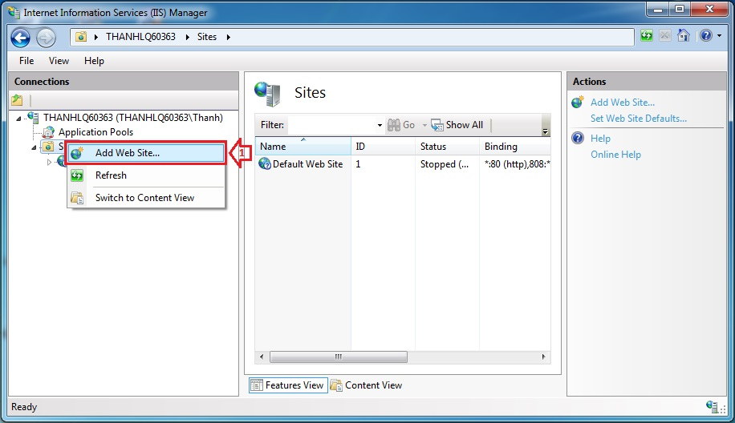

**Figure 63: Deploy Application Guide (1)**

* Enter “Site Name”.
* Click on “Select” button to select Application pool.

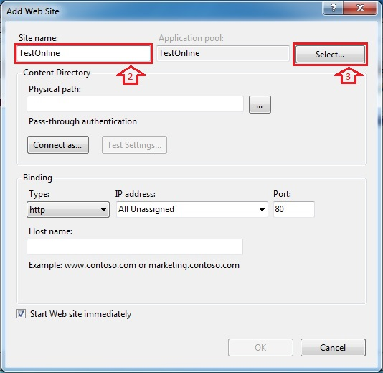

**Figure 64: Deploy Application Guide (2)**

* Select “ASP.NET v4.0”.

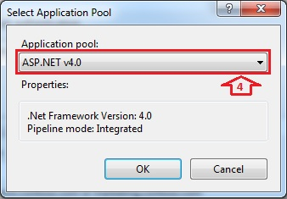

**Figure 65: Deploy Application Guide (3)**

* Browse physical path: “~/Deploy Package/TestOnlineProject”.

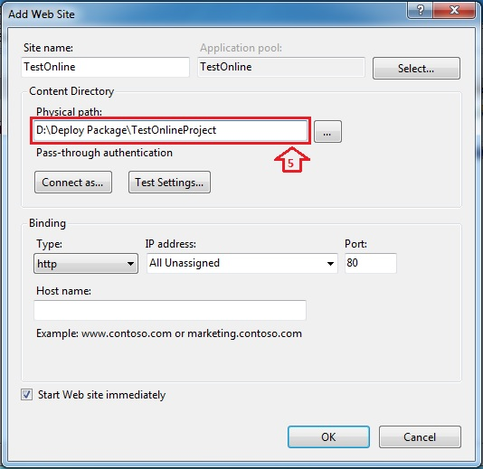

**Figure 66: Deploy Application Guide (4)**

* Open “~/Deploy Package/TestOnlineProject/Web.config” file by Notepad.

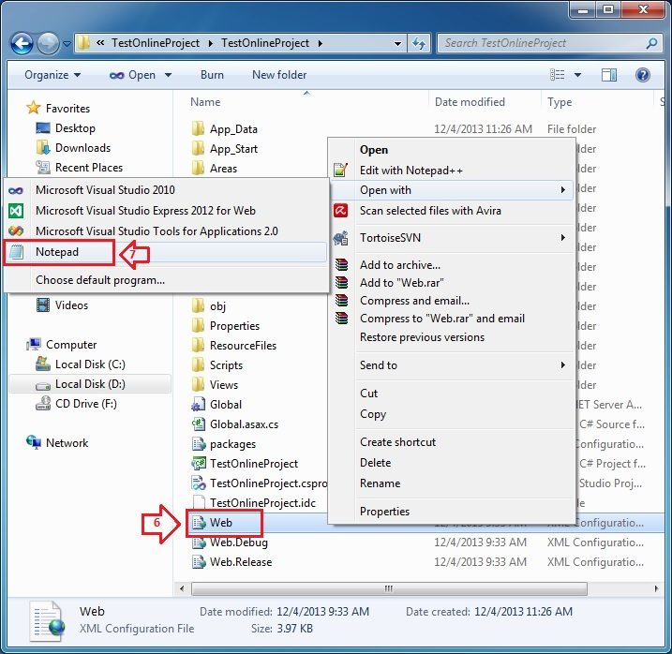

**Figure 67: Deploy Application Guide (5)**

* Find “connectionStrings” tag, change “Server Name”, “User ID” and “Password” in its connection string depend on your computer.

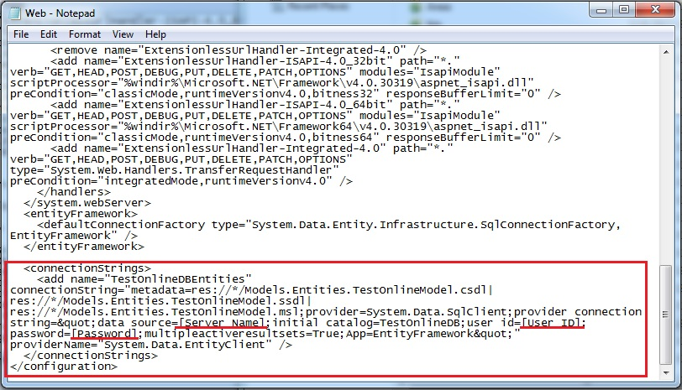

**Figure 68: Deploy Application Guide (6)**

* Right click on new site name (TestOnline) in left content -> Manage Web Site -> Browse to view the website.

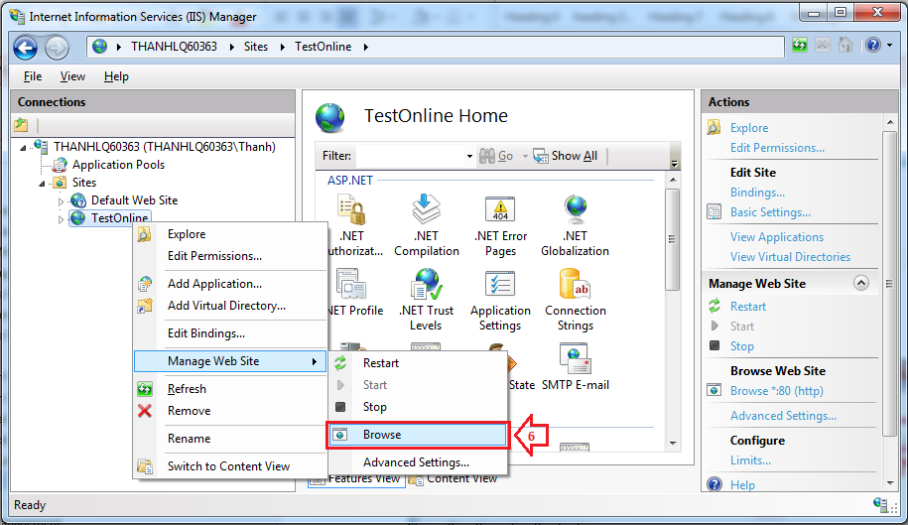

**Figure 69: Deploy Application Guide (7)**

* The website is deployed.

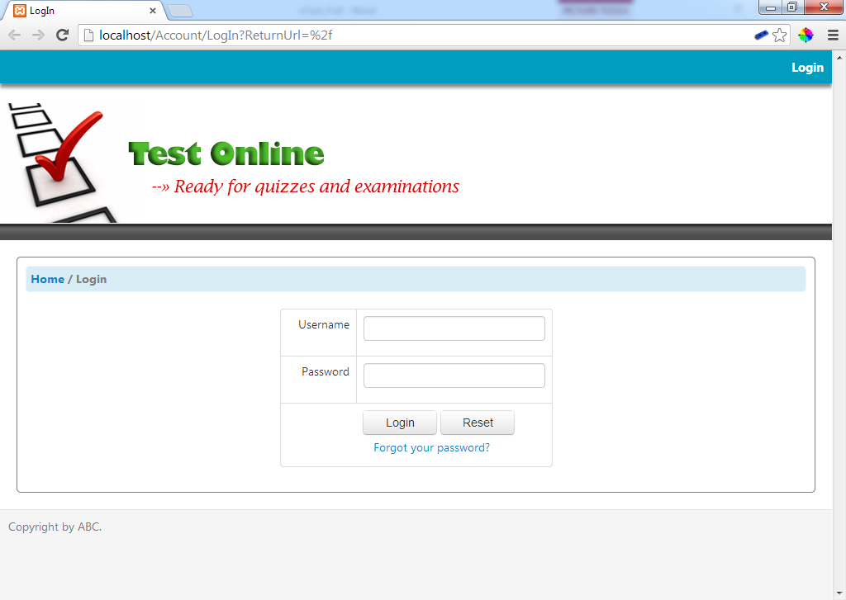

**Figure 70: Deploy Application Guide (8)**

## User’s Guide

* + Reference to CD: <root>/Documents/eTest Document - Full.docx

List of Figures

Figure 1 - Waterfall model 4

Figure 2 - Overall use case diagram 11

Figure 3 – Student’s use case diagram 12

Figure 4 – Teacher’s use case diagram 13

Figure 5 – Admin’ use case diagram 14

Figure 6 - Login UseCase 15

Figure 7 – Change Password UseCase 16

Figure 8 – Create User UseCase 18

Figure 9 – Import User UseCase 20

Figure 10 – Create Participant UseCase 22

Figure 11 – Import Participant UseCase 24

Figure 12 – Create Subject UseCase 26

Figure 13 – Import Subject UseCase 29

Figure 14 – Create Section UseCase 31

Figure 15 – Create Question UseCase 33

Figure 16 – Import Question UseCase 35

Figure 17 – Add Question to Section UseCase 37

Figure 18 – Create Test UseCase 39

Figure 19 – Take the Test UseCase 41

Figure 59 – Take the Quick Test UseCase 42

Figure 20 – Create Discussion UseCase 44

Figure 21 – Send Question Report UseCase 46

Figure 22 – Send Section Report UseCase 48

Figure 23 – Send Discussion Report UseCase 49

Figure 24 – Send Test Report UseCase 51

Figure 25 – Send Feedback UseCase 53

Figure 26 – Entity Relationship Diagram 56

Figure 27 – MVC implemented in 3 tiers architecture 58

Figure 28 – MVC architecture 59

Figure 29 – Component diagram 61

Figure 30 – Account Component 62

Figure 31 – User Component 63

Figure 32 – Subject Component 64

Figure 33 – Participant Component 65

Figure 34 – Section Component 66

Figure 35 – Question Component 67

Figure 36 – Test Component 68

Figure 37 – Discussion Component 69

Figure 38 – Report Component 70

Figure 39 – Feedback Component 71

Figure 40 – Login Sequence 72

Figure 41 – Change Password Sequence 74

Figure 42 – Create User Sequence 76

Figure 43 – Import User Sequence 78

Figure 44 – Create Participant Sequence 80

Figure 45 – Import Participant Sequence 82

Figure 46 – Create Subject Sequence 84

Figure 47 – Import Subject Sequence 86

Figure 48 – Create Section Sequence 88

Figure 49 – Create Question Sequence 90

Figure 50 – Import Question Sequence 92

Figure 51 – Add Question to Section Sequence 93

Figure 52 – Create Test Sequence 95

Figure 54 – Take the Test Sequence 97

Figure 55 – Take the Quick Test Sequence 98

Figure 56 – Create Discussion Sequence 100

Figure 57 – Send Question Report Sequence 102

Figure 161 – Send Section Report Sequence 103

Figure 163 – Send Test Report Sequence 105

Figure 61 – Send Feedback Sequence 107

Figure 62 – Physical Diagram 109

Figure 63 – Deplay Application Guide (1) 175

Figure 64 – Deplay Application Guide (2) 176

Figure 65 – Deplay Application Guide (3) 176

Figure 66 – Deplay Application Guide (4) 177

Figure 67 – Deplay Application Guide (5) 178

Figure 68 – Deplay Application Guide (6) 179

Figure 69 – Deplay Application Guide (7) 179

Figure 70 – Deplay Application Guide (8) 180

**The End**